Style Guidelines for Final Year Project Reports

Air Pollution Detection through Sensors

**Final Year Project– 1st Report**

**Session 2015-2019**

**A 4th Year Student**

A project submitted in partial fulfilment of the

COMSATS University

Of

BSc. (Hons.)BS in Software Engineering (CIIT)



Department of Computer Science

COMSATS Institute of Information Technology, Lahore

08 December 2018

**Evaluation**

|  |  |  |  |  |
| --- | --- | --- | --- | --- |
| **Project Group Members**(To be filled by students) | | | | (To be filled by supervisor) |
| Sr.# | Reg. # | Student Name | *Signature | Obtained Marks (Total Marks: 10) |
| (i) | Sp15-BSE-066 | Fazal-ur-Rahman |  |  |
| (ii) | Sp15-BSE-060 | Maria Khan |  |  |
| (iii) | Sp15-BSE-064 | Shanzeh Shaukat |  |  |

*The candidates confirm that the work submitted is their own and appropriate credit has been given where reference has been made to work with others.

Supervisor Name: ____________________________ Supervisor Signature:______________

Remarks (if any): ______________________________________________________________

______________________________________________________________

______________________________________________________________

**Abstract**

Our Project is about the detection of air Pollution by using different sensors and propose a method or a way that how can we reduce the air pollution that is by planting how many trees, we can reduce this pollution and in what span of time, we can reduce this pollution to its minimum level. This project will allow you to detect the harmful particles and gases like carbon monoxide and provide us with the method or way to eradicate these harmful particles or gases from our environment that is by planting trees.

* **Table of Contents**

1 Chapter #1: Introduction 9

1.1 Introduction 9

1.2 Objectives 9

1.3 Problem Statement 10

1.4 Assumptions and Constraints 10

1.5 Project Scope 11

2 Chapter #2: Requirement Analysis 13

2.1 Literature Review 13

2.2 Stakeholder List 14

2.3 Requirement Elicitation 15

2.3.1 Functional Requirements 15

2.3.2 Non Functional Requirements 21

2.3.3 Requirement Traceability Matrix 22

2.4 Use Case Descriptions 28

2.5 Use Case Diagram 54

2.6 Software Development Life Cycle 71

3 Chapter #3: System Design 72

3.1 Work Breakdown Structure 72

3.2 Activity Diagram 73

3.3 Sequence Diagram 92

3.4 Software architecture 112

3.5 Class Diagram 114

3.6 Database Diagram 115

3.7 Network Diagram 116

4 Chapter #4: System Testing 117

4.1 Test cases 117

5 References 132

**List of Tables**

Table 1 - FR01: Customer Accounts 16

Table 2 - FR02: Admin’s Account 16

Table 3- FR03: Log in 16

Table 4 - FR04: Shopping Cart 17

Table 5 - FR05: Payment Method 17

Table 6 - FR06: View Order History 18

Table 7 - FR07: Search Item 18

Table 8 - FR08: Feedback and Suggestions 18

Table 9 - FR9: Deals 19

Table 10 - FR10: Refreshment box (Customized) 19

Table 11 - FR11: Checkout 20

Table 12 - FR12: Chat Box 20

Table 13 - FR13: Boxes 20

Table 14 - FR14: View Order 20

Table 15 - FR15: Order Status 21

Table 16 - FR16: Confirmation Email 21

Table 17 - FR17: Product 21

Table 18 - FR18: Deals 22

Table 19 - FR19: Toppings 22

Table 20 - FR20: Verify Customer 22

Table 21 -NFR01: Performance 23

Table 22 - NFR02: Security 23

Table 23 - NFR03: Defects-Maintenance 23

Table 24 - NFR09: Disaster Recovery 23

Table 25 - Create Account UC Description 29

Table 26 - Login UC Description 31

Table 27 - Search UC Description 33

Table 28 - Order Processing UC Description 34

Table 29 - Individual Custom Order UC Description 36

Table 30 - Individual Order UC Description 38

Table 31 – Customized Refreshment Box UC Description 39

Table 32 - Non-Customized Deals UC Description 42

Table 33 - Select Box UC Description 43

Table 34 - Add Sample Box (Admin) UC Description 44

Table 35 - Delete Sample Box (Admin) UC Description 45

Table 36 - Update Sample Box (Admin) UC Description 46

Table 37–Add Deals (Admin) UC Description 47

Table 38 – Update Deals (Admin) UC Description 48

Table 39- Update Order Status UC Description 49

Table 40 - View Order History UC Description 50

Table 41 - ChatBot UC Description 52

Table 42 - Check Feedback and Suggestion UC Description 53

**List of Figures**

Figure 1 - Bake My Day UC diagram 55

Figure 2 - Create Customer Account UC Diagram 56

Figure 3- Create Admin Account UC Diagram 57

Figure 4- Login UC Diagram 58

Figure 5 - Search UC Diagram 59

Figure 6 - Order Processing UC Diagram 60

Figure 7 - Individual Custom Order UC Diagram 61

Figure 8 - Individual Non Custom Order UC Diagram 62

Figure 9 - Customized Deals 63

Figure 10 - Non Customized Deals UC Diagram 64

Figure 11 - Manage Refreshment Boxes UC Diagram 65

Figure 12- Manage Deals UC Diagram 66

Figure 13 - Manage Toppings UC Diagram 67

Figure 14 - Order Status and Order History UC Diagram 68

Figure 15 - ChatBot UC Diagram 69

Figure 16 - Manage Feedback and Suggestion UC Diagram 70

Figure 17 - Customer Feedback UC Diagram 71

Figure 18 - Bake My Day WBS 73

Figure 19 - Customer Account Activity Diagram 74

Figure 20 - Admin Account Activity Diagram 75

Figure 21 - Login Activity Diagram 76

Figure 22 - Shopping Cart Activity Diagram 77

Figure 23 - Payment Activity Diagram 78

Figure 24 Order History Activity Diagram 79

Figure 25 - Search Activity Diagram 80

Figure 26 - Customer Feedback Activity Diagram 81

Figure 27 - Admin Feedback Module Activity Diagram 82

Figure 28 - Individual Non Custom Order Activity Diagram 83

Figure 29- Individual Custom Order Activity Diagram 84

Figure 30 - Deals Order Activity Diagram 85

Figure 31- Customize Refreshment Box Order Activity Diagram 86

Figure 33 - Chatbot Customer Side Activity Diagram 87

Figure 34 - Admin Chatbot Activity Diagram 88

Figure 35 - Boxes (CRUD) Activity Diagram 89

Figure 37 - Update Order Status Activity Diagram 90

Figure 38 - Product (CRUD) Activity Diagram 91

Figure 39 - Deals (CRUD) Activity Diagram 92

Figure 40 - Customer Account Sequence Diagram 93

Figure 41- Admin Account Sequence Diagram 94

Figure 42 - Login Sequence Diagram 95

Figure 43 - Shopping Cart Sequence Diagram 96

Figure 44 - Payment Module Sequence Diagram 97

Figure 45- Order History Sequence Diagram 98

Figure 46 - Search Sequence Diagram 99

Figure 47 - Customer Feedback Sequence Diagram 100

Figure 48 - Admin Feedback Sequence Diagram 101

Figure 49 - Individual Order Sequence Diagram 102

Figure 50 - Individual Custom Order Sequence Diagram 103

Figure 51- Custom Deals Order Sequence Diagram 104

Figure 52 - Non Custom Deal Order Sequence Diagram 105

Figure 53 - Checkout Sequence Diagram 106

Figure 54 - Customer Side Chat Bot Sequence Diagram 107

Figure 55 - Admin Side Chat Bot Sequence Diagram 108

Figure 56- Boxes CRUD Sequence Diagram 109

Figure 57- Order CRUD Sequence Diagram 110

Figure 58- Product CRUD Sequence Diagram 111

Figure 59 - Deal CRUD Sequence Diagram 112

Figure 60 - Software Architecture 114

Figure 61 - Bake My Day Class Diagram 115

Figure 62 - Bake My Day Database Diagram 116

Figure 63 - Network Diagram 117

* **Chapter #1: Introduction**
* **Introduction**

Nowadays Pollution is the main cause of temperature elevation of earth and different types of other problems that we encountered in our daily life. And Air pollution plays an important role in the upbringing of these problems and to reduce this pollution, we should plant trees. Our Project is basically detecting the air pollution in a certain area in which we place our sensors. Sensors detect the air pollutant particles that are harmful for the human and we fetch the data from these sensors and analyze this data to make a prediction that if we plant this much trees in this area, we would be able to reduce the air pollution in specific area. We are basically implementing wireless sensor networking in our project.

* **Objectives**

The main objective of our project is to detect the air pollutant in the air and make a prediction that how we can reduce the air pollution to an acceptable limit.

* Our project will detect all the harmful particles and gases in the atmosphere and provide us with the information that how many trees we should plant to reduce/eradicate these harmful gases from the atmosphere.
* We will develop an android app in which the user can see all the simulation results.
* The app will be able run on all android devices.
* The results will tell the user the number of trees they need to plant in the specific area to reduce the pollution to an acceptable level.
* **Problem Statement**

Pollution is one of the major issues in our country. The Air quality index describes that how rapidly the atmosphere here is getting polluted. The one way to reduce the pollution is to plant the trees. But there is no proper mechanism which describes how much trees we have to plant to make the environment more suitable.

The main motive of our project is to describe the actual number of trees that should be planted in an area to reduce the amount of pollution. Each tree have different capability to produce the oxygen or to filter the air in this so by using this project we can plant the number of trees that are required in the specific place.

**Assumptions and Constraints**

Following are the assumptions for our project

* All the three sensors are developed individually and each sensor performs its own task.
* The mobile application is for android based platforms.
* The land on which we choose to plant the trees should be fertile.
* Our application is not web based.

Following are the constraints of our project

* The project has to be complete in four months till April 2018.
* The project requires an internet connection.
* The project doesn’t need an internet connection.
* Daily working hours for the project are not more than 6 hours.
* **Project Scope**

Today pollution is becoming the main problem or issue of the world. The temperature of the earth is increasing day by day. We need to reduce air pollution to reduce the temperature of the earth and prevent polluted environment to harm human. That’s we have chosen this project. In this way, we can detect the polluted environment and guide people to plant trees and reduce air pollution. The scope of project is wide. As we can reduce air pollution by planting trees.

* **Chapter #2: Requirement Analysis**
* **Literature Review**

For ordering products, some previously existing systems are present for this food ordering process in which customer needs to have a physically present copy of the menu. He has a deficiency of a visible confirmation that the order is placed properly. The necessity for the bakery to have staff answering the phone and take orders and poor services.

* As concerned to foodpanda app, when it has pros of Easily find, order, pay, and get delivery of your favorite food, finding a wide variety of cuisines, keeping track of previous orders so you can reorder items, exclusive money-saving deals to be found, customer interface is smooth and have attractive images. It also has cons of not supporting multiple countries. Also, sometimes its content is slow to load. [1]
* Similarly, my online bakery app has pros of a simple format, customer friendly and customer support. Customers can order online from any device. Customer support is usually very consistent. They have a lot of various reports to fit any need the customer has. When a customer had an issue, they were quick to follow up and resolve. There are also some cons present like difficult to control orders due to the out of stock items, executing reports is not so easy either and introducing into quick books have proved to be a challenge. It wasn't excellent spontaneous at first so it was easy to make mistakes. [2]
* Bake-Wheel-Basic app is beneficial for those bakers agency that doesn’t need cost accounting, inventory and advance report and Bake Wheel professional is an advanced tool for all bakers. It is machine-driven and it cuts back daily massive calculations and paperwork. It is simple to use, for baker and client. It frees from having to book orders over the phone and email. It provides all invoicing and delivery notes. But we tend to may have inventory, we tend to may have accounting except for our bakery size it might build it too complicated. [3]
* Supermeal is online food ordering service facilitating food lovers to search out restaurants on the go and place online orders at their ease and considering the budget. Supermeal helps to order food from anywhere in Pakistan. It serves urban centres, Lahore, Hyderabad, the national capital, and city. The Supermeal app helps to search out deals and location from the current vicinity. It mechanically detects the location and shows restaurants consequently. We can conjointly manually opt for the placement to search restaurants in this space. We are able to get cash back on each order that we have a tendency to place on Supermeal. The money earned from money back will be used for next order to any restaurants that provide e-cash facility. One feature is that it provides discount and earn points once ordered online. But their Customer services are not good. Sometimes, they cancel the order of customer on their own. And also don’t apologize and write any issue or sorry voucher. Their food quality is not good so they have to be bound some selective restaurant. [4]
* UberEats give the fewest choices in terms of restaurants. Users rate the eating house on a five-star scale. Specific dishes are rated, too, however solely with thumbs-up or thumbs-down.. It additionally highlights specific problems that individuals mention like portion size, temperature and taste. But it delivers the order late. Not confirmation of delivery to the customer that they accepted the order or not, Slow processing of software mean not a good performance. Sometimes they deliver the wrong or invalid order. [5]
* **Stakeholder List**

|  |  |
| --- | --- |
| Names | Roles |
| Miss Sabeen Amjad | Project Supervisor |
| Miss Shaina Ashraf | Project Co-Supervisor |
| Fazal-ur-Rahman | Programmer |
| Shanzeh Shaukat | Documentation |
| Maria Khan | Documentation |

* **Requirement Elicitation**
* **Functional Requirements**

Table 1 - FR01: Sign Up

|  |  |
| --- | --- |
| **Req. No.** | **Functional Requirements** |
| FR01-01 | The system shall enable the Environmentalist or Forest Manager to create a new account by pressing Sign up option which will redirect them to the sign up panel. |
| FR01-02 | The system shall enable the environmentalist or forest manager to enter his/her First name, Last name, password, user name, cnic, resident address, email address, contact number and select their user profile by selecting the radio button either the “Environmentalist” or “Forest Manager”. |
| FR01-03 | After validating the credentials the environmentalist or forest manager shall get registered. |
| FR01-04 | The system shall redirect the environmentalist or forest manager to their login page. |

Table 2 - FR02: Login

|  |  |
| --- | --- |
| **Req. No.** | **Functional Requirements** |
| FR02-01 | The system shall provide admin, environmentalist and forest manager the login panel. |
| FR02-02 | The system shall provide the drop down list to select the role of the person whether he/she is admin or environmentalist or forest manager. |
| FR02-03 | The login view should contain the email or password option. |
| FR02-04 | The system shall allow the admin, environmentalist or forest manager to view and manage their account. |
| FR02-05 | After validating the credentials the admin, environmentalist or forest manager shall login. |
| FR02-06 | After login the system shall enable the admin, environmentalist or forest manager to access the TRIP (Trees Required in Place) application services. |

Table 3- FR03: Forgot Password

|  |  |
| --- | --- |
| **Req.no.** | **Functional requirements** |
| FR03-01 | The system will provide a “Forget Password” option on login page in case if the any of the user forget it. |
| FR03-02 | The system shall allow admin, environmentalist or forest manager to enter his/her email id to get a new password. |
| FR03-03 | The system shall allow admin, environmentalist or forest manager to get a password that will be sent to his/her email id. |
| FR03-04 | After authentication, the system shall allow the admin, environmentalist or forest manager go to the login page to access the TRIP (Trees Required in Place) application system. |

Table 4 - FR04: View User Details (For Admin)

|  |  |
| --- | --- |
| **Req. No.** | **Functional Requirements** |
| FR04-01 | After login to TRIP, the system shall enable the admin to select on the “View activities” button to view environmentalist or forest manager accounts details. |
| FR04-02 | After selecting the button, the Admin shall be directed to the next page to select whether he/she wanted to view environmentalist or forest manager account details through checkboxes. |
| FR04-03 | The system shall allow the admin to check the individual activities of environmentalist or forest manager accounts and could check the reports that have been generated by their simulations. |

Table 5 - FR05: Add Trees Data

|  |  |
| --- | --- |
| **Req. No.** | **Functional Requirements** |
| FR05-01 | After login to TRIP (Trees Required in Place) the system shall enable the admin to add more trees(ID, Name, type, percentage of filter air(ppm) and oxygen provide) into the database by selecting on the add tree button which is display in the Home page menu. |
| FR05-02 | After authentication, the system shall display the confirmation message to admin that tree (ID, Name, type, percentage of filter air (ppm) and oxygen- provide) is added into the database successfully and admin will be redirected to home page. |

Table 6 - FR06: Update Trees Data

|  |  |
| --- | --- |
| FR06-01 | After login to TRIP (Trees Required in Place) the system shall enable the admin to update tree ID, Name, type, percentage of filter air(ppm) or oxygen attributes by select on the edit tree button which is display in the Home page menu. |
| FR06-02 | After authentication, the system shall display the confirmation message to admin that tree ID, Name, type, percentage of filter air(ppm) or oxygen-provide attributes are edited successfully and admin will be redirected to home page |

Table 7 - FR07: Delete Tress Data

|  |  |
| --- | --- |
| **Req. No.** | **Functional Requirements** |
| FR07-01 | After login to TRIP (Trees Required in Place) the system shall enable the admin to remove tree (ID, Name, type, percentage of filter air(ppm) and oxygen) field by select on the delete tree button which is display in the Home page menu . |
| FR07-02 | After authentication, the system hall display the confirmation message to admin that tree (ID, Name, type, percentage of filter air(ppm) or oxygen )field is deleted successfully and admin will be redirected to home page. |

Table 8 - FR08: Remove User Profiles

|  |  |
| --- | --- |
| **Req. No.** | **Functional Requirements** |
| FR08-01 | After login to TRIP (Trees Required in Place) the system shall enable the admin to remove user (ID, Name, type of user and activity) field by select on the delete user record button which is display in the Home page. |
| FR08-02 | After authentication, the system shall display the confirmation message to admin that user (ID, Name, type of user and activity) field is deleted successfully and admin will be redirected to home page. |

Table 9 - FR9: Launch Sensors

|  |  |
| --- | --- |
| **Req. No.** | **Functional Requirements** |
| FR9-01 | After login to TRIP (Trees Required in Place) the system shall be directed to the home page. |
| FR9-02 | After selecting on the start button, a page shall load in which the system shall allow the Admin /environmentalist or forest manager enter region name and select sensors which they want to include in the simulation and select on the launch button. |
| FR9-03 | After selecting on the launch sensor button, the system shall display the detected amount of SO2, CO or Smog in the ppm i.e. parts per million and prediction table in which Tree Image, Trees Name and Quantity of each tree. |

Table 10 - FR10: Compare Result

|  |  |
| --- | --- |
| **Req. No.** | **Functional Requirements** |
| FR10-01 | The system shall provide the “Compare Results” option to admin, environmentalists or forest manager to compare the results with the previous simulation executed in the same region. |
| FR10-02 | The system shall compare the results by matching the Region name with the last simulation executed in the same region. |
| FR10-03 | The system shall display the graph between the current one and the previous one. |

Table 11 - FR11: Report of Previous Simulations

|  |  |
| --- | --- |
| **Req. No.** | **Functional Requirements** |
| FR11-01 | After login to TRIP (Trees Required in Place), the system shall enable the Admin /environmentalist or forest manager to select the Report from TRI Bar menu. | |
| FR12-02 | The system shall display the table in which all previous simulation results will be displayed. | |

Table 12 - FR12: Logout

|  |  |
| --- | --- |
| **Req. No.** | **Functional Requirements** |
| FR12-01 | The Admin /environmentalist or forest manager accesses the system. |
| FR12-02 | The Admin /environmentalist or forest manager is presented to a TRI Bar that includes a logout link. |
| FR12-03 | The Admin /environmentalist or forest manager requests to be logged out. |
| FR12-04 | The Admin /environmentalist or forest manager is logged out and their simulation results will be saved In the database. |

* **Non Functional Requirements**

Table 13 -NFR01: Performance

|  |  |
| --- | --- |
| NFR01-01 | Average load time of the starting page of the system shall be less than 2 seconds. |
| NFR01-02 | Average processing time taken by the system to complete a request shall be less than 10 seconds. |
| NFR01-03 | Average system response time shall not be greater than 5 seconds. |
| NFR01-04 | 100 customers shall be able to simultaneously access the system. |

Table 14 – NFR02: Security

|  |  |
| --- | --- |
| NFR02-01 | The system shall provide access to authorized environmentalist/Forest Manager and admin only who access the system through login module. |
| NFR02-02 | No environmentalist/Forest Manager shall view data of any other environmentalist/Forest Manager through any report or views provided by the system. |
| NFR02-03 | At the end of environmentalist, Forest Manager and admin session, no information shall be saved anywhere on the environmentalist/Forest Manager machine. |

Table 15 - NFR03: Defects-Maintenance

|  |  |
| --- | --- |
| NFR03-01 | Post Release defects of the system shall not exceed 1 critical bug per month. |
| NFR03-02 | Post Release bug fixing shall not take more than 5 hours. |

Table 16 - NFR04: Disaster Recovery

|  |  |
| --- | --- |
| NFR09-01 | In case of client /server crash all information/data should be recoverable within 30 minutes of the incidence. |

* **Requirement Traceability Matrix**

|  |  |  |  |  |
| --- | --- | --- | --- | --- |
| **ID** | **Associate ID** | **Requirement Description** | **Use case ID** | **Test Case ID** |
| 1.1 | FR01 | The system shall enable the customer to create a new account by entering his personal information. For example, name, CNIC, address, contact no. | UC ID 001 | TC ID 001 |
| 2.1 | FR02 | The system shall enable the admin to create a new account by entering personal information. | UC ID 001 | TC ID 001 |
| 3.1 | FR03 | The system shall allow admin/customer to login with a username and password before using the system. | UC ID 002 | TC ID 002 |
| 4.1 | FR04 | The system shall enable the customer to select his\her desired bakery product and to add/delete the product and also he can edit the quantity along with customizations. | UC ID 004 | TC ID 003 |
| 5.1 | FR05 | The system shall enable the customer to select the payment method (Credit Card, Debit Card, Master Card, Visa Card or Cash on delivery). | UC ID 004 | TC ID 004 |
| 6.1 | FR06 | The system shall allow the customer to view his/her order history, he can also see progress status of his/her order. | UC ID 014 |  |
| 7.1 | FR07 | The system shall enable the customer to search item according to his/her choices by choosing flavours and ingredients. | UC ID 003 |  |
| 8.1 | FR08 | The system shall allow the customer to give his/her feedback about a product that he\she purchased. The system shall enable the admin to view, approve, and remove the feedback and suggestions. | UC ID 016 |  |
| 9.1 | FR09 | The system shall allow the customer to view different deals for refreshment boxes by showing items that will be included in the box and all the details of the items and order non customized deals. | UC ID 005  UC ID 006  UC ID 008 | TC ID 006 |
| 10.1 | FR10 | The system shall allow the customer to order a customized refreshment box by selecting items from the menu. | UC ID 007  UC ID 010 | TC ID 005 |
| 11.1 | FR11 | The system shall allow the customer to view order detail and shipping information for confirmation before checkout. | UC 1D 004 | TC ID 004 |
| 12.1 | FR12 | The system shall enable the customer to ask any question about the product through the chat box and allows the admin to reply. | UC ID 015 |  |
| 13.1 | FR13 | The system shall enable the customer to select boxes according to their requirements or theme like wedding, meeting, birthday etc. The system shall allow the admin to add/delete sample boxes according to size and themes. | UC ID 009  UC ID 010  UC ID 011  UC ID 012 | TC ID 007 |
| 14.1 | FR14 | The system shall enable the admin view details of an order like product name, product quantity, price and total. | UC ID 013 |  |
| 15.1 | FR15 | The system shall allow the admin to update and view the status of the order. | UC ID 013 | TC ID 008 |
| 16.1 | FR16 | The system shall allow the admin to send an email to the customer on successful order placement and payment processing with complete order details. | UC ID 004 | TC ID 004 |
| 17.1 | FR17 | The system shall allow the admin to add, delete and update different bakery product categories. | UC ID 004 | TC ID 004 |
| 18.1 | FR18 | The system shall allow the admin to add, delete and update deals for refreshment boxes. | UC ID 013  UC ID 014 |  |
| 19.1 | FR19 | The system shall allow the admin to add, delete and update toppings for refreshment boxes. | UC ID 013  UC ID 014 |  |
| 20.1 | FR20 | The system shall allow the admin to verify the customer from his\her email id. | UC ID 001 |  |

* **Use Case Descriptions**

Table 17 - Create Account UC Description

|  |  |  |  |
| --- | --- | --- | --- |
| **Use case ID 001 Use case Name: Create Account** | | | |
| **Priority High/** | | | |
| **Actors:**  Environmentalist, Forest Manager | | | |
| **Use Case Summary** | Sign-up allows the user who is new to the system to create his account that will allow him to fully use the TRIP (Trees Required in Place) application. | | |
| **Pre-condition:** | Login page has already been loaded. | | |
| **Normal Flow of Events** | | | **Alternative Path** |
| **1.** The Environmentalist or Forest Manager select the sign up button on the login page so to create an account. | | |  |
| **2.** The system responds by displaying the sign-up page. | | |  |
| **3.** Then Environmentalist or Forest Manager verified by the system. | | |  |
| **4.** The Environmentalist or Forest Manager will enter their personal information First name, Last name, password, user name, cnic, resident address, email address contact number and select their user profile. | | | **4a:** If the Environmentalist, Forest Manager does not enter a name the system prompts the user to enter a name.  **4b:** If the Environmentalist, Forest Manager does not enter a username that is already exist the system prompts the user to enter a new user name.  **4c:** If the Environmentalist, Forest Manager does not enter the correct email address format or left it blank the system prompts the user to enter the correct email address  **4d:** If the Environmentalist, Forest Manager does not enter the password the system will prompt the user to enter the correct alpha-numeric password of 6 or more digit.  **4e.** If the Environmentalist, Forest Manager does not enter contact number or it exceeds the limited digit number the system prompts the user to enter the correct contact number.  **4f.** If the Environmentalist, Forest Manager does not select their role the system prompts the user to select a role. |
| **5.** The Environmentalist, Forest Manager confirms sign-up by selecting its button. | | | **5a:** If the Environmentalist, Forest Manager does not want to create an account they can select the cancel button. |
| **6.** The system responds by creating the account. | | |  |
| **7.** A system responds by redirecting the Environmentalist, Forest Manager to the “Login” page where the user can proceed to enter in his/her account | | |  |
| **Post Conditions** | | | |
| **Step#1** | | | **Description** |
|  | | | The account of a new Environmentalist, Forest Manager created |
| **Use Case Cross References** | | | |
| **Includes** | | None | |
| **Extends** | | None | |

Table 18 - Login UC Description

|  |  |  |  |
| --- | --- | --- | --- |
| **Use case ID 002 Use case Name: Log in** | | | |
| **Priority High** | | | |
| **Actors:**  Admin, Environmentalist, Forest Manager | | | |
| **Use Case Summary** | Log in allows the Admin, Environmentalist, Forest Manager who already have an account in the system to access the respective accounts that will allow them to fully use TRIP (Trees Required in Place) application. | | |
| **Pre-condition:** | The account in TRIP system already exists and the login page is loaded. | | |
| **Normal Flow of Events** | | | **Alternative Path** |
| **1.** The system responds by displaying the log in page. | | |  |
| **2.** The Admin, Environmentalist or Forest Manager will login by entering their username and password. | | | **2a:** If the Admin, Environmentalist or Forest Manager does not enter correct username the system prompts the Admin, Environmentalist or Forest Manager to enter the correct username.  **2b:** If the Admin, Environmentalist or Forest Manager does not enter correct password the system prompts the Admin, Environmentalist or Forest Manager to enter the correct password. |
| **4.** The Admin, Environmentalist or Forest Manager confirms log in by selecting login button. | | |  |
| **5.** The system responds by opening the respective account. | | |  |
| **6.** A system responds by redirecting the Admin, Environmentalist or Forest Manager to the “My Account” page where the user can proceed and start the simulation. | | |  |
| **Post Conditions** | | | |
| **Step#1** | | | **Description** |
|  | | | The account holder gets access to their account. |
| **Use Case Cross References** | | | |
| **Includes** | | None | |
| **Extends** | | None | |

Table 19 – Forgot password UC Description

|  |  |  |  |
| --- | --- | --- | --- |
| **Use case ID 003 Use case Name: Forgot Password** | | | |
| **Priority High** | | | |
| **Actors:**  Admin, Environmentalist or Forest Manager | | | |
| **Use Case Summary** | Forget password option enables the Admin, Environmentalist or Forest Manager to retrieve their account password in case if they forget their original password. | | |
| **Pre-condition:** | The Admin, Environmentalist or Forest Manager have forget their password. | | |
| **Normal Flow of Events** | | | **Alternative Path** |
| **1.** System has displayed the login page to the Admin, Environmentalist or Forest Manager. | | |  |
| 2. The Admin, Environmentalist or Forest Manager writes the incorrect username or password. | | |  |
| 3. The system show the error of invalid username or password. | | |  |
| **4.** The Admin, Environmentalist or Forest Manager selects on the forget password option. | | |  |
| **5.** The application will display the “Password retrieval” page. | | |  |
| **6.** The Admin, Environmentalist or Forest Manager responds by entering their email address which they provided during the signup process. | | | **6a:** If the Admin, Environmentalist or Forest Manager have entered the wrong email the system will prompt he user to enter the correct email. |
| **7.** After providing the email address the Admin, Environmentalist or Forest Manager will press “Confirm Email” button. | | |  |
| **8.** The system will send the new password to the Admin, Environmentalist or Forest Manager provided email address and will redirected to the login page. | | |  |
| **Post Conditions** | | | |
| **Step#1** | | | **Description** |
|  | | | The Admin, Environmentalist or Forest Manager can login into the account now. |
| **Use Case Cross References** | | | |
| **Includes** | | None | |
| **Extends** | | None | |

Table 20 – View User Detail UC Description (For Admin)

|  |  |  |  |
| --- | --- | --- | --- |
| **Use Case ID 004 Use case Name: View user Detail** | | | |
| **Priority** High | | | |
| **Actors:**  Admin | | | |
| **Use Case Summary** | Admin have the authority to view the activities of accounts of the Environmentalist or Forest Manager. | | |
| **Pre-condition:** | The admin has been logged in the system. | | |
| **Normal Flow of Events** | | | **Alternative Path** |
| **1.** The system has been redirected to the homepage. | | |  |
| **2.** The admin can select on the “View Users” button to view the Environmentalist or Forest Manager account. | | |  |
| **3.** The admin can select both or any one of them and select “Done” button. | | | **3a:** If the admin doesn’t select any type of user profile and press the “Done” button the system will prompt the admin to select at least one type of user profile. |
| **Post Conditions** | | | |
| **Step#** | | | **Description** |
| **1.** | | | The admin can view the user profile. |
| **Use Case Cross References** | | | |
| **Includes** | | None | |
| **Extends** | | None | |

Table 29 – Add Tree Data UC Description

|  |  |  |  |  |
| --- | --- | --- | --- | --- |
| **Use Case ID 005 Use case Name: Add Tree Data** | | | | |
| **Priority** High | | | | |
| **Actors:**  Admin | | | | |
| **Use Case Summary** | Add Tree Data module allows the admin to add specific tree data in the database. | | | |
| **Pre-condition:** | Admin must be logged in to the system. | | | |
| **Normal Flow of Events** | | | **Alternative Path** | |
| **1**. After the Admin’s login, he will be able to select on the Add tree button to add specific tree details in the database. | | | | **1a:** Admin is unable to log-in the web page. |
| After selecting on the Add Tree button, the system shall display a form in which Admin can add Tree details like   * ID * Name * Type * %_FilterAir * Oxygen_Provide | | | |  |
| **3.** After adding the (ID, Name, Type, %_FilterAir, Oxygen_Provide) in the text-field, Admin shall select on the submit button to add the Tree details in the database. | | | | 3a. If the Admin, Environmentalist or Forest Manager does not enter ID in the given text-field, the system will prompts a message that please enter ID.  3b. If the Admin, Environmentalist or Forest Manager does not enter name in the given text-field, the system will prompts a message that please enter name.  3c. If the Admin, Environmentalist or Forest Manager does not enter type in the given text-field, the system will prompts a message that please enter type.  3d. If the Admin, Environmentalist or Forest Manager does not enter %_FilterAir in the given text-field, the system will prompts a message that please enter %_FilterAir.  3e. If the Admin, Environmentalist or Forest Manager does not enter Oxygen_Provide in the given text-field, the system will prompts a message that please enter Oxygen_Provide. |
| **Post Conditions** | | | | |
| **Step#** | | | | **Description** |
| **1.** | | | | An confirmation message will be displayed that Tree Detail has been added successfully. |
| **Use Case Cross References** | | | | |
| **Includes** | | None | | |
| **Extends** | | None | | |

Table 30 – Delete Tree Data UC Description

|  |  |  |  |  |  |
| --- | --- | --- | --- | --- | --- |
| **Use Case ID 006 Use case Name: Delete Tree Data** | | | | | |
| **Priority** High | | | | | |
| **Actors:**  Admin | | | | | |
| **Use Case Summary** | Delete Tree Data module allows the admin to delete specific tree data in the database. | | | | |
| **Pre-condition:** | 1. Admin must be logged in to the system. 2. Record should be present in the database. | | | | |
| **Normal Flow of Events** | | | **Alternative Path** | | |
| **1.** After the Admin’s login, he will be able to select on the Delete tree button to delete specific tree details in the database. | | |  | | |
| **2.** After selecting on the Delete Tree button, the system shall display a page in which Admin can delete Tree details through   * ID * Name | | |  | | |
| **3.** Admin shall add ID or Name of the particular record that he wanted to delete in the text-field. | | | 3a. If both fields i.e. ID and Name are empty then system will prompt a message that Enter ID or Name. | | |
| **4.** After adding the ID or Name in the text-field, Admin shall select on the delete button to delete record from the database and Admin will be redirected to the home page. | | |  | | |
| **Post Conditions** | | | | |
| **Step#** | | | | **Description** |
| **1.** | | | | The Record has been deleted from the database. |
| **Use Case Cross References** | | | | |
| **Includes** | | None | | |
| **Extends** | | None | | |

Table 31 – Update Tree Data UC Description

|  |  |  |  |  |  |
| --- | --- | --- | --- | --- | --- |
| **Use Case ID 007 Use case Name: Update Tree Data** | | | | | |
| **Priority** High | | | | | |
| **Actors:**  Admin | | | | | |
| **Use Case Summary** | Update Tree Data module allows the admin to update specific tree data in the database. | | | | |
| **Pre-condition:** | Admin must be logged in to the system. | | | | |
| **Normal Flow of Events** | | | **Alternative Path** | | |
| **1.** After the Admin’s login, he will be able to select on the Update tree button to update specific tree details in the database. | | | |  |
| After selecting on the Update Tree button, the system shall display a page in which Admin can search Tree details through  ID  Name | | | |  |
| 1. Admin shall add ID or Name of the particular record that he wanted to update in the text-field and press enter. | | | |  |
| **4.** The system will fetch all the records against the input ID or Name and there will be an edit button against every record in the database. | | | |  |
| **5.** Admin shall select on the edit button to update the record. | | | |  |
| **6.** After selecting on the edit button, the system shall display a form in which all the attributes(ID, Name, Type, %_FilterAir, Oxygen_Provide) will already be filled with previous values. | | | |  |
| **7.** The Admin will edit the particular field that he wants to edit. | | | |  |
| **8.** After editing the text-fields, the Admin shall select on the update button to update the record in the database and he/she will be redirected to the home page. | | | | **8a:** Update button is not responding as the content is too slow to load. |
| **Post Conditions** | | | | |
| **Step#** | | | | **Description** |
| **1.** | | | | Record has been updated in the database. |
| **Use Case Cross References** | | | | |
| **Includes** | | None | | |
| **Extends** | | None | | |

Table 32 – Remove User Profile UC Description

|  |  |  |  |  |
| --- | --- | --- | --- | --- |
| **Use Case ID 008 Use case Name: Remove User Profile** | | | | |
| **Priority** High | | | | |
| **Actors:**  Admin | | | | |
| **Use Case Summary** | | Delete User Profile module allows the admin to delete User Profile from the database. | | |
| **Pre-condition:** | | User should have an account in the TRIP. | | |
| **Normal Flow of Events** | | | | **Alternative Path** |
| **1.** After the Admin’s login, he will be able to select on the Remove User Profile button to delete specific user Profile details in the database. | | |  | |
| **2.** After selecting on the Remove User Profile button, the system shall display a page in which Admin can delete user profile details through Username. | | |  | |
| **3.** The Admin will enter the user name and press enter to remove the user profile and Admin will be redirected to the home page. | | | 3a. If the entered username is not found in the database, the system shall display the message that username not found.  3b. If the username is empty, the system shall display the message that enter username. | |
| **Post Conditions** | | | | |
| **Step#** | | | **Description** | |
| **1.** | | | User profile has been deleted. | |
| **Use Case Cross References** | | | | |
| **Includes** | None | | | |
| **Extends** | None | | | |

Table 33 – Launch Sensors UC Description

|  |  |  |  |
| --- | --- | --- | --- |
| **Use Case ID 009 Use case Name: Launch Sensors** | | | |
| **Priority** High | | | |
| **Actors:**  Environmentalist, Forest Manager and Admin | | | |
| **Use Case Summary** | This module will allow us to detect gases in the atmosphere through sensors and display the amount of gases in the ppm detected from that specific area. | | |
| **Pre-condition:** | Sensors should be in working condition. | | |
| **Normal Flow of Events** | | | **Alternative Path** |
| **1.** After login, the system shall allow the Environmentalist, Forest Manager and Admin to select on the start button to start the simulation. | | |  |
| **2.** After selecting on the start button, a page shall load in which the system shall allow the Admin /environmentalist or forest manager to enter region name and select sensors which they want to include in the simulation and select on the launch button. | | |  |
| **3.** Environmentalist, Forest Manager and Admin shall enter the region name and select the sensors which they want to include in the simulation and select on the launch sensor button. | | | 3a. If none of the sensors has been selected then the system will display a message that select at least one sensor. |
| **4.** After selecting on the launch sensor button, the system will display a page on which gases’ amount that is been detected from the atmosphere will be displayed in ppm and prediction table which includes attributes like   * **Tree Image** * **Tree Name** * **Quantity** | | |  |
| **Post Conditions** | | | |
| **Step#** | | | **Description** |
| **1.** | | | Simulation data has been stored in the database. |
| **Use Case Cross References** | | | |
| **Includes** | | None | |
| **Extends** | | None | |

Table 34 – Compare Results UC Description

|  |  |  |  |
| --- | --- | --- | --- |
| **Use Case ID 010 Use case Name: Compare Results** | | | |
| **Priority** High | | | |
| **Actors:**  Environmentalist, Forest Manager and Admin | | | |
| **Use Case Summary** | Compare Results module allows us to compare results of the current simulation and the previous one in the specific region. | | |
| **Pre-condition:** | Environmentalist, Forest Manager and Admin must be logged in to the system. | | |
| **Normal Flow of Events** | | | **Alternative Path** |
| **1.** When Environmentalist, Forest Manager and Admin logs in to the system, the system shall provide compare results option in the TRI Bar menu. | | |  |
| **2.** Environmentalist, Forest Manager and Admin shall select on the compare result option in the TRI Bar menu. | | |  |
| **3.** After selecting the compare result option, the system shall display the page in which region name and comparison years will be present. | | |  |
| **4.** Environmentalist, Forest Manager and Admin shall enter the region name and comparison years and select the compare button. | | | 4a. if region name is not entered, the system will display a message that please enter region name.  4b if comparison years is not entered, the system will display a message that please enter comparison years.  4c. if incorrect region name is entered then the system will display the message that please enter the correct region name.  4d. if incorrect comparison years is entered then the system will display the message that please enter the correct comparison years. |
| **5.**After selecting the compare button, the system shall display the graph. Between year and %removal. | | |  |
| **Post Conditions** | | | |
| **Step#** | | | **Description** |
| **1.** | | | Environmentalist, Forest Manager and Admin will come to know about the improvement in the air quality. |
| **Use Case Cross References** | | | |
| **Includes** | | None | |
| **Extends** | | None | |

Table 35 – Report of previous simulations UC Description

|  |  |  |  |
| --- | --- | --- | --- |
| **Use Case ID 011 Use case Name: Report of previous simulations** | | | |
| **Priority** High | | | |
| **Actors:**  Environmentalist and Forest Manager | | | |
| **Use Case Summary** | Report of previous simulations module allows Environmentalist and Forest Manager to view the record of their previous simulations. | | |
| **Pre-condition:** | Environmentalist and Forest Manager must be logged in to the system. | | |
| **Normal Flow of Events** | | | **Alternative Path** |
| **1.** When Environmentalist and Forest Manager logs in to the system, the system shall allow them to select the previous simulation option in the TRI Bar menu. | | |  |
| **2.** Environmentalist and Forest Manager shall select the previous simulation option. | | |  |
| **3.**After selecting the previous simulation option, the system shall display the report of his/her all previous simulations. | | | 3a. if Environmentalist and Forest Manager have not perform any simulation, the system will display the message that no previous simulations found. |
| **Post Conditions** | | | |
| **Step#** | | | **Description** |
| **1.** | | | Environmentalist and Forest Manager will come to know about the previous simulations details of him/her. |
| **Use Case Cross References** | | | |
| **Includes** | | None | |
| **Extends** | | None | |

Table 36 – Report of previous simulations (Admin) UC Description

|  |  |  |  |
| --- | --- | --- | --- |
| **Use Case ID 012 Use case Name: Report of previous simulations** | | | |
| **Priority** High | | | |
| **Actors:**  Admin | | | |
| **Use Case Summary** | Report of previous simulations module allows admin to view the record of all users’ previous simulations. | | |
| **Pre-condition:** | Admin must be logged in to the system. | | |
| **Normal Flow of Events** | | | **Alternative Path** |
| **1.** When Admin logs in to the system, the system shall allow them to select the previous simulation option in the TRI Bar menu. | | |  |
| **2.** Admin shall select the previous simulation option. | | |  |
| **3.**After selecting the previous simulation option, the system shall display the report of all users’ previous simulations. | | | 3a. if Environmentalist and Forest Manager have not perform any simulation, the system will display the message that no previous simulations found. |
| **Post Conditions** | | | |
| **Step#** | | | **Description** |
| **1.** | | | Admin will come to know about the previous simulations details of him/her. |
| **Use Case Cross References** | | | |
| **Includes** | | None | |
| **Extends** | | None | |

Table 37 – logout UC Description

|  |  |  |  |
| --- | --- | --- | --- |
| **Use Case ID 013 Use case Name: Update Sample Box** | | | |
| **Priority** High | | | |
| **Actors:**  Environmentalist, Forest Manager and Admin | | | |
| **Use Case Summary** | Logout module allows Environmentalist, Forest Manager and Admin to sign out from the TRIP application. | | |
| **Pre-condition:** | Environmentalist, Forest Manager and Admin must be logged in to the system. | | |
| **Normal Flow of Events** | | | **Alternative Path** |
| **1.** The Admin /environmentalist or forest manager logs in to the system. | | |  |
| **2.** After login, the system will allow the Admin /environmentalist or forest manager select the logout link in the TRI Bar menu. | | |  |
| **3.** The Admin /environmentalist or forest manager select the logout link in the TRI Bar menu. | | |  |
| **4.** The Admin /environmentalist or forest manager is logged out and their simulation results will be saved In the database. | | |  |
| **Post Conditions** | | | |
| **Step#** | | | **Description** |
| **1.** | | | The system shall be redirected to login page. |
| **Use Case Cross References** | | | |
| **Includes** | | None | |
| **Extends** | | None | |

* **Use Case Diagram**

Figure 1 - Bake My Day UC diagram

Figure 2 - Create Customer Account UC Diagram

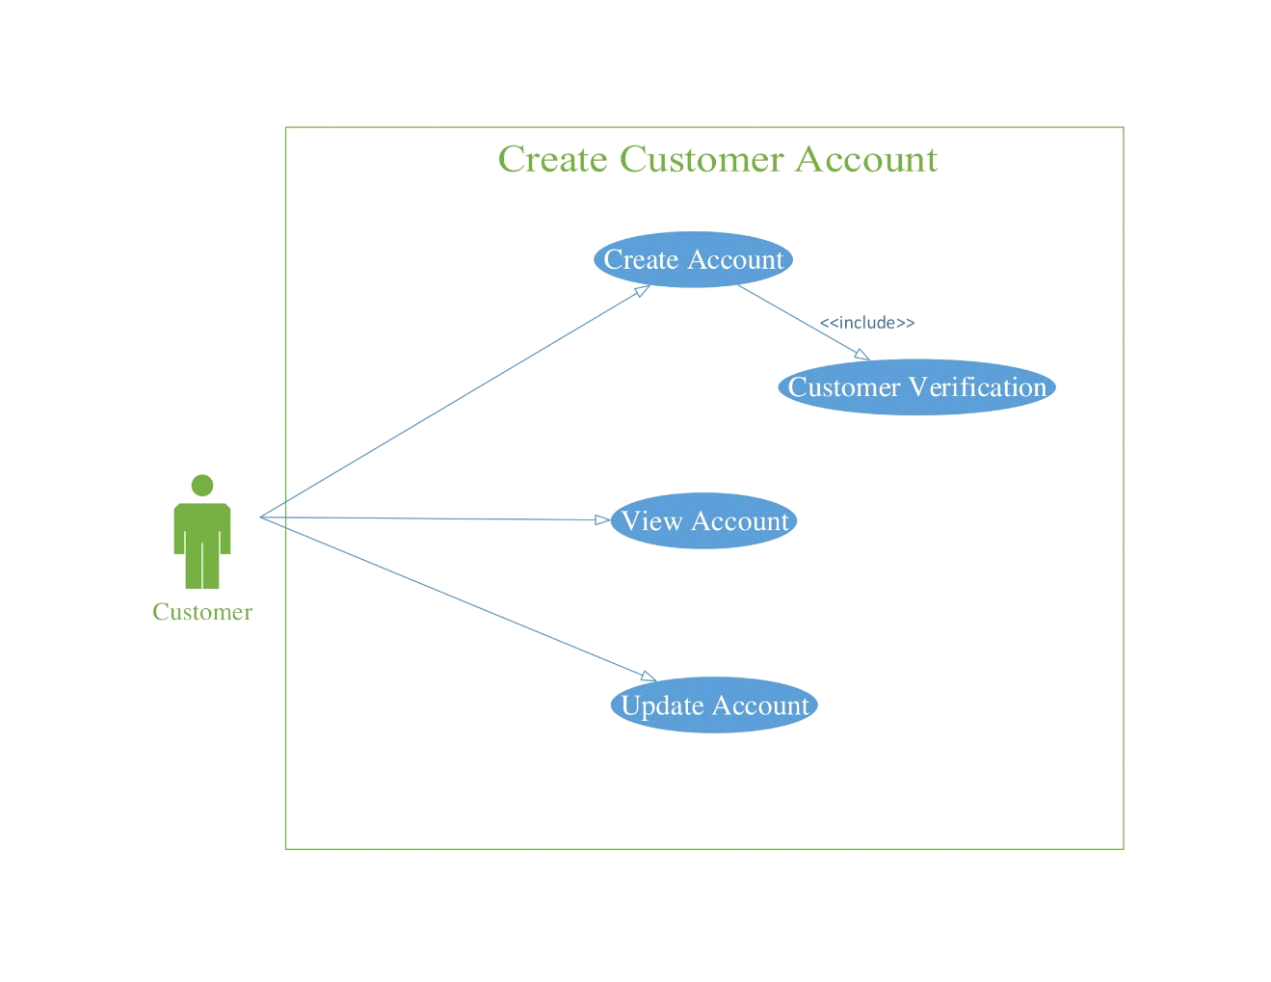

Figure 3- Create Admin Account UC Diagram

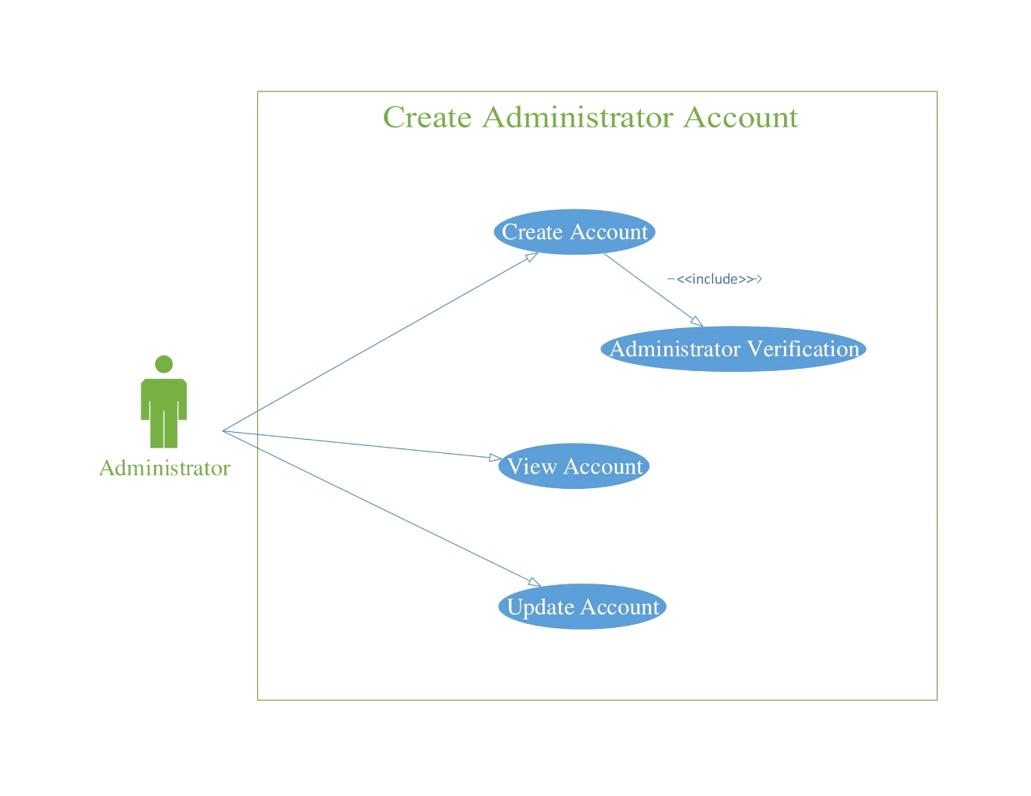

Figure 4- Login UC Diagram

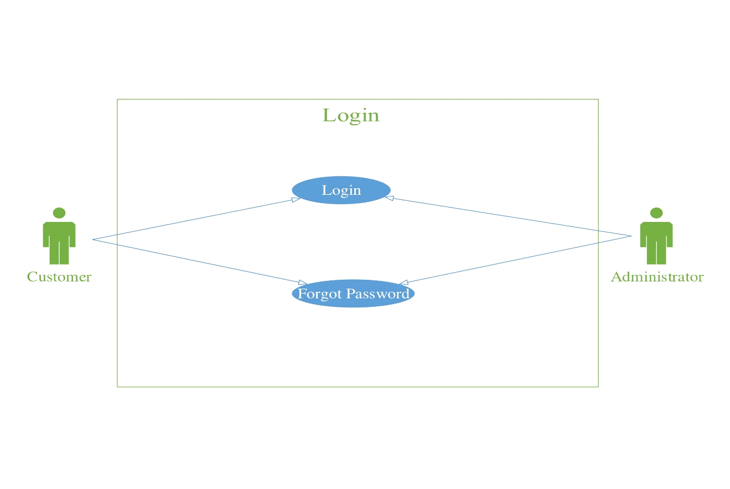

Figure 5 - Search UC Diagram

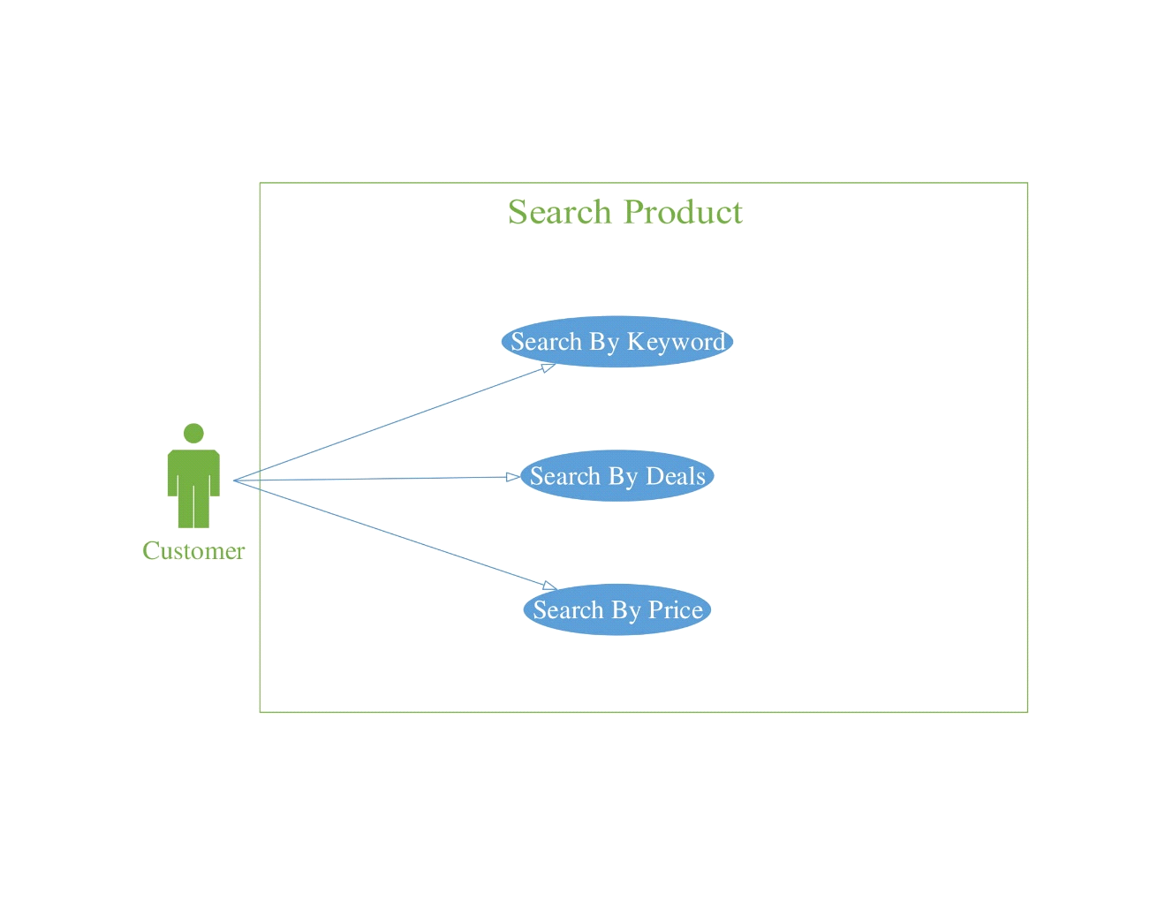

Figure 6 - Order Processing UC Diagram

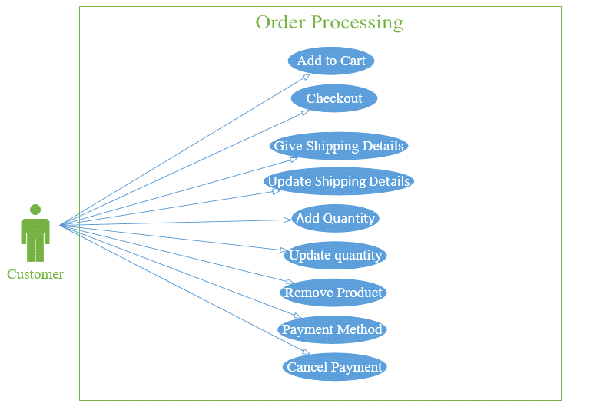

Figure 7 - Individual Custom Order UC Diagram

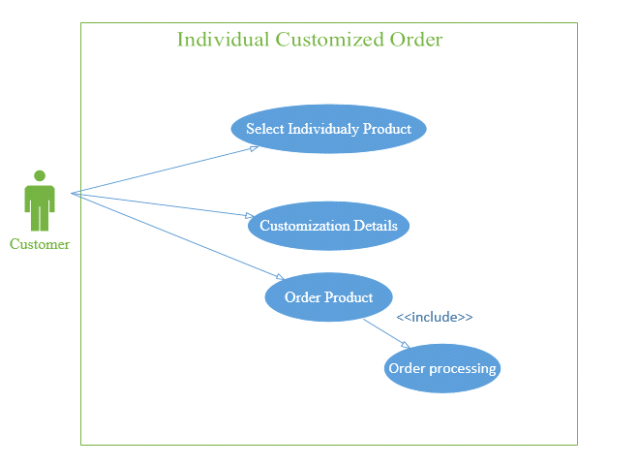

*Figure 8 - Individual Non Custom Order UC Diagram*

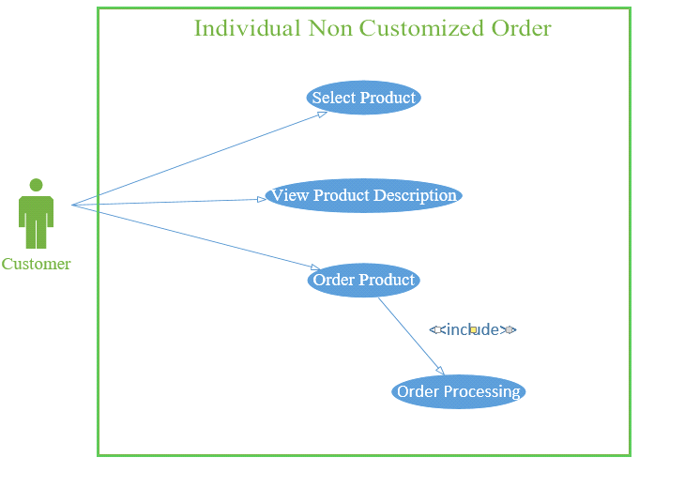

Figure 9 - Customized Deals

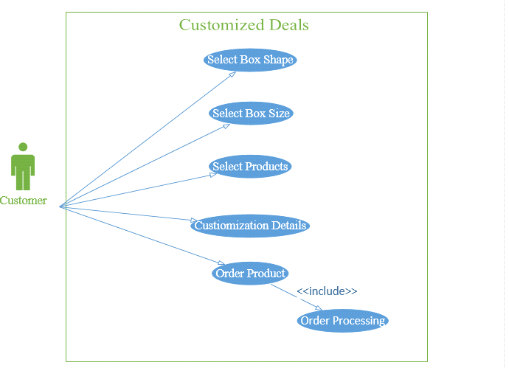

Figure 10 - Non Customized Deals UC Diagram

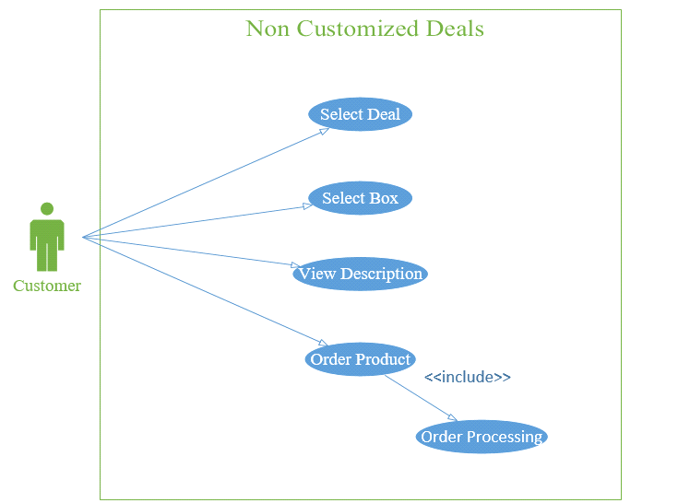

Figure 11 - Manage Refreshment Boxes UC Diagram

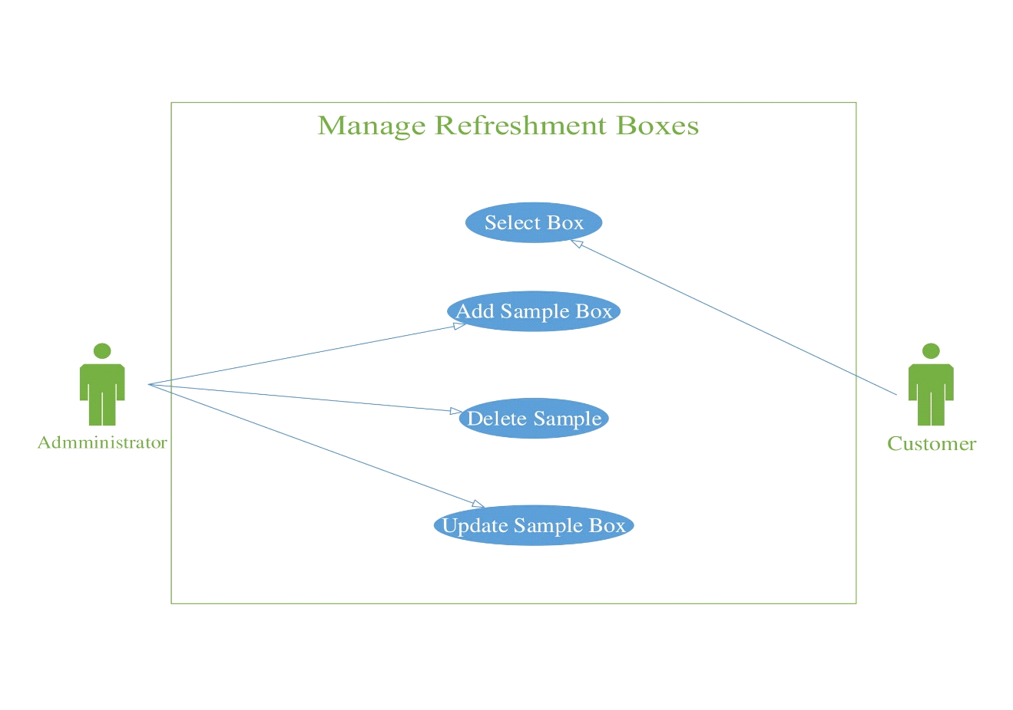

*Figure 12- Manage Deals UC Diagram*

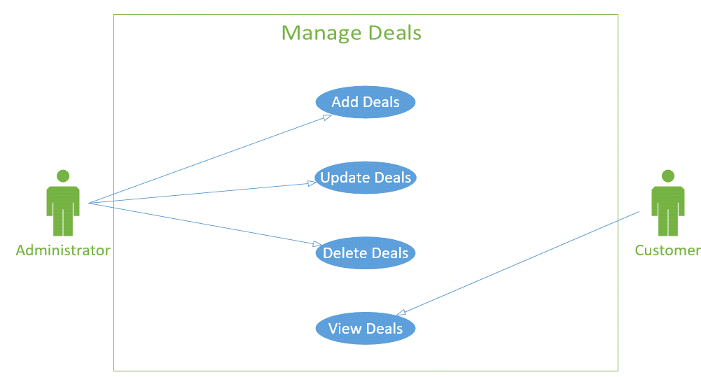

*Figure 13 - Manage Toppings UC Diagram*

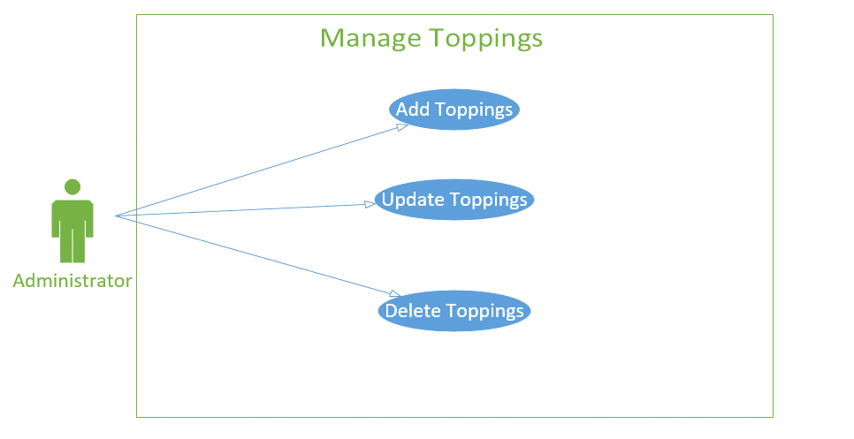

*Figure 14 - Order Status and Order History UC Diagram*

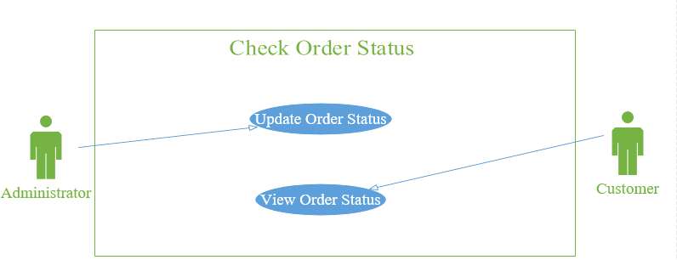

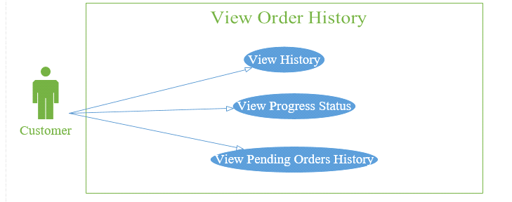

*Figure 15 - ChatBot UC Diagram*

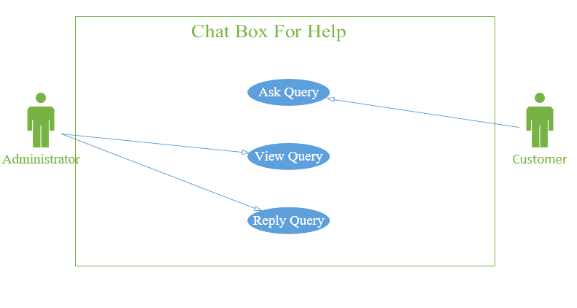

*Figure 16 - Manage Feedback and Suggestion UC Diagram*

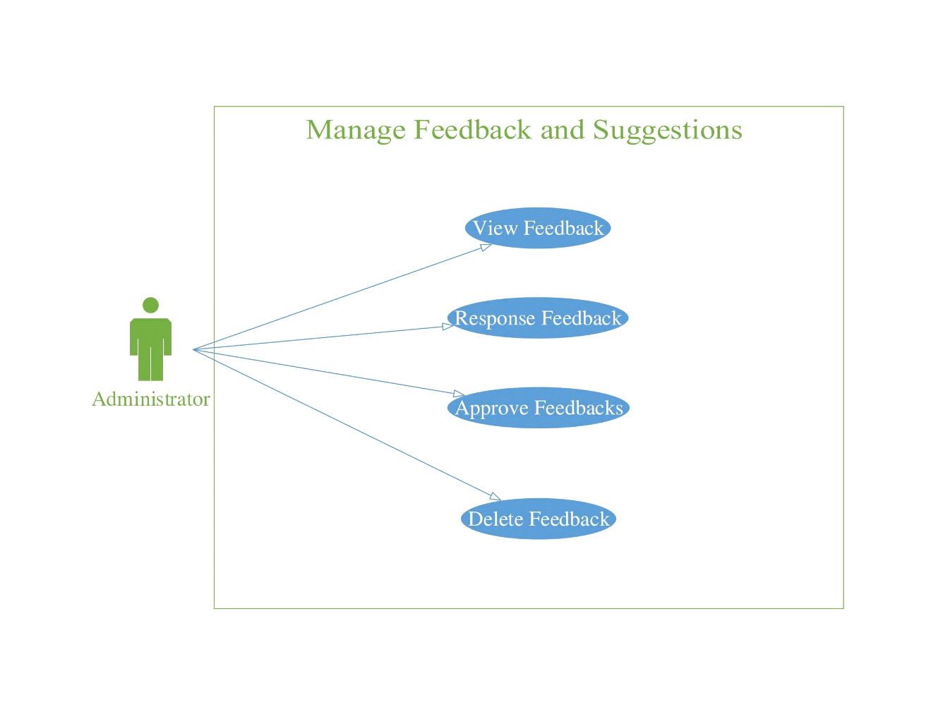

*Figure 17 - Customer Feedback UC Diagram*

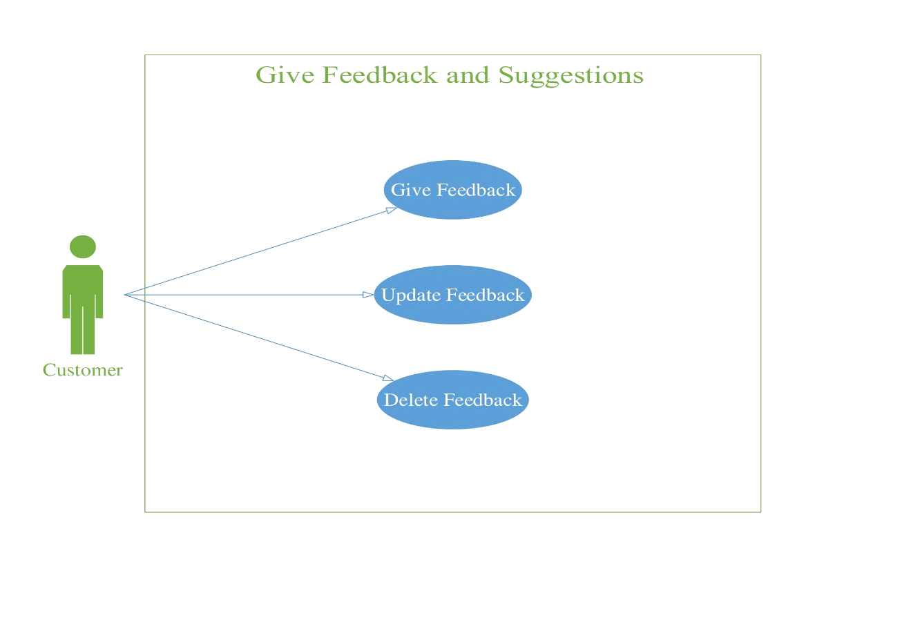

* **Software Development Life Cycle**

We are applying waterfall model in our Bake My Day project. The waterfall model is a developed to aid the developers during the software development (Waterfall Model, 2012). This model will guide us in creating software step-by-step. The model got his name from the shape of its processes which resembles a waterfall. By applying this model, the project will be split into many stages in which a stage have to be completed before proceeding to another stage. The stages in the waterfall model are:

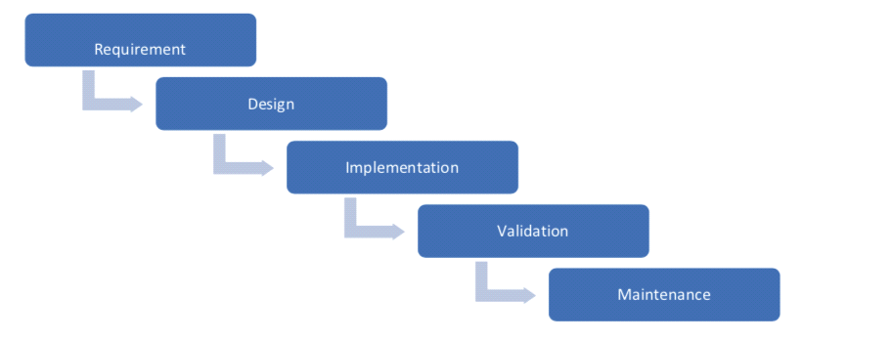

The waterfall model has few advantages; it consists of detailed requirement which can be identified earlier before proceeding to the next stage to prevent the change of requirement. The waterfall model is common models which are used by the developers due to its simplicity and it is easy to understand. The detailed description in every stage helps the new members in the development team to understand the software better so that they could carry on with their task as soon as possible.

* **Chapter #3: System Design**
* **Work Breakdown Structure**

Figure 18 - Bake My Day WBS

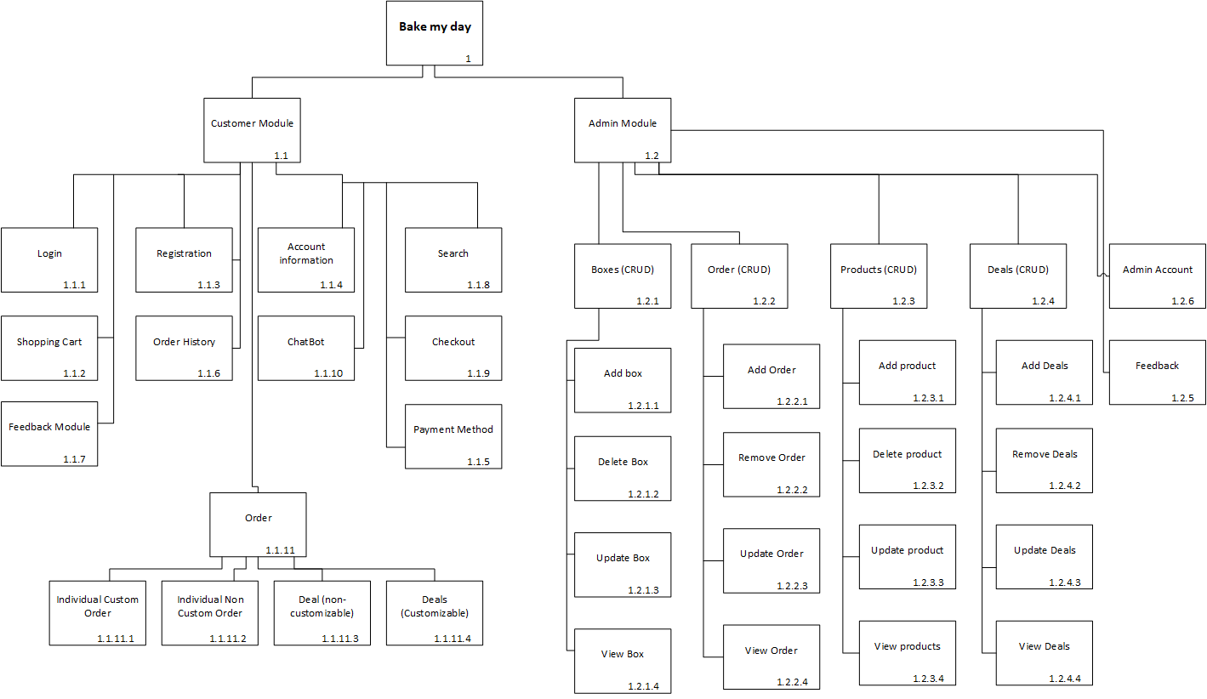

* 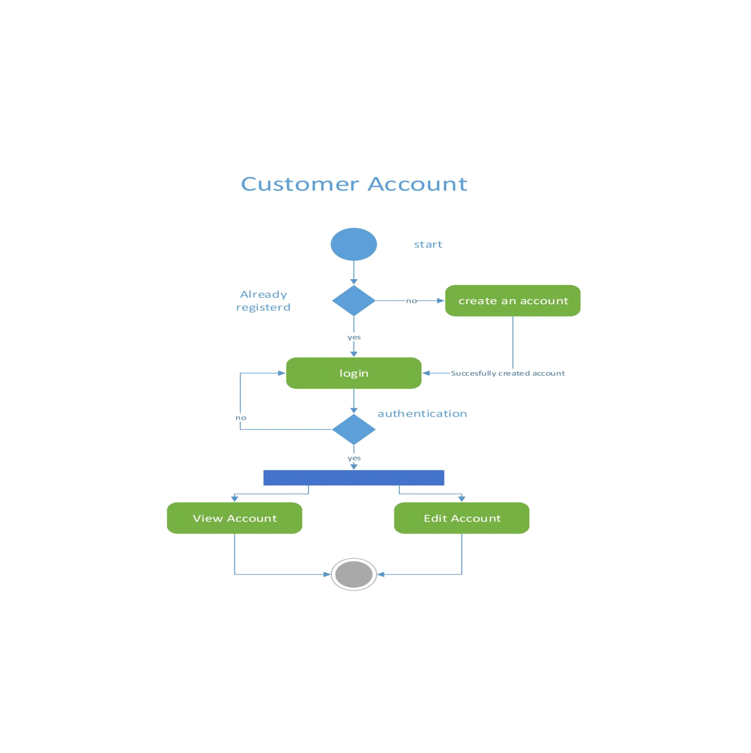***Figure 19 - Customer Account Activity Diagram***
* **Activity Diagram**

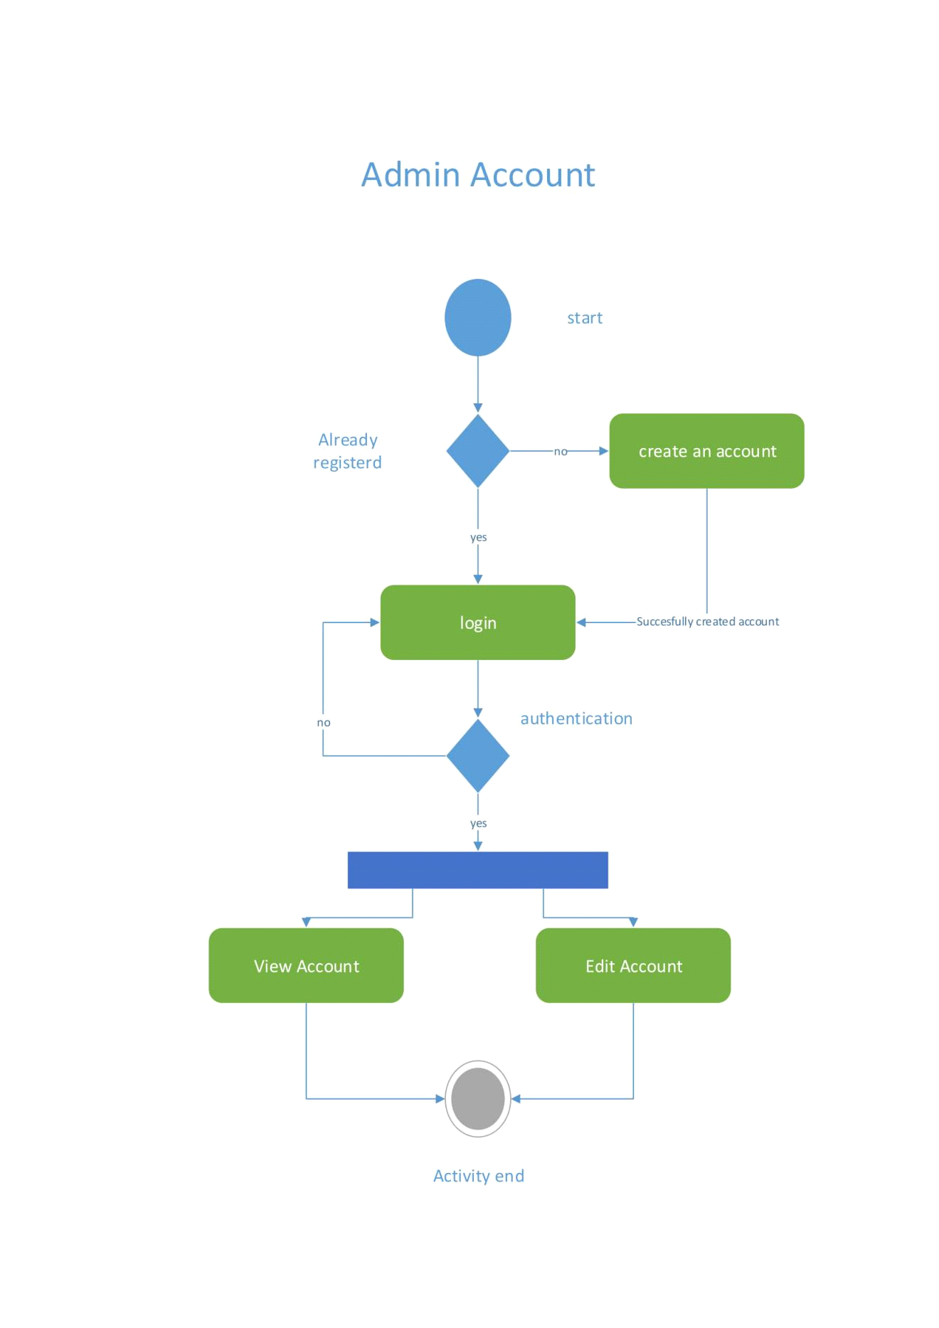

Figure 20 - Admin Account Activity Diagram

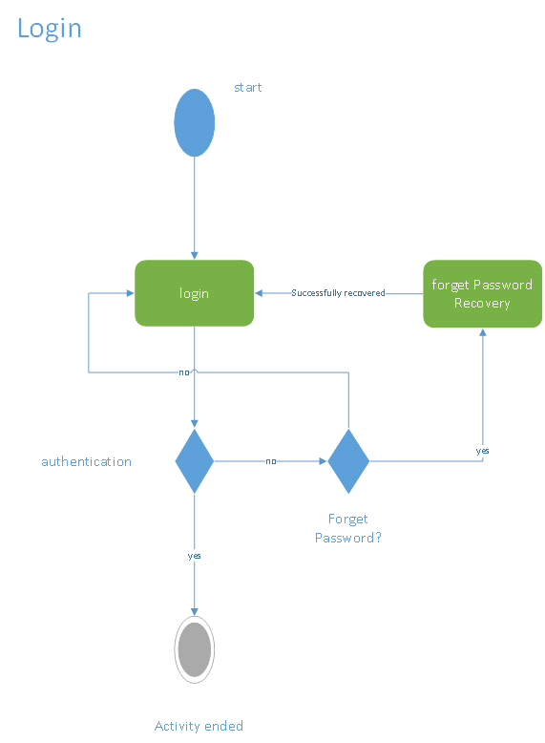

Figure 21 - Login Activity Diagram

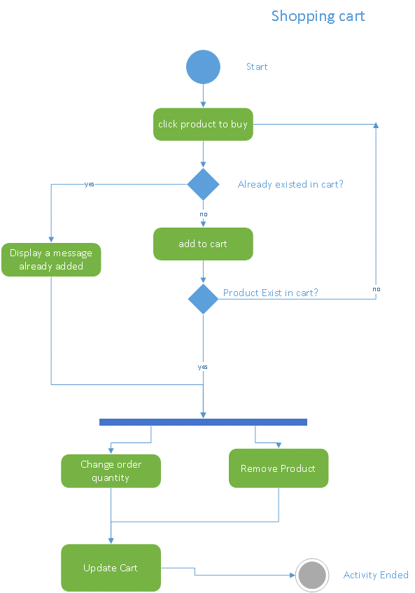

Figure 22 - Shopping Cart Activity Diagram

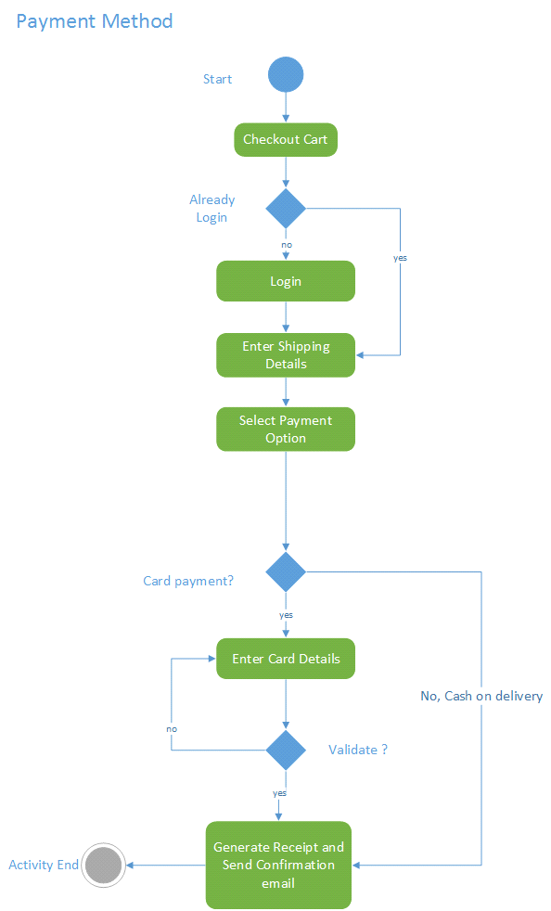

Figure 23 - Payment Activity Diagram

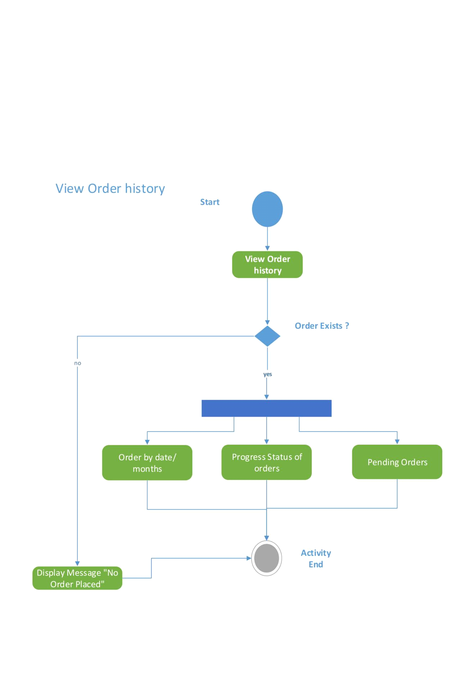

*Figure 24 Order History Activity Diagram*

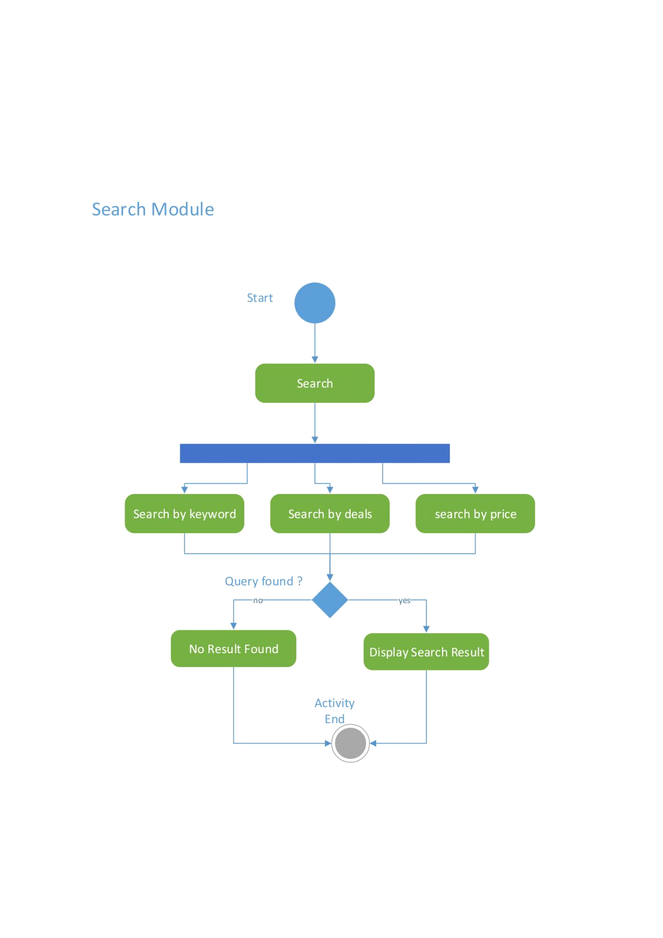

Figure 25 - Search Activity Diagram

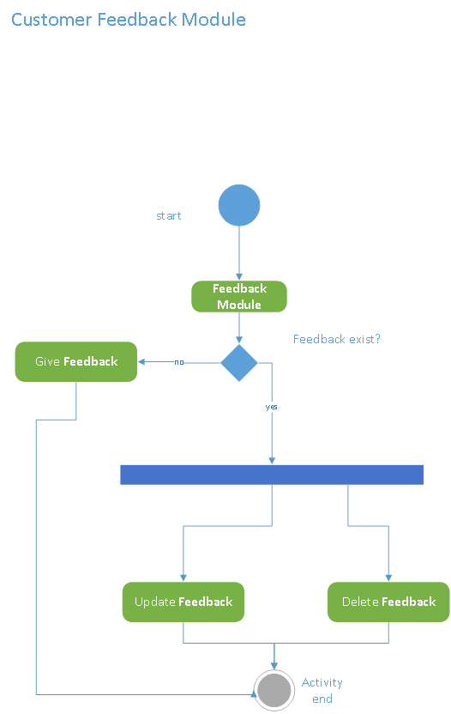

Figure 26 - Customer Feedback Activity Diagram

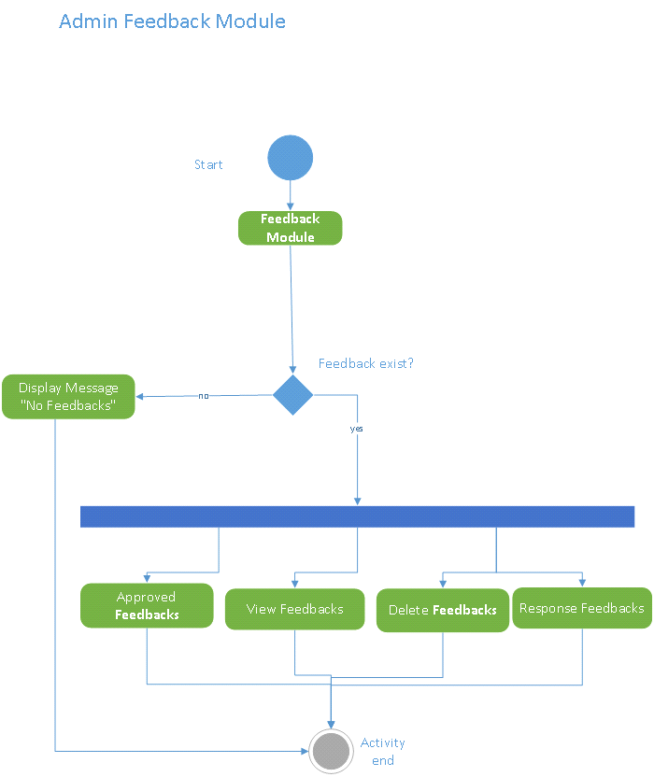

Figure 27 - Admin Feedback Module Activity Diagram

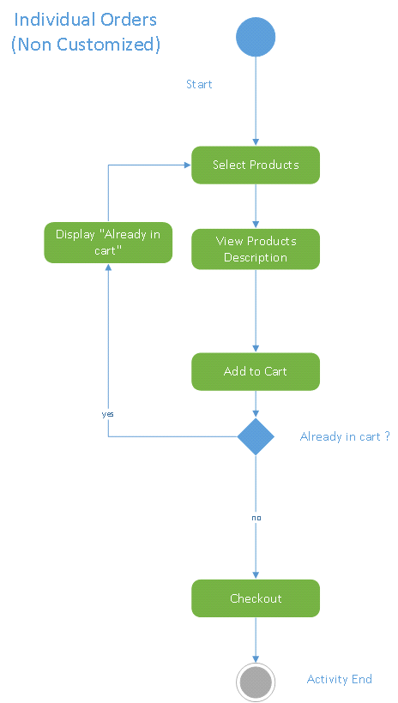

Figure 28 - Individual Non Custom Order Activity Diagram

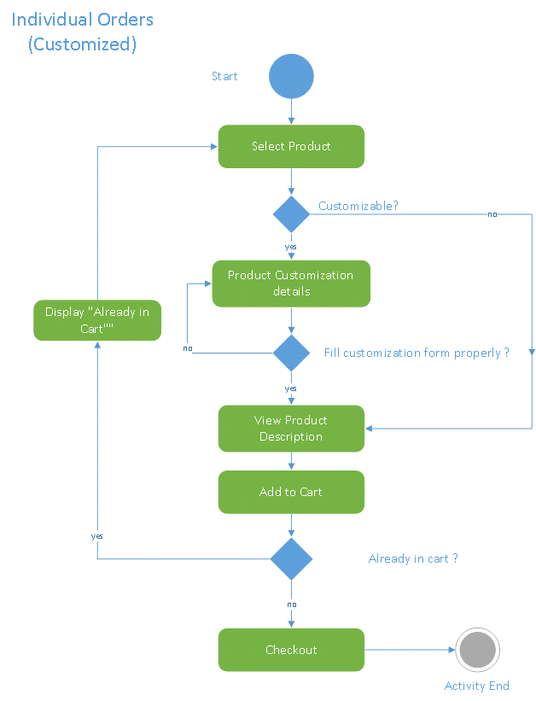

Figure 29- Individual Custom Order Activity Diagram

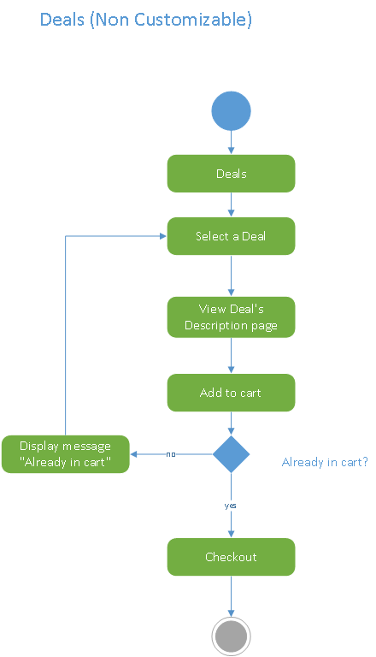

Figure 30 - Deals Order Activity Diagram

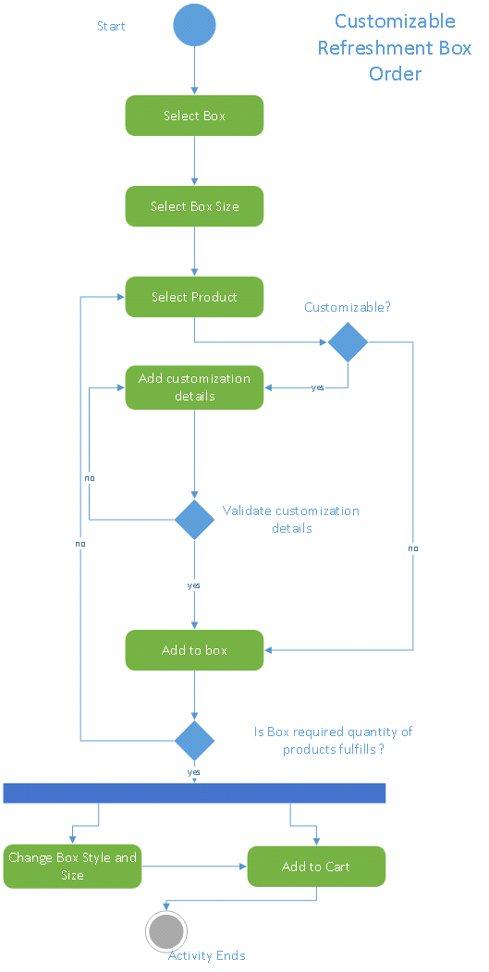

Figure 31- Customize Refreshment Box Order Activity Diagram

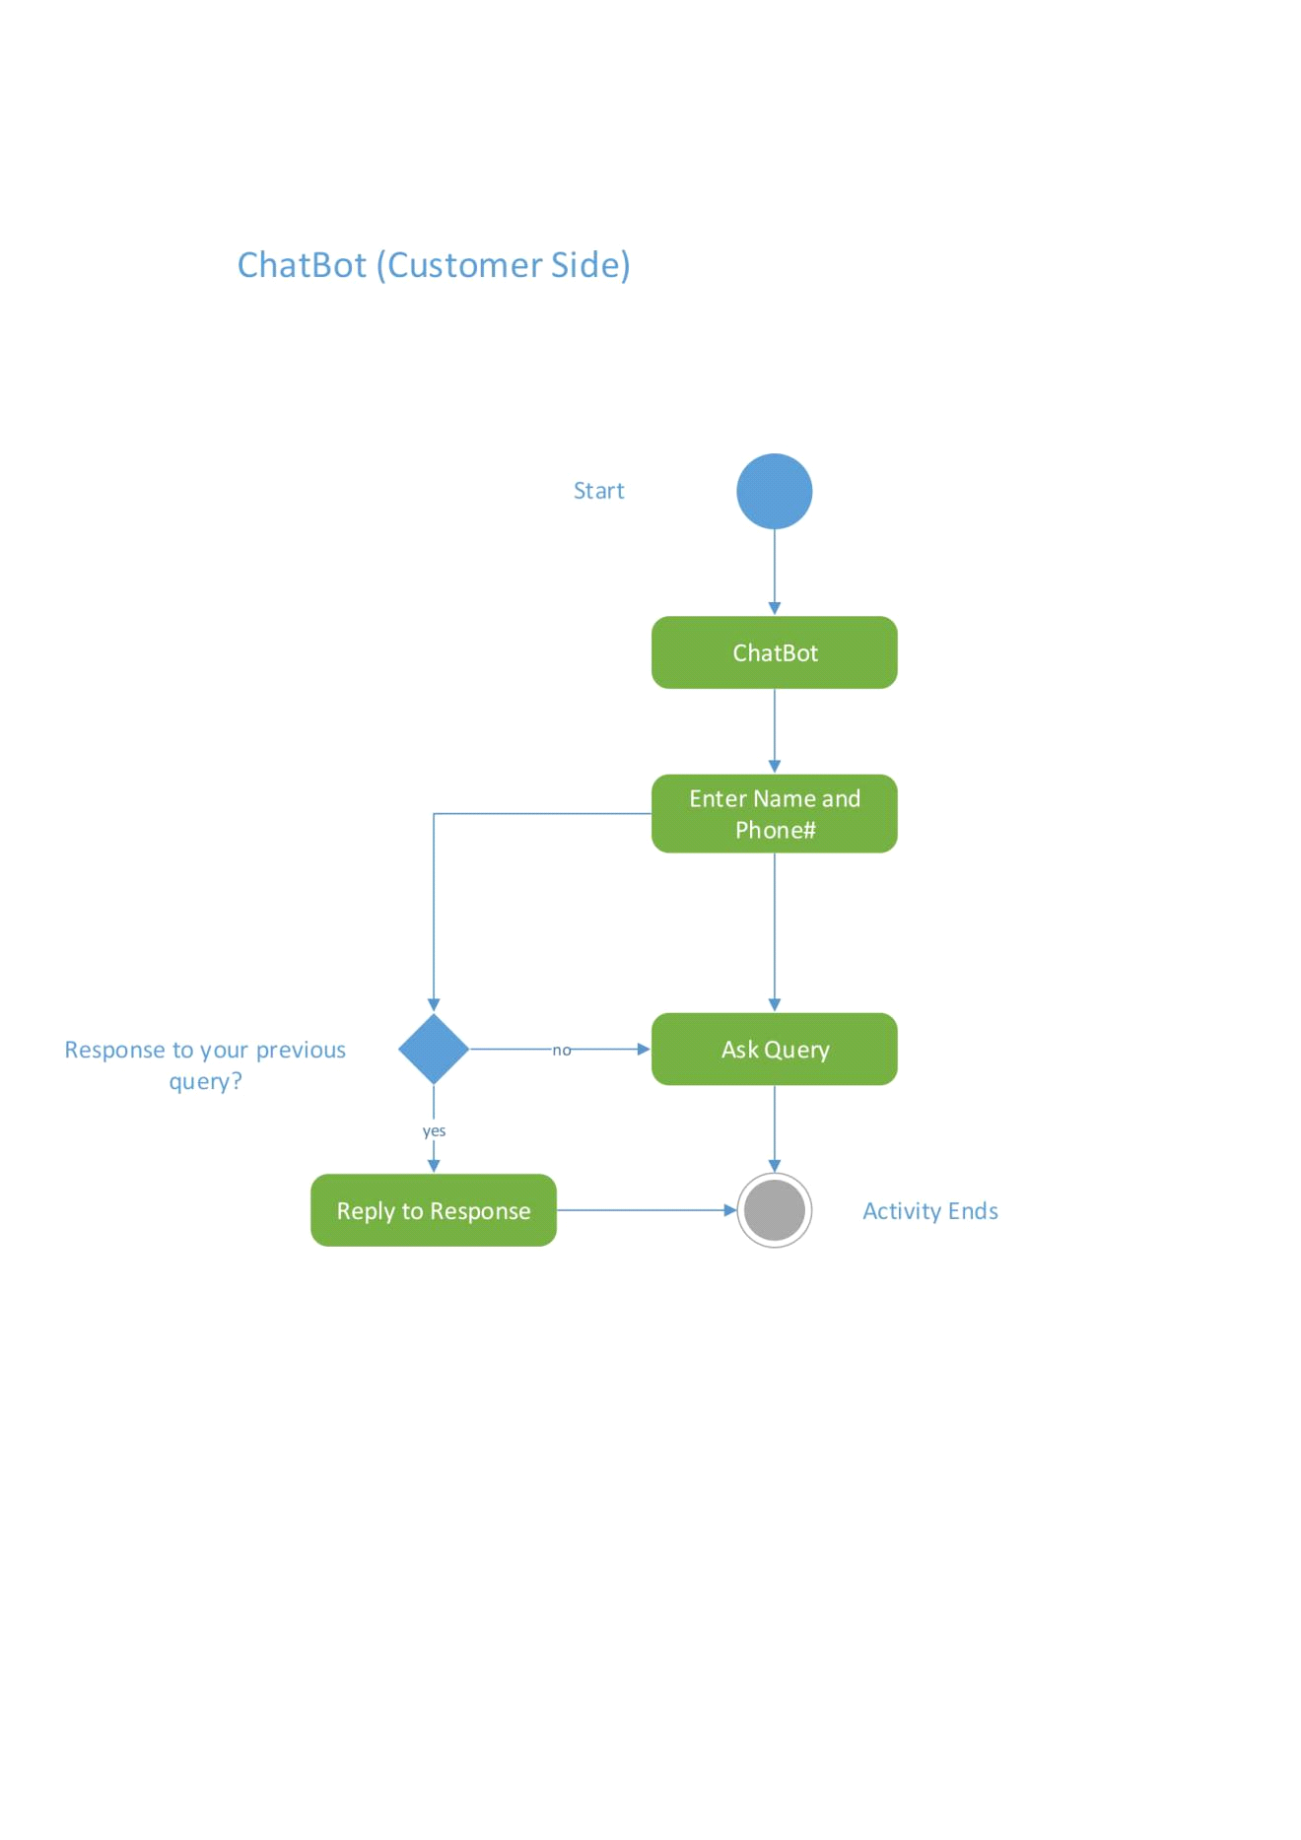

Figure 33 - Chatbot Customer Side Activity Diagram

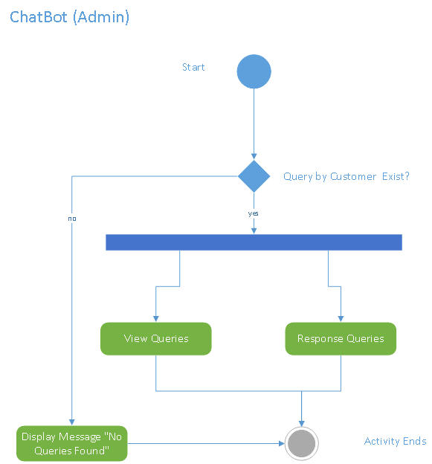

Figure 34 - Admin Chatbot Activity Diagram

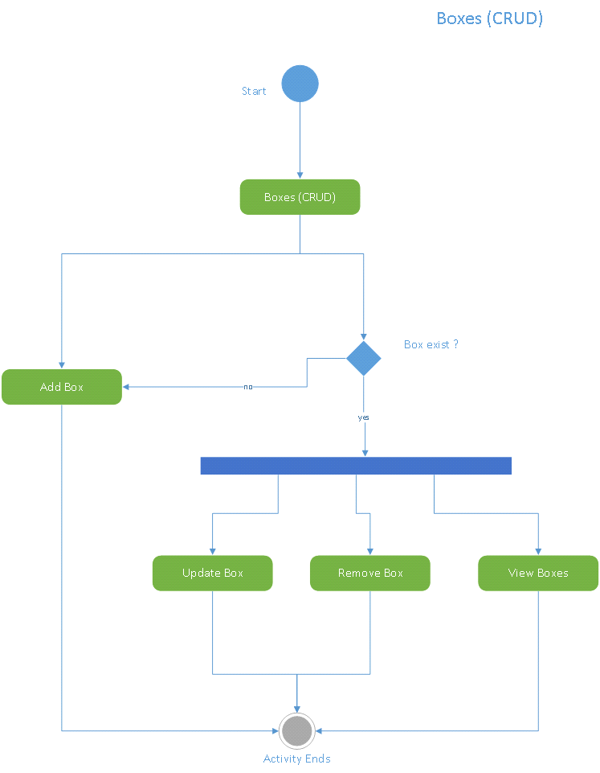

Figure 35 - Boxes (CRUD) Activity Diagram

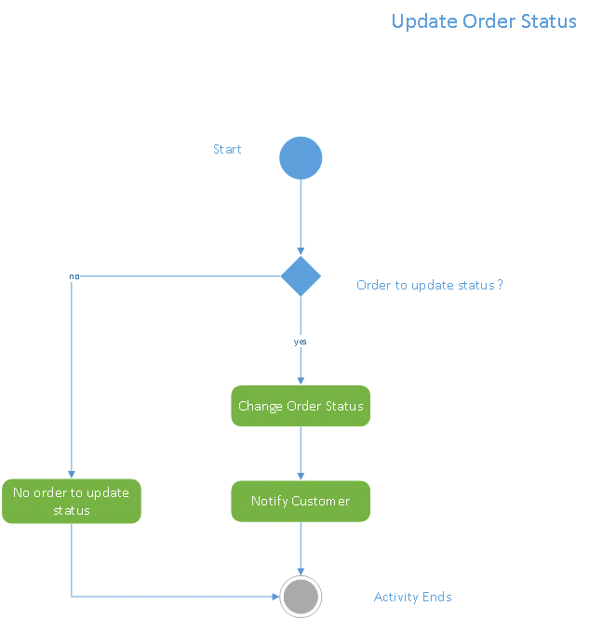

Figure 37 - Update Order Status Activity Diagram

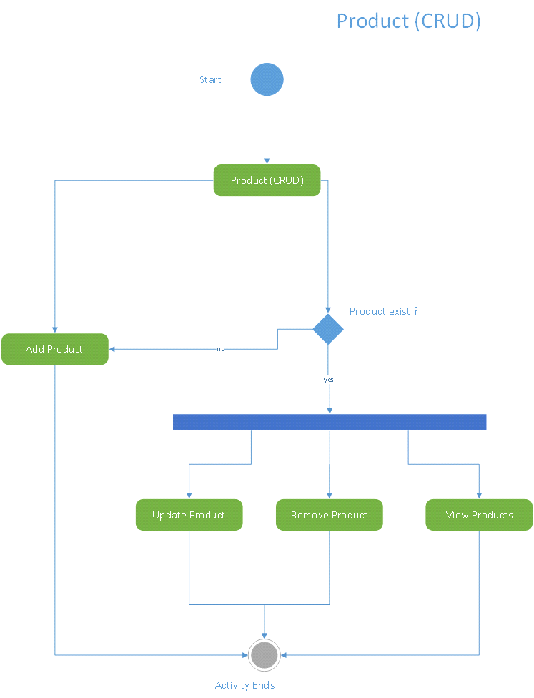

Figure 38 - Product (CRUD) Activity Diagram

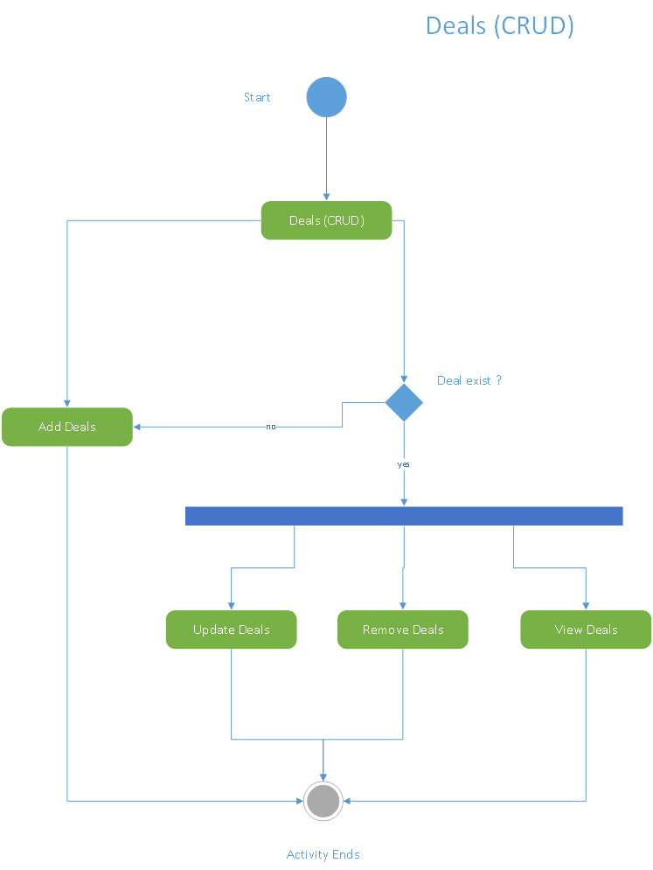

Figure 39 - Deals (CRUD) Activity Diagram

* **Sequence Diagram**

Figure 40 - Customer Account Sequence Diagram

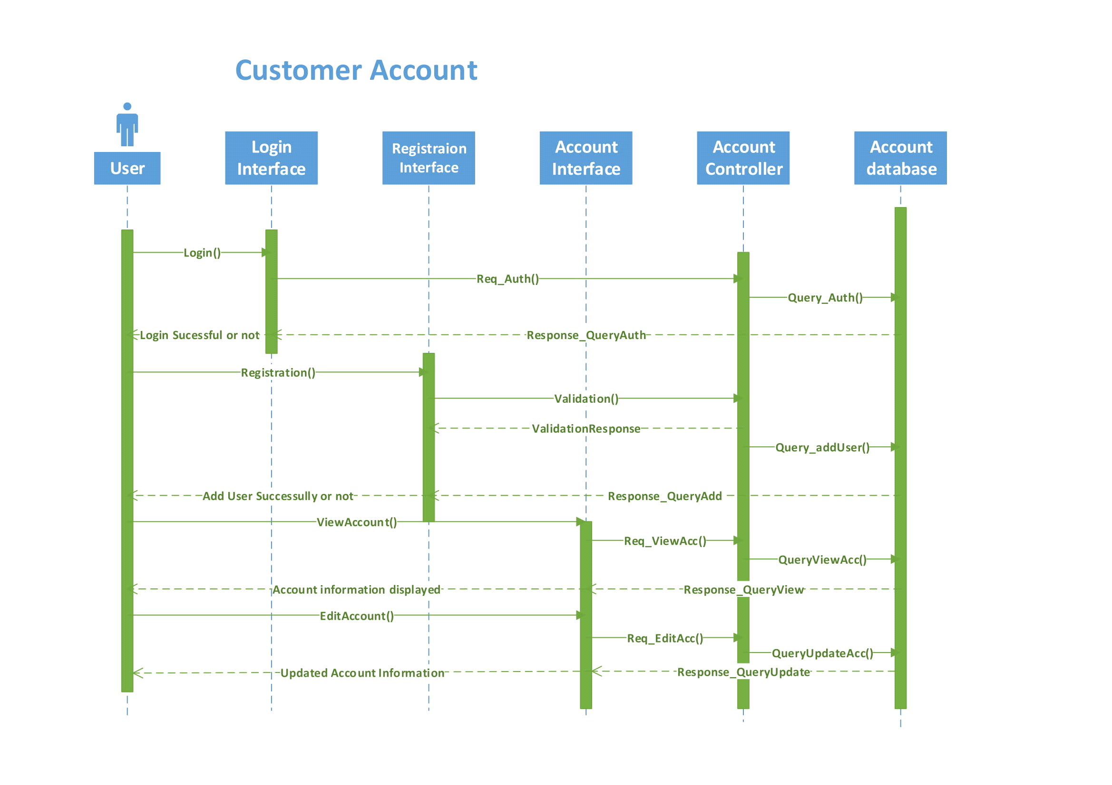

Figure 41- Admin Account Sequence Diagram

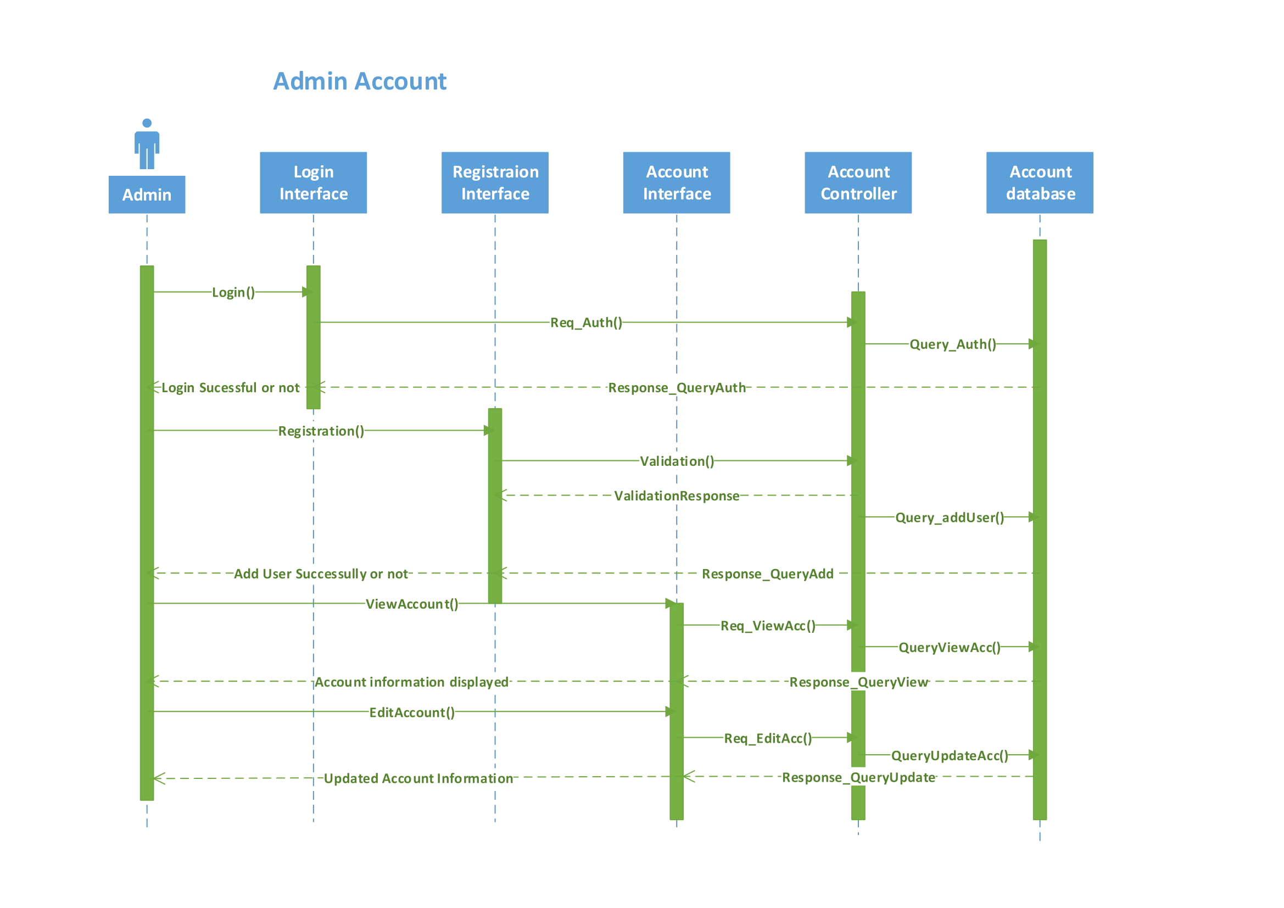

Figure 42 - Login Sequence Diagram

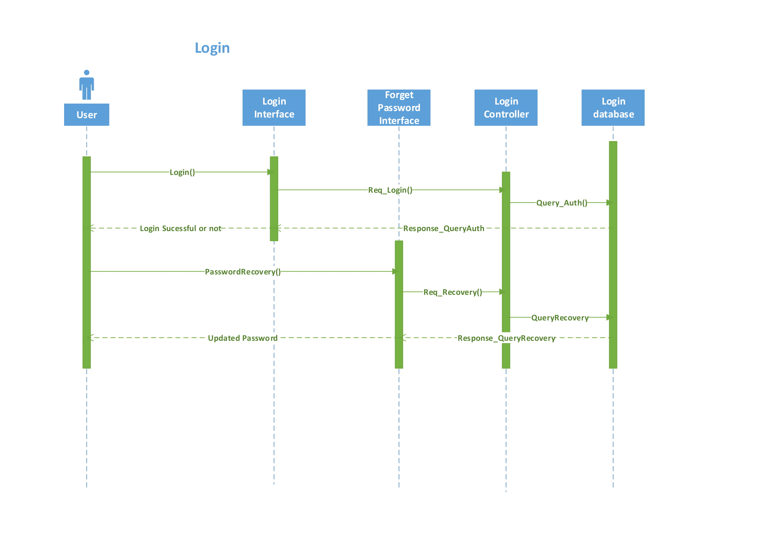

Figure 43 - Shopping Cart Sequence Diagram

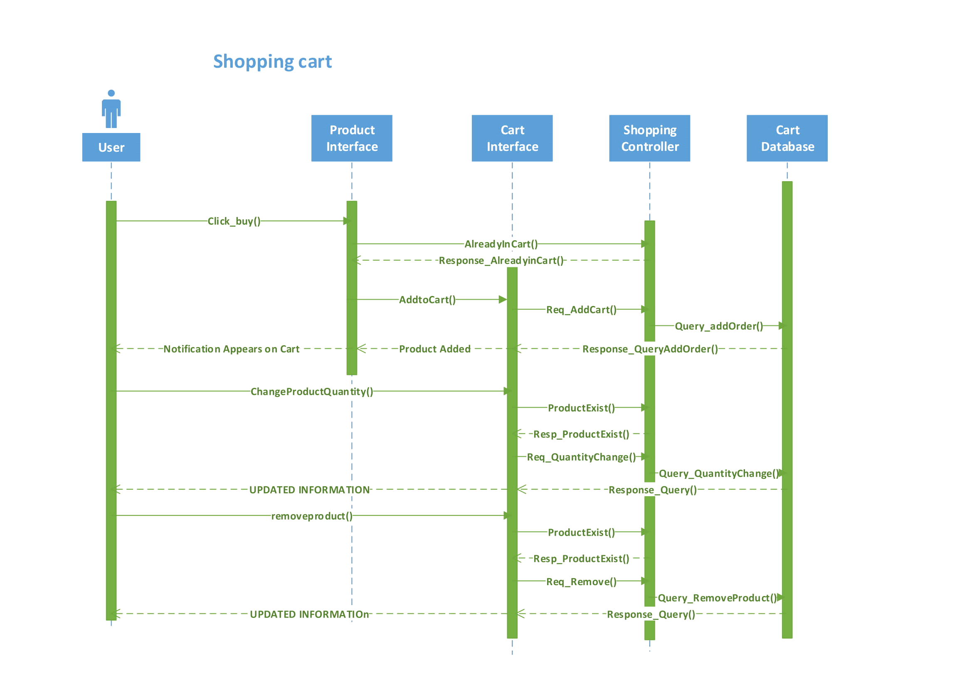

Figure 44 - Payment Module Sequence Diagram

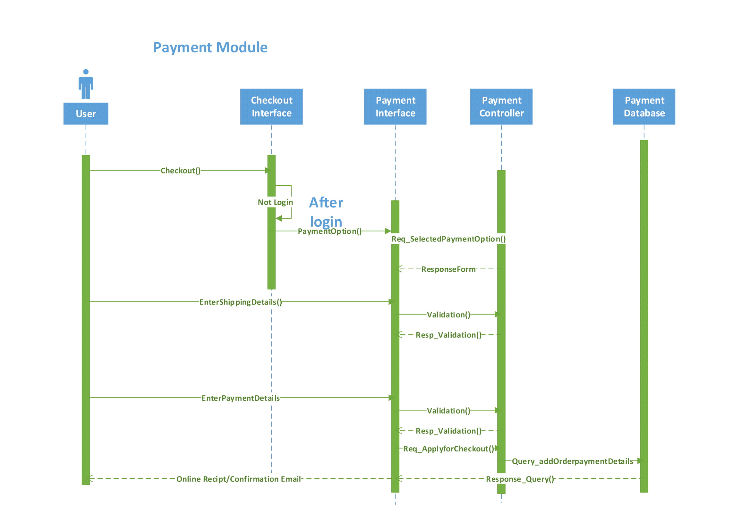

Figure 45- Order History Sequence Diagram

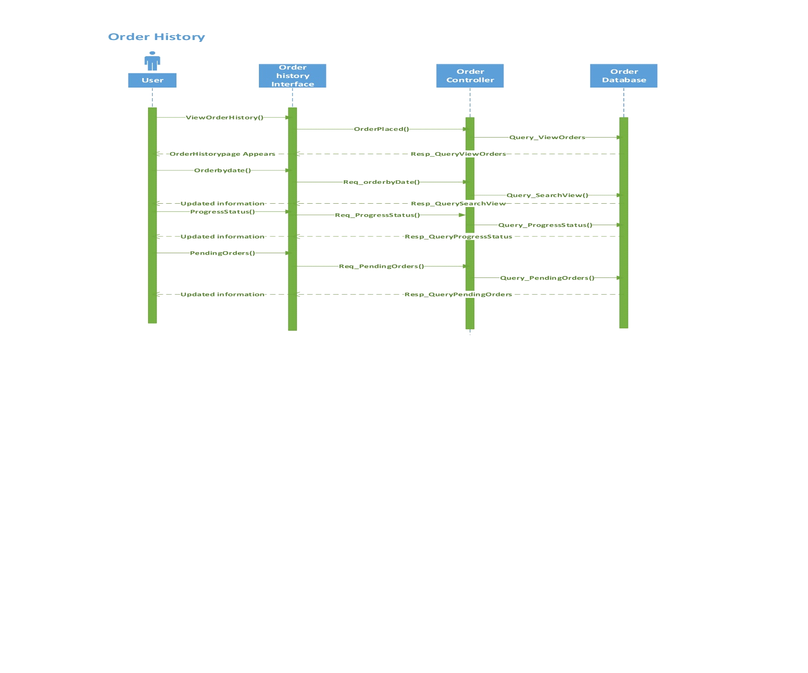

Figure 46 - Search Sequence Diagram

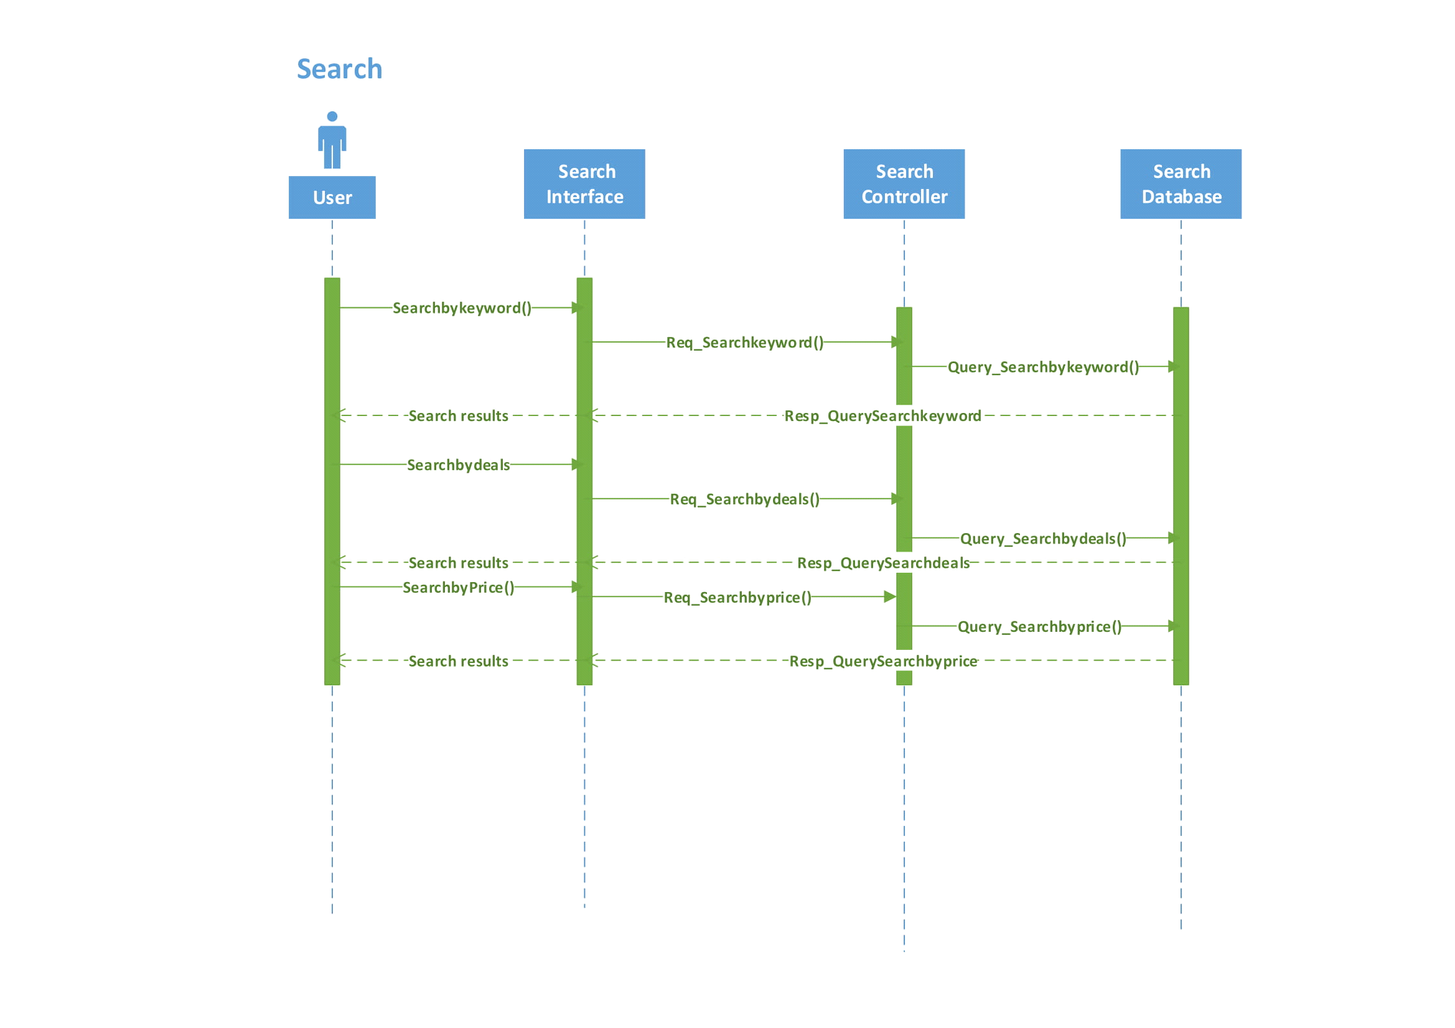

Figure 47 - Customer Feedback Sequence Diagram

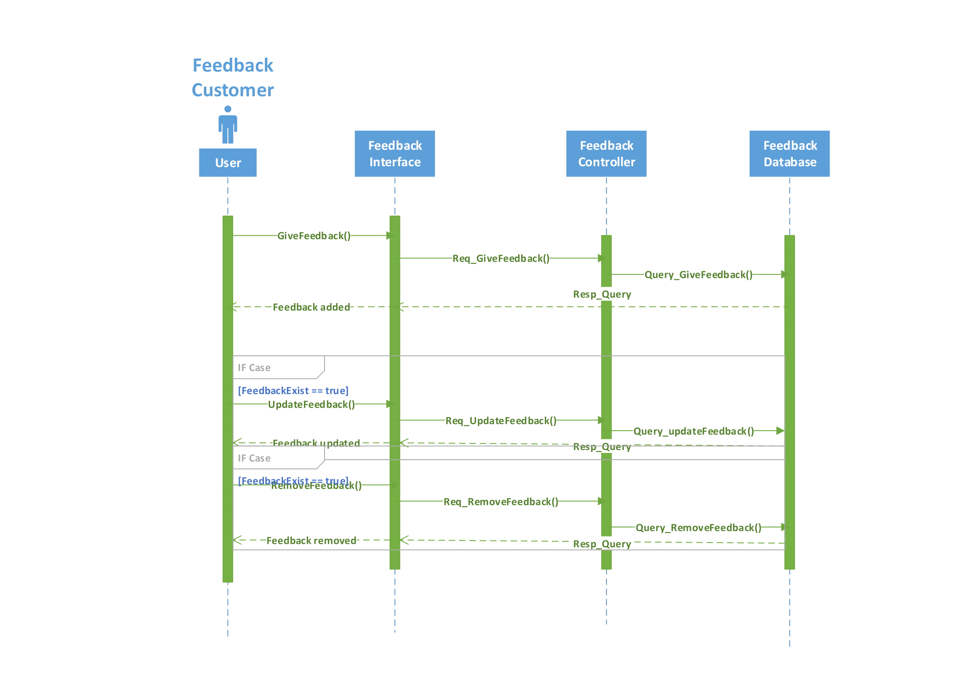

Figure 48 - Admin Feedback Sequence Diagram

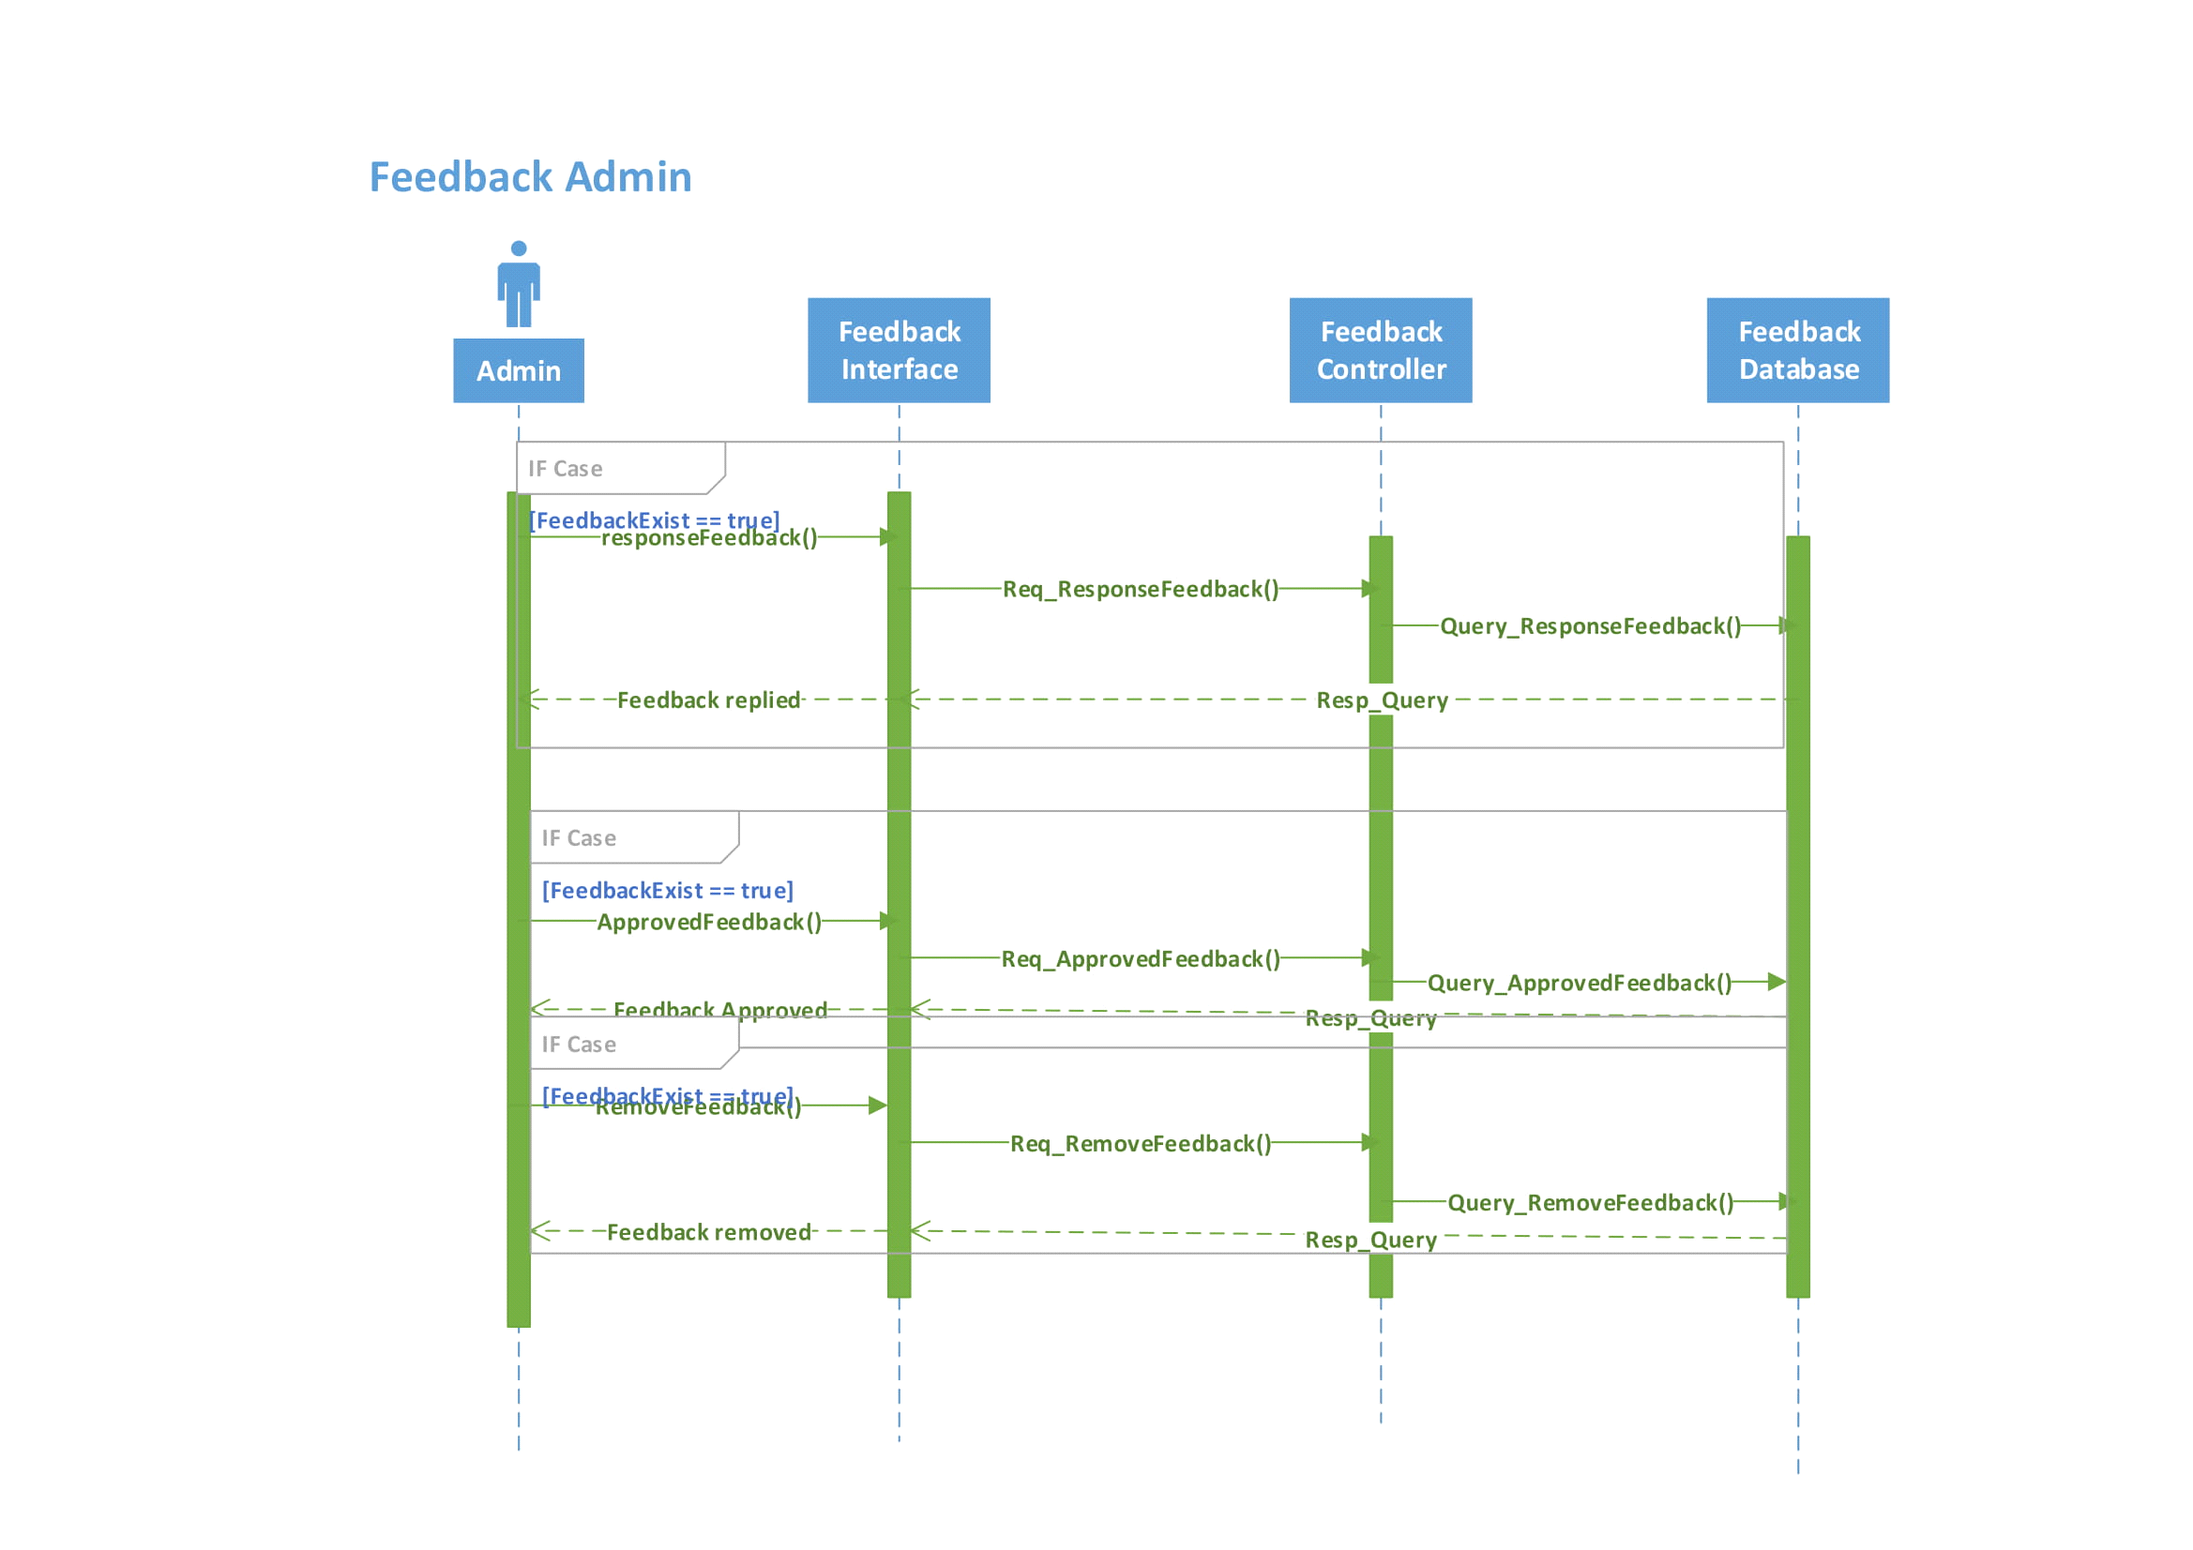

Figure 49 - Individual Order Sequence Diagram

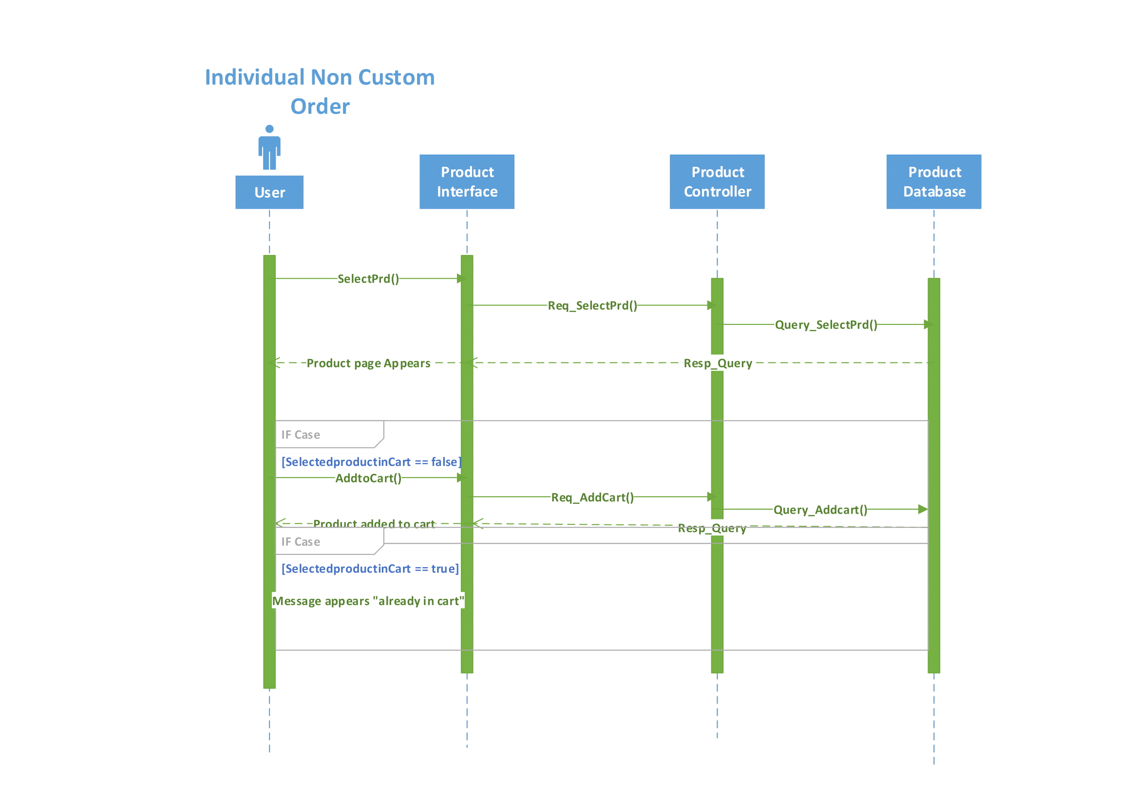

Figure 50 - Individual Custom Order Sequence Diagram

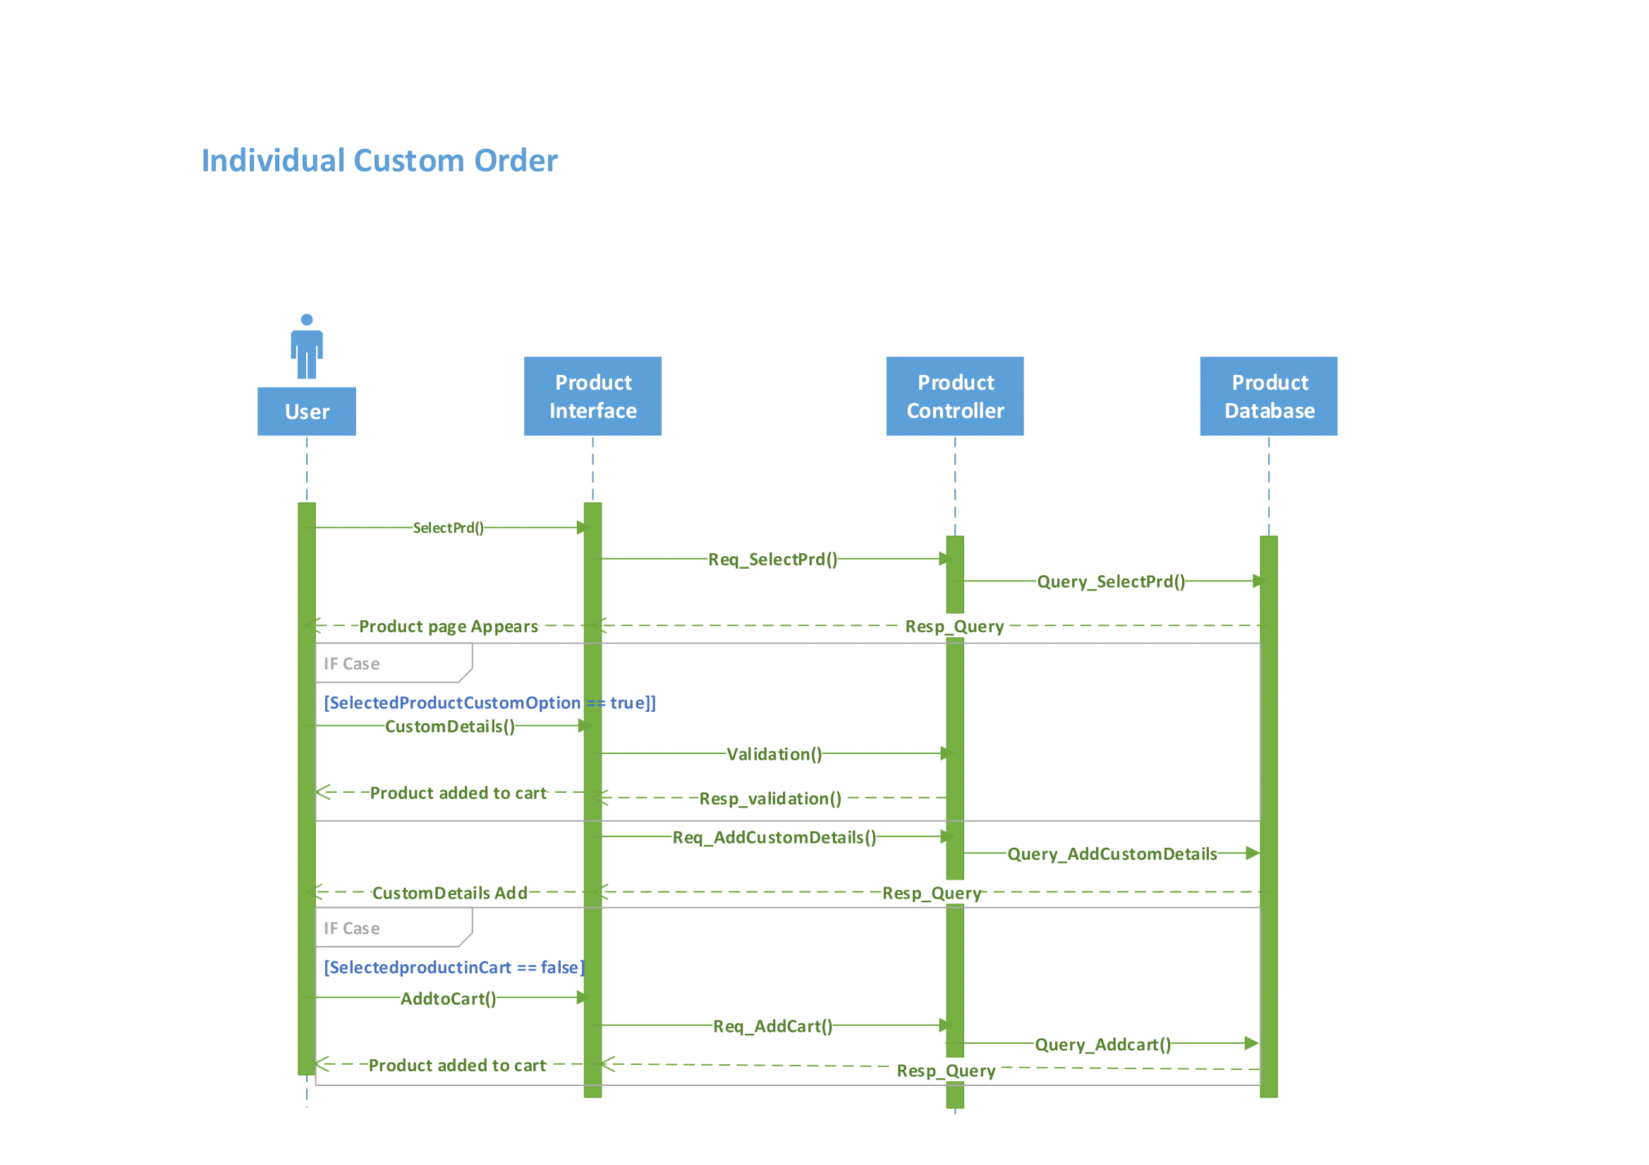

Figure 51- Custom Deals Order Sequence Diagram

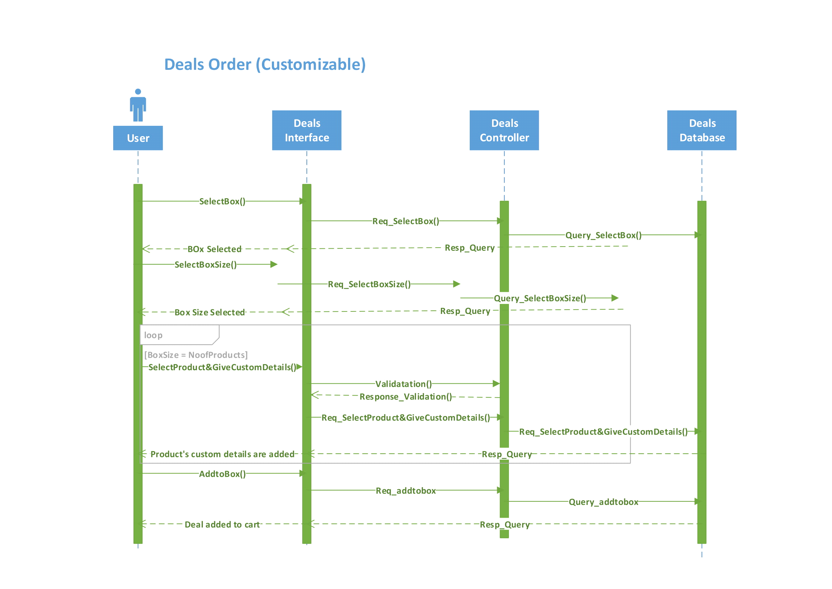

Figure 52 - Non Custom Deal Order Sequence Diagram

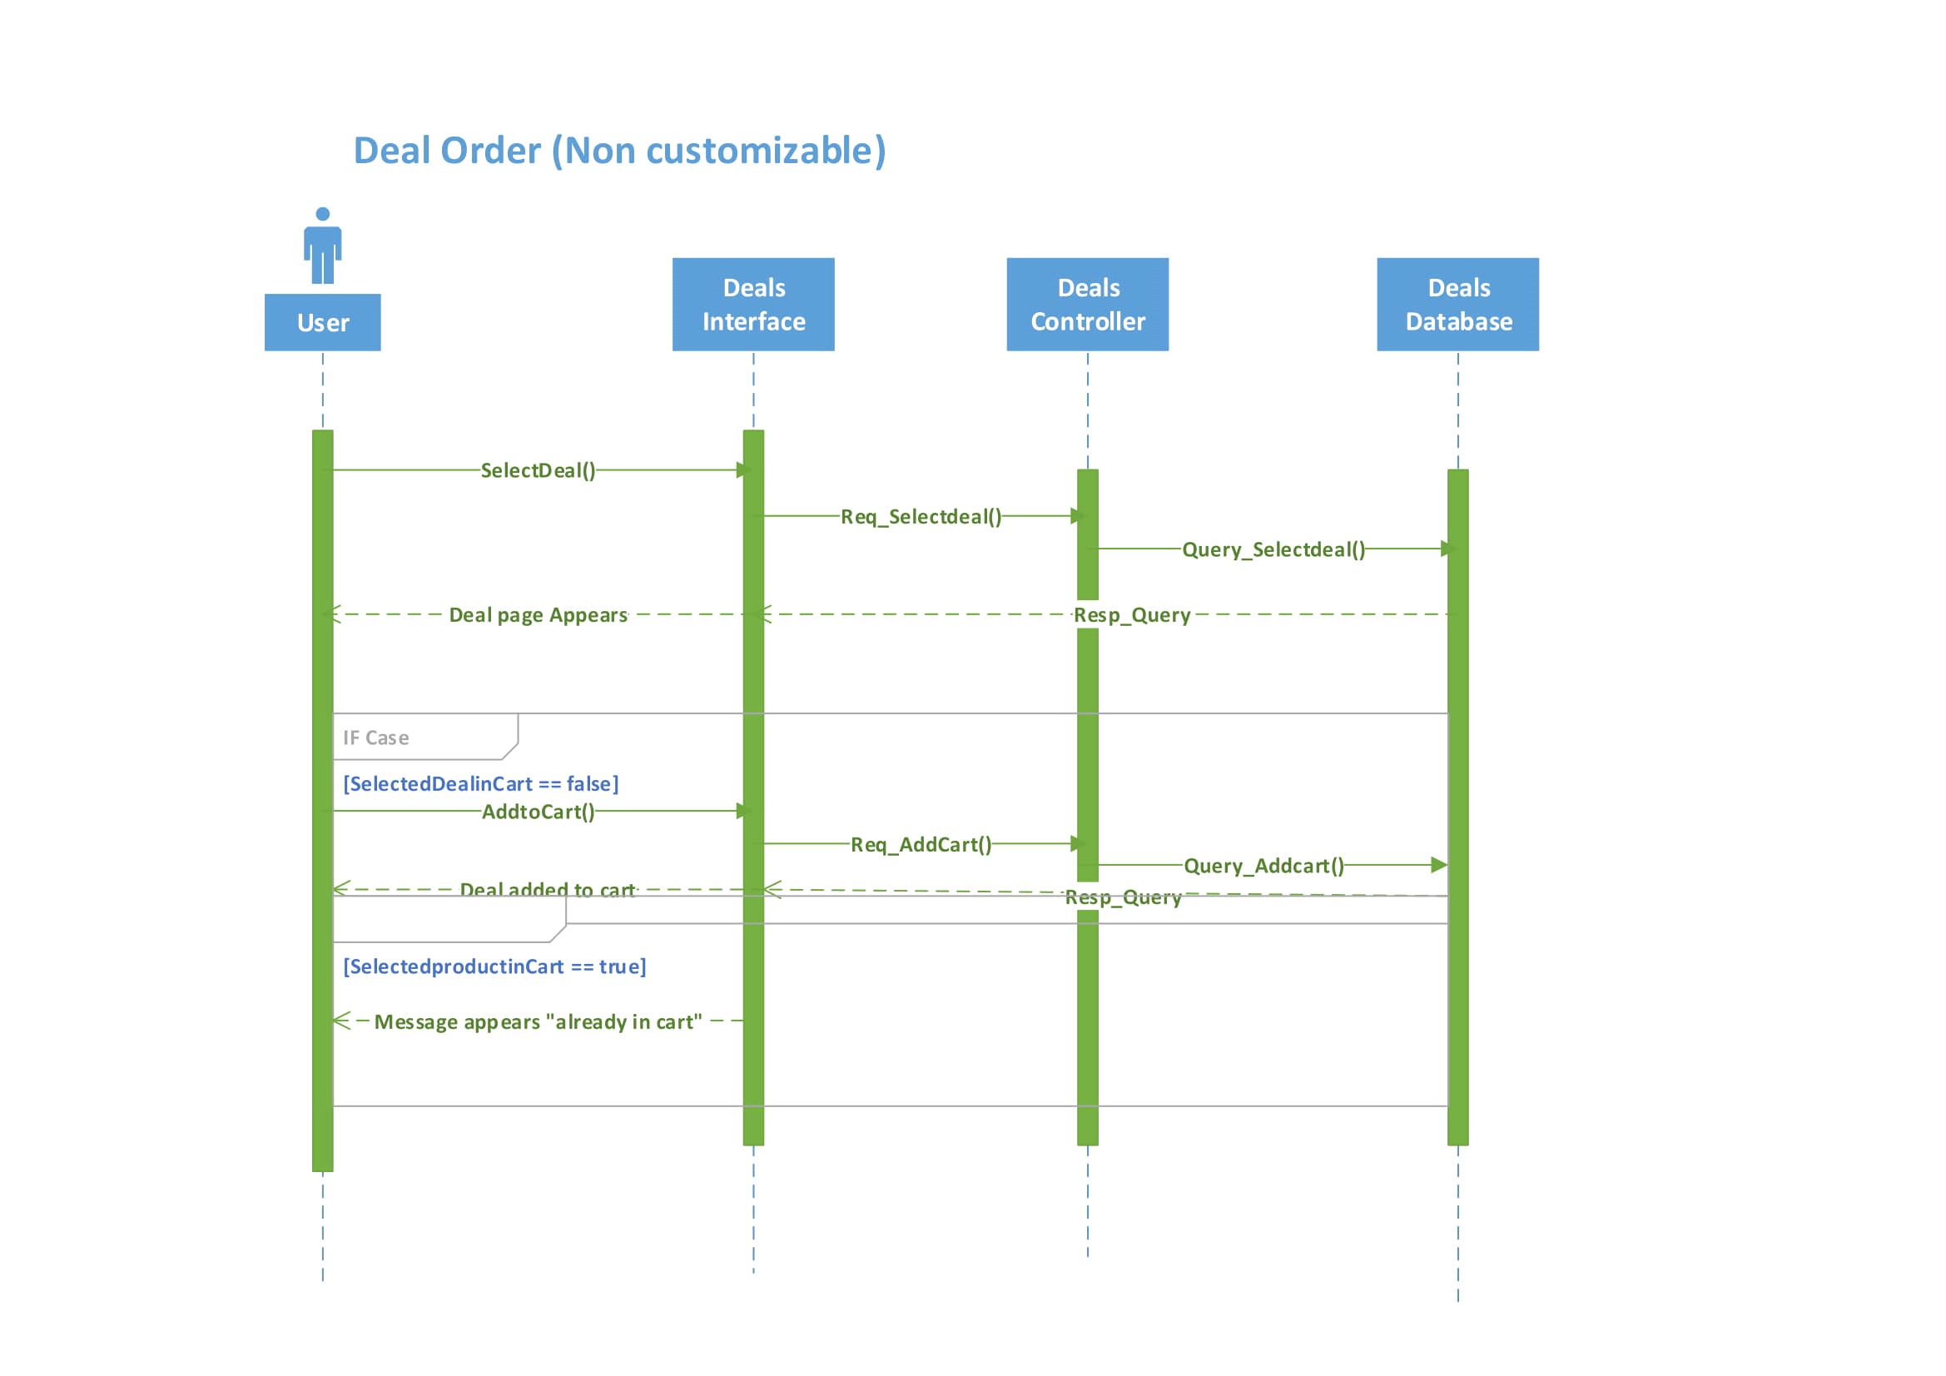

Figure 53 - Checkout Sequence Diagram

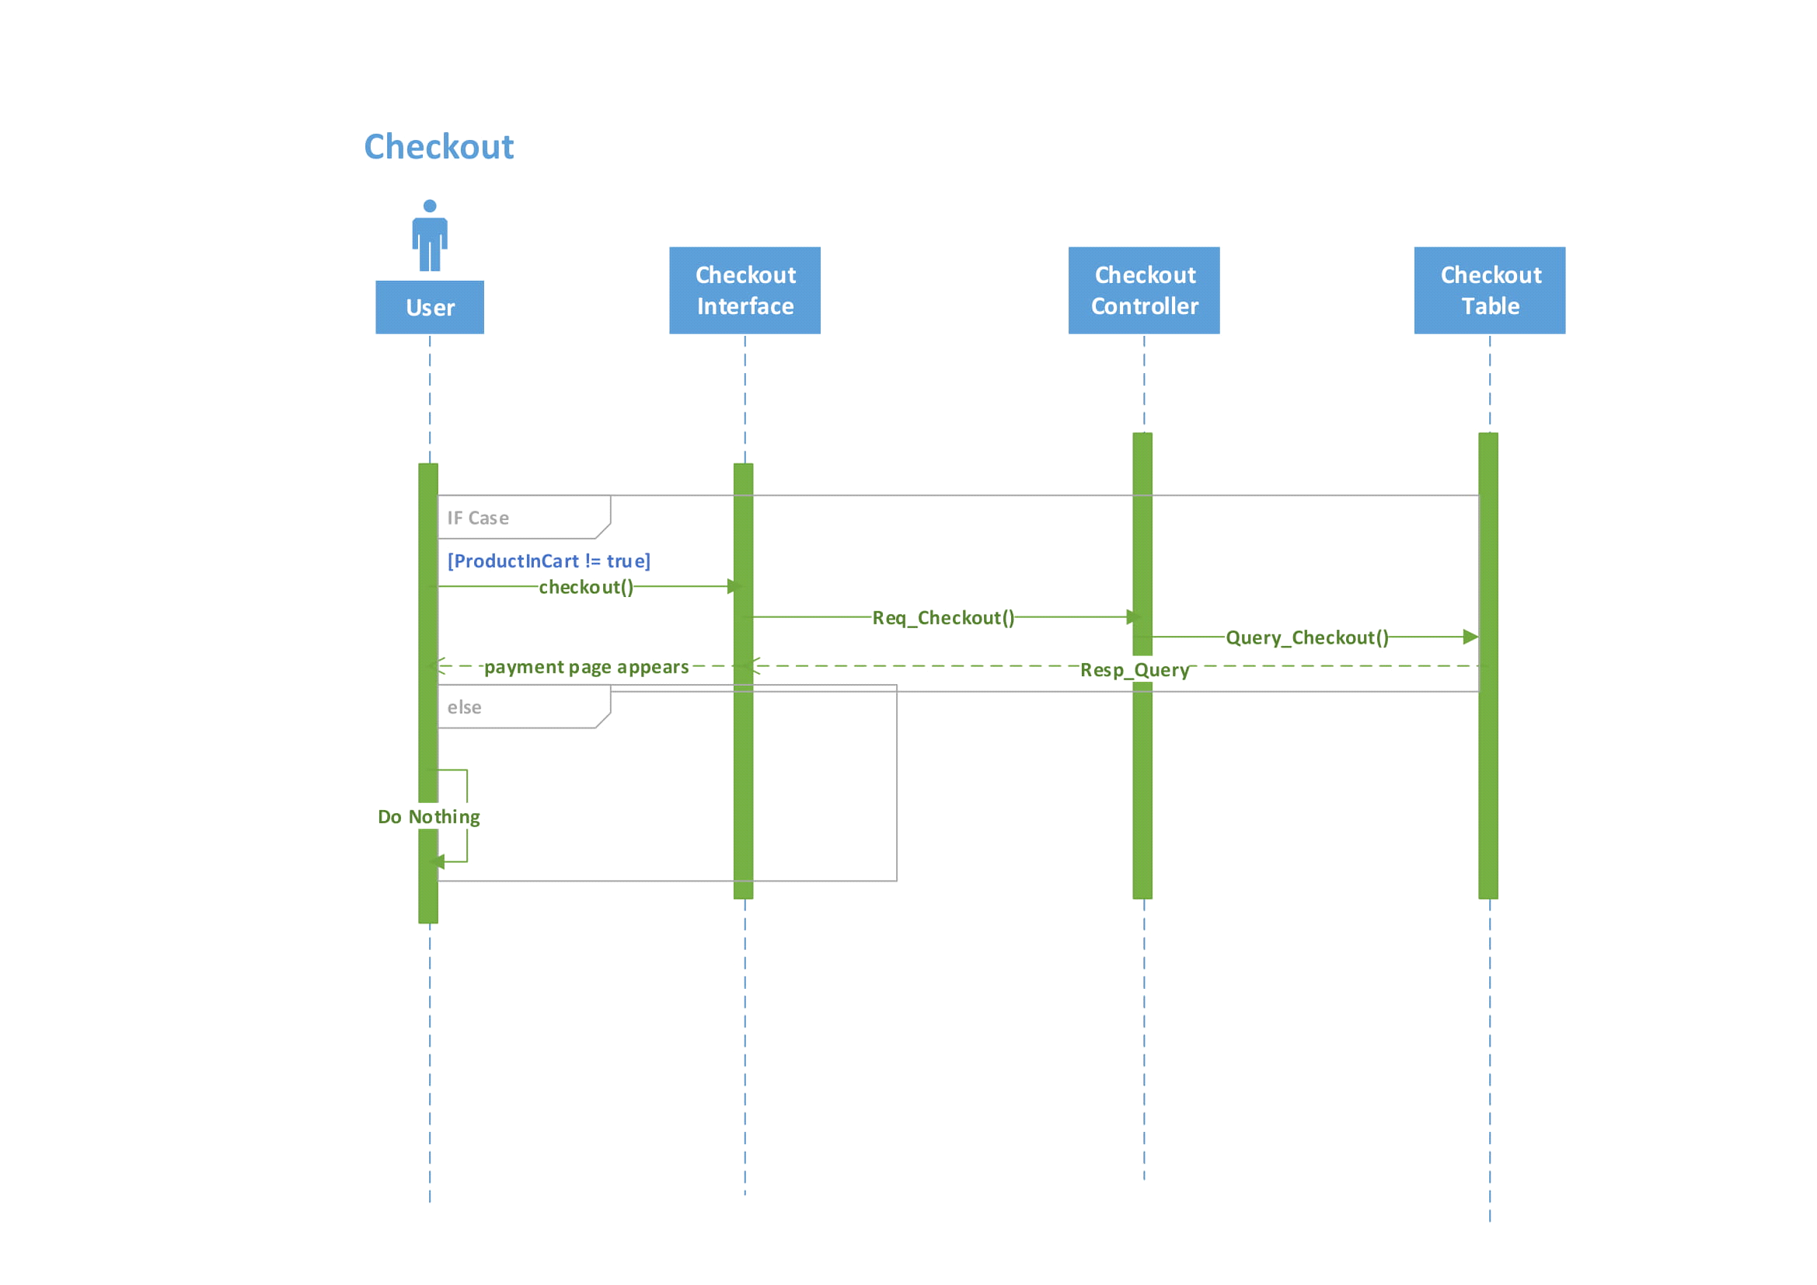

Figure 54 - Customer Side Chat Bot Sequence Diagram

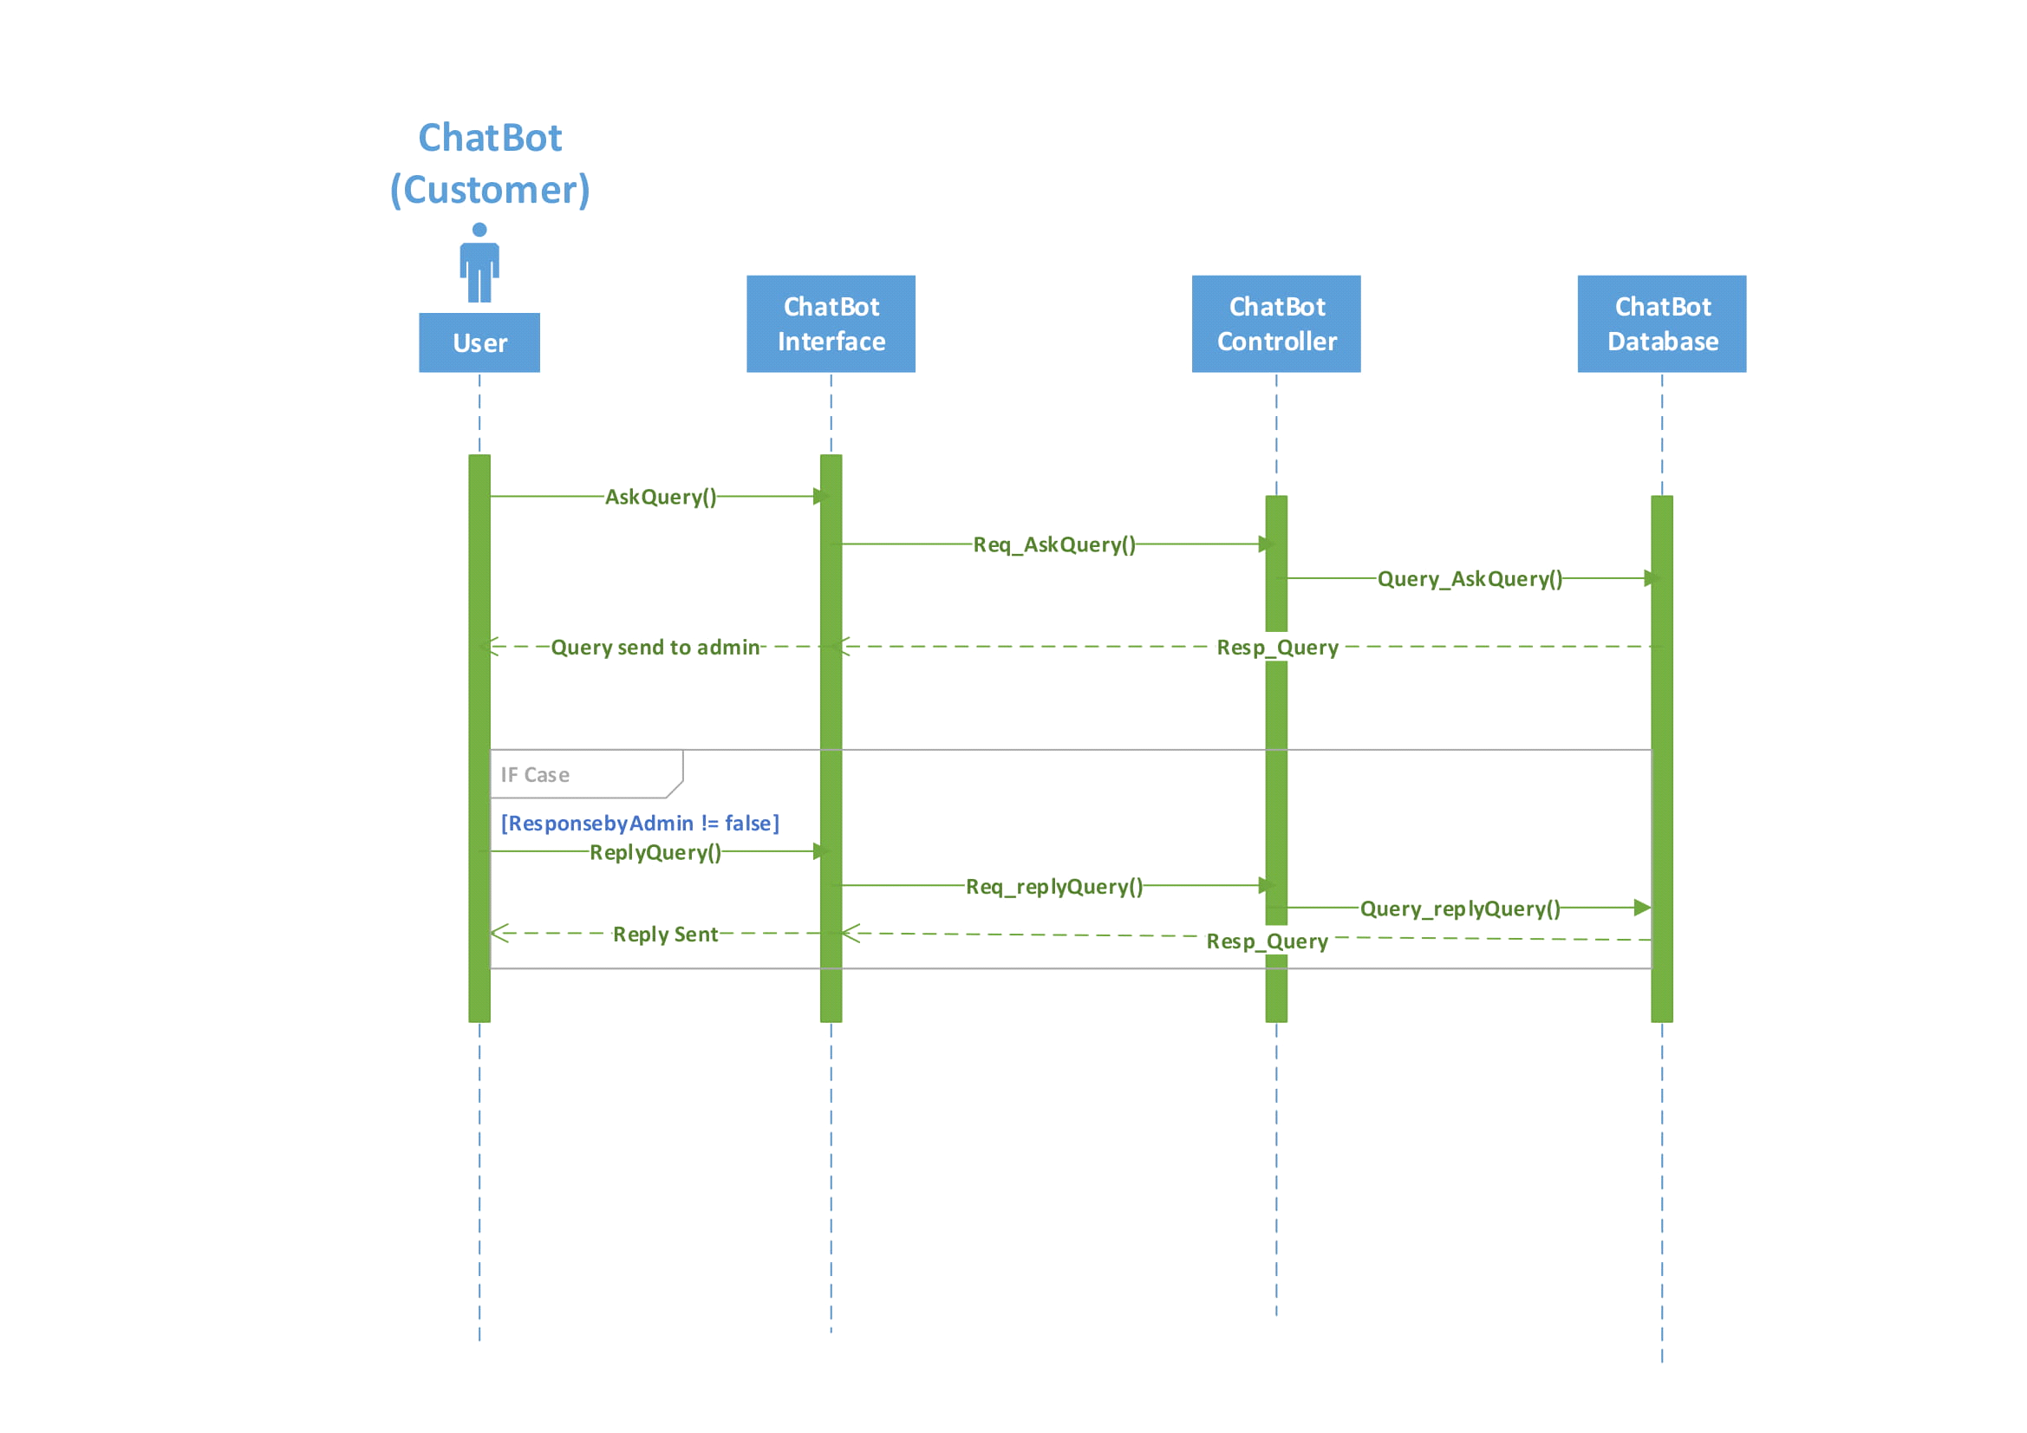

Figure 55 - Admin Side Chat Bot Sequence Diagram

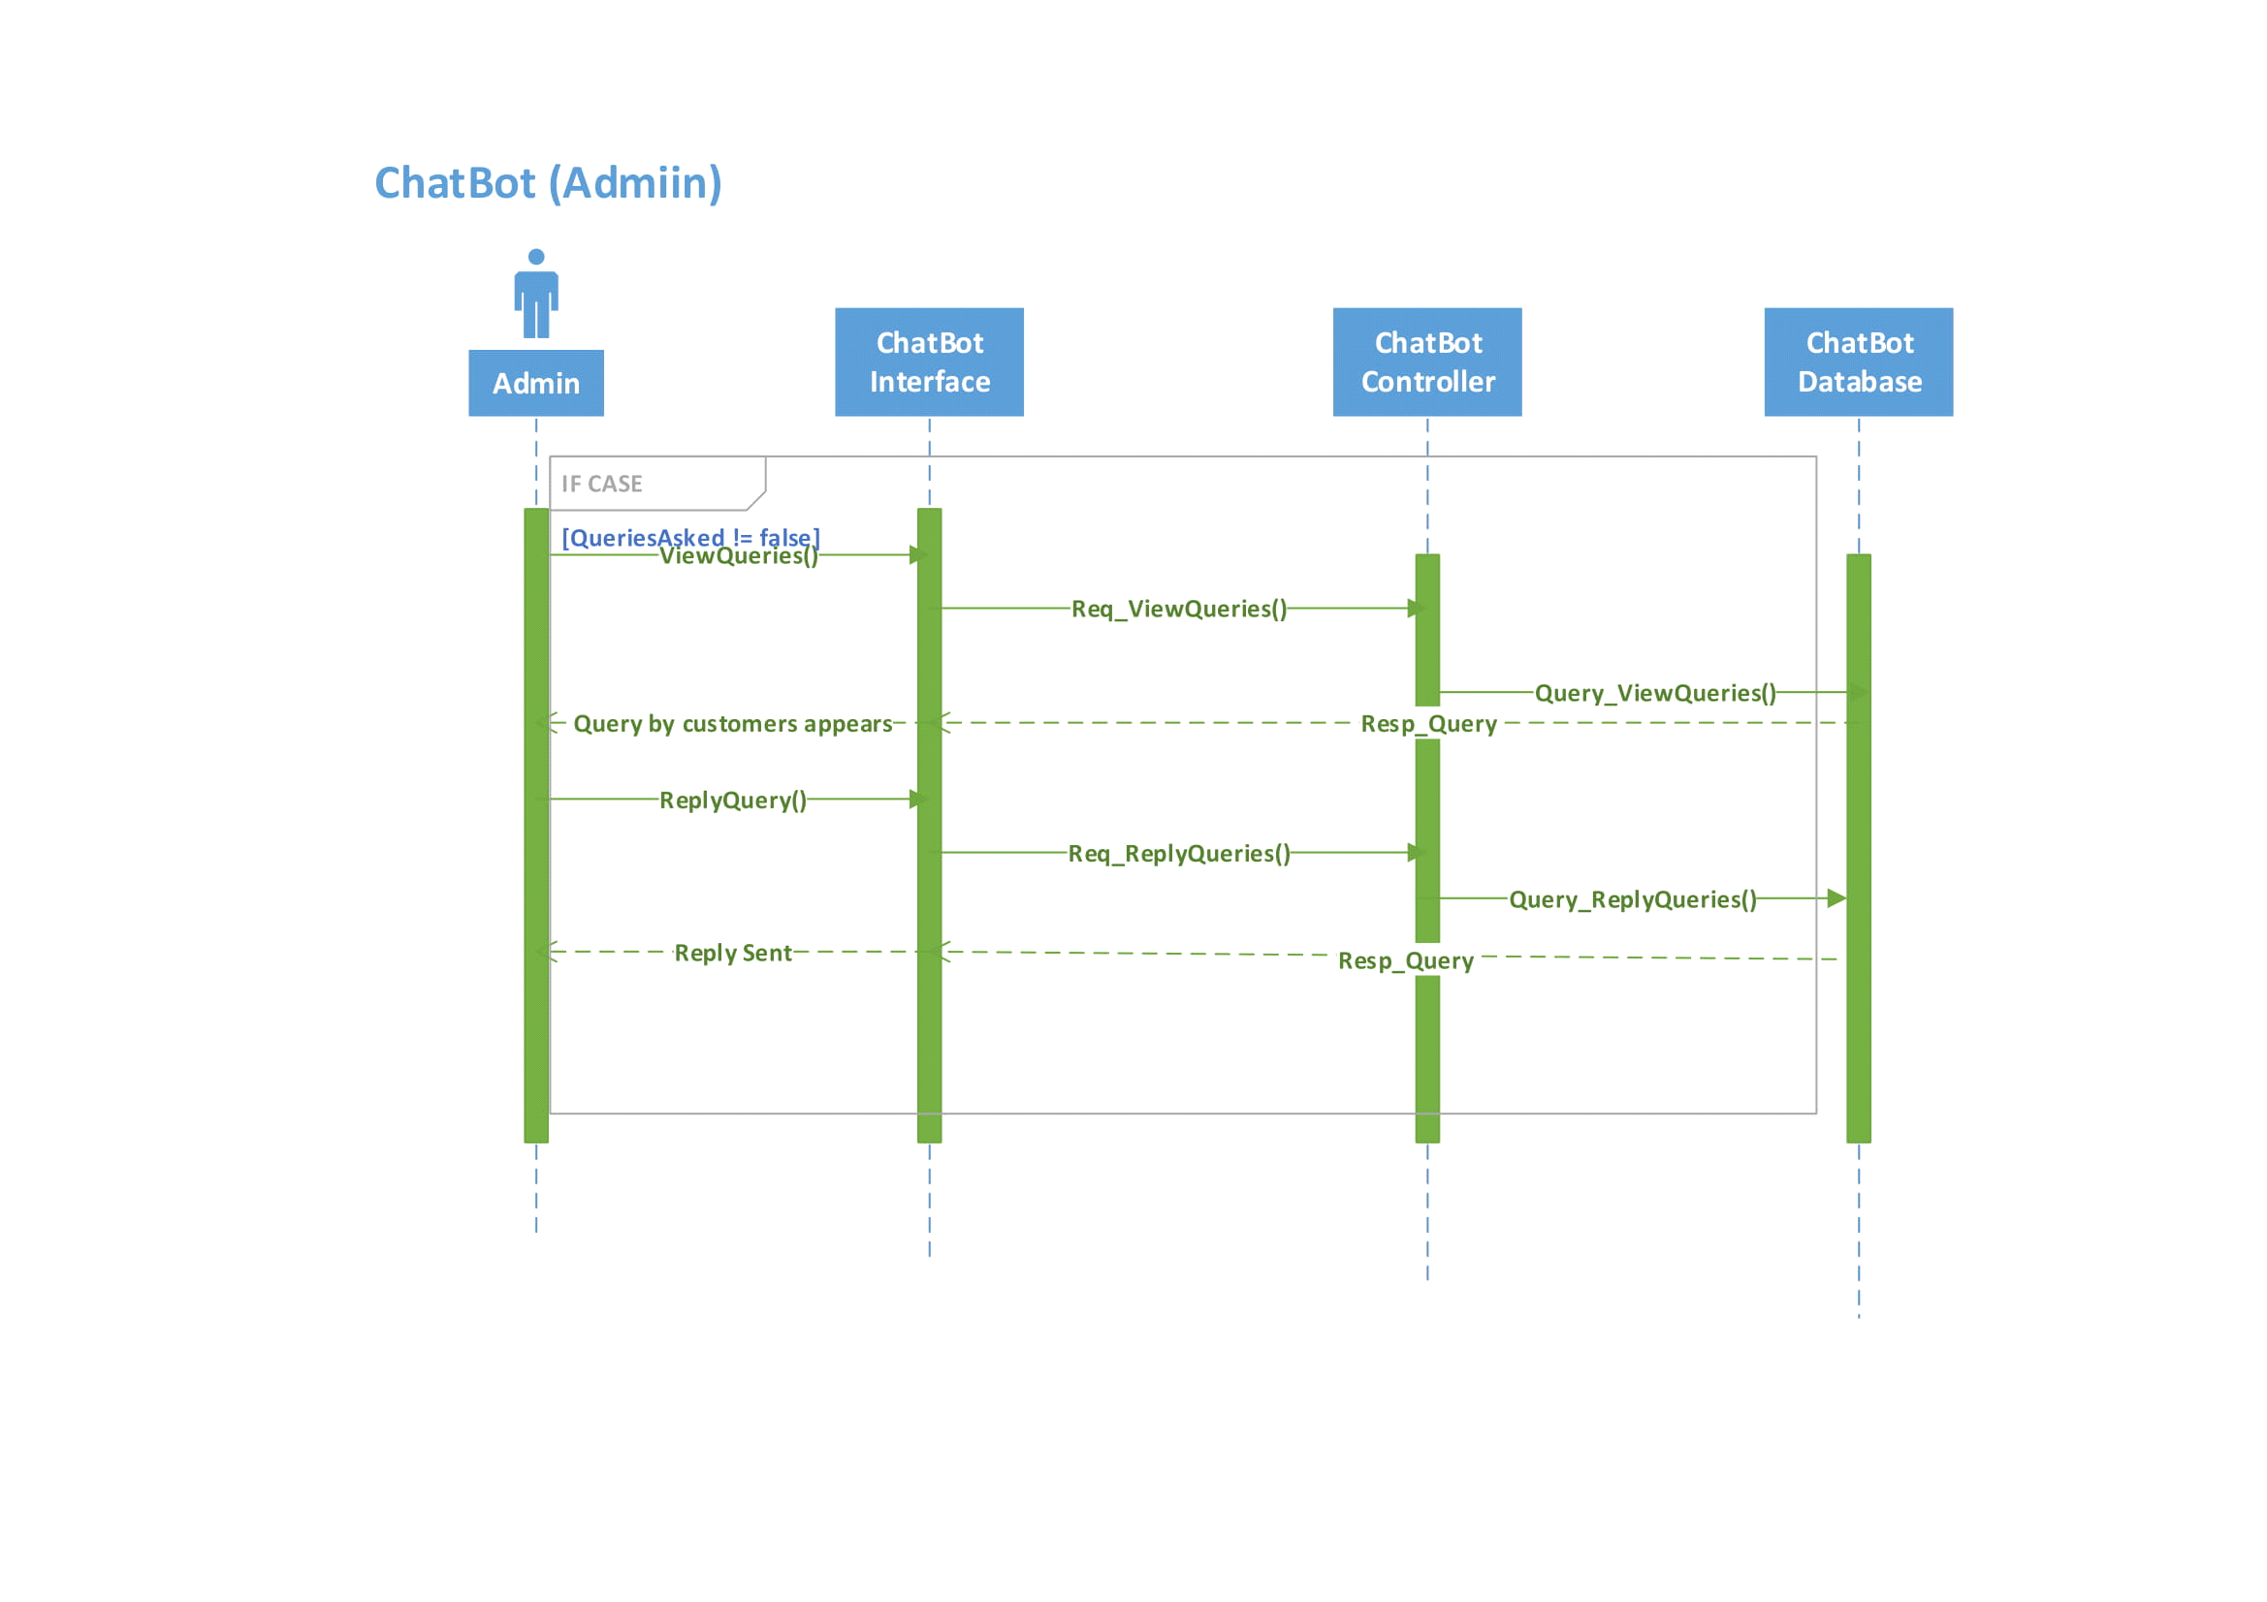

Figure 56- Boxes CRUD Sequence Diagram

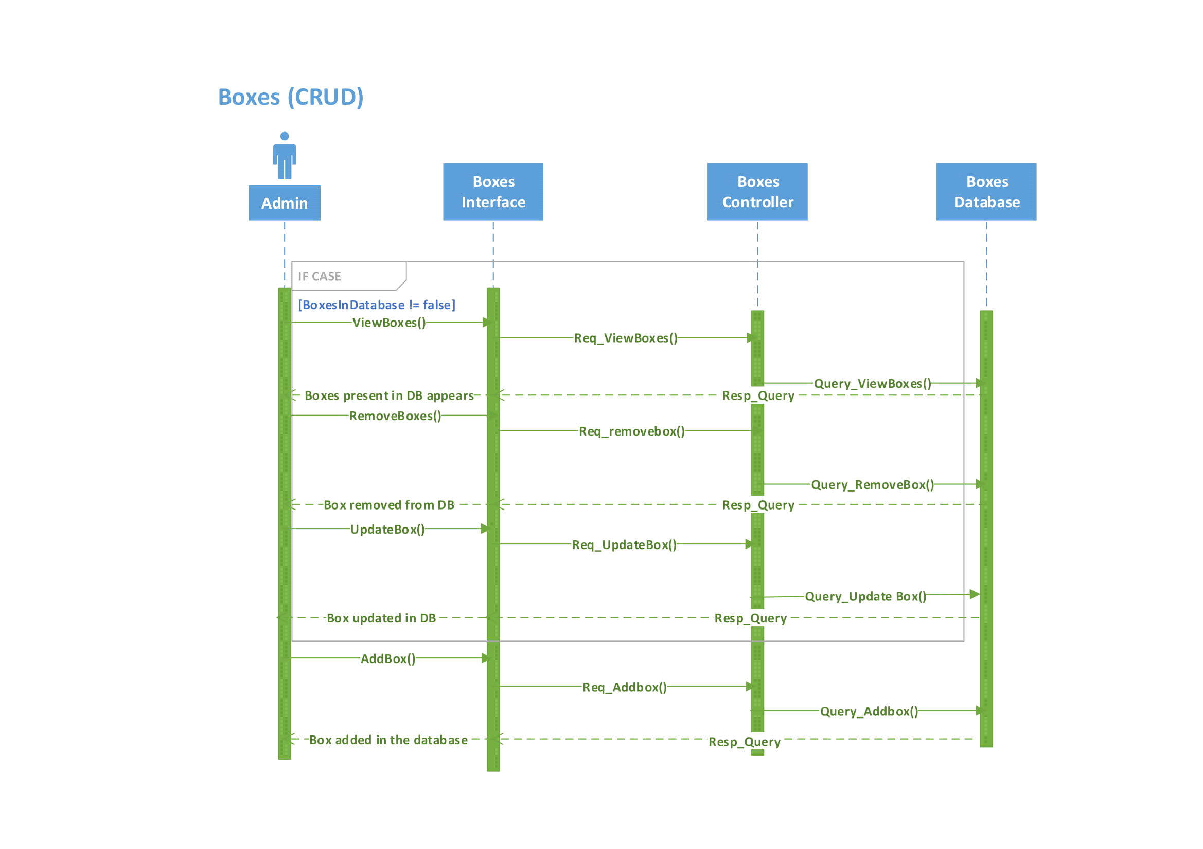

Figure 57- Order CRUD Sequence Diagram

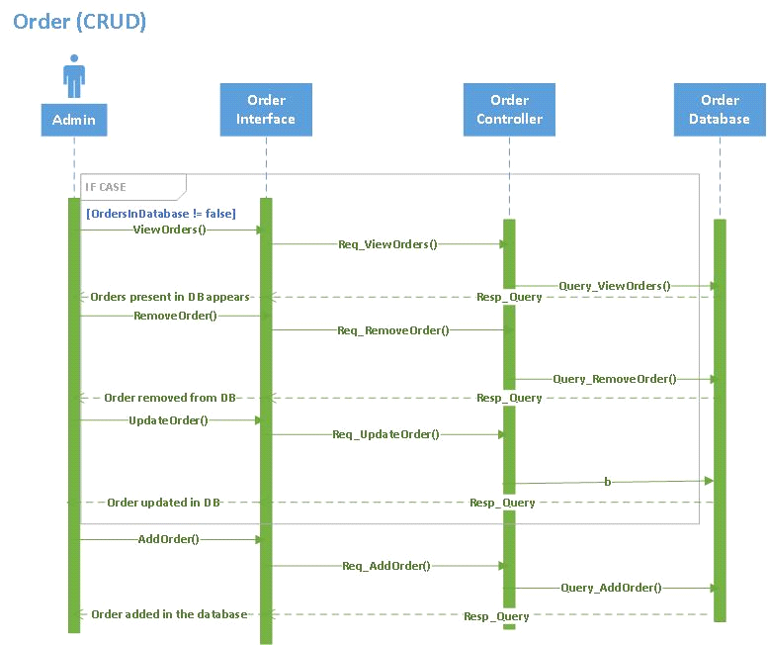

Figure 58- Product CRUD Sequence Diagram

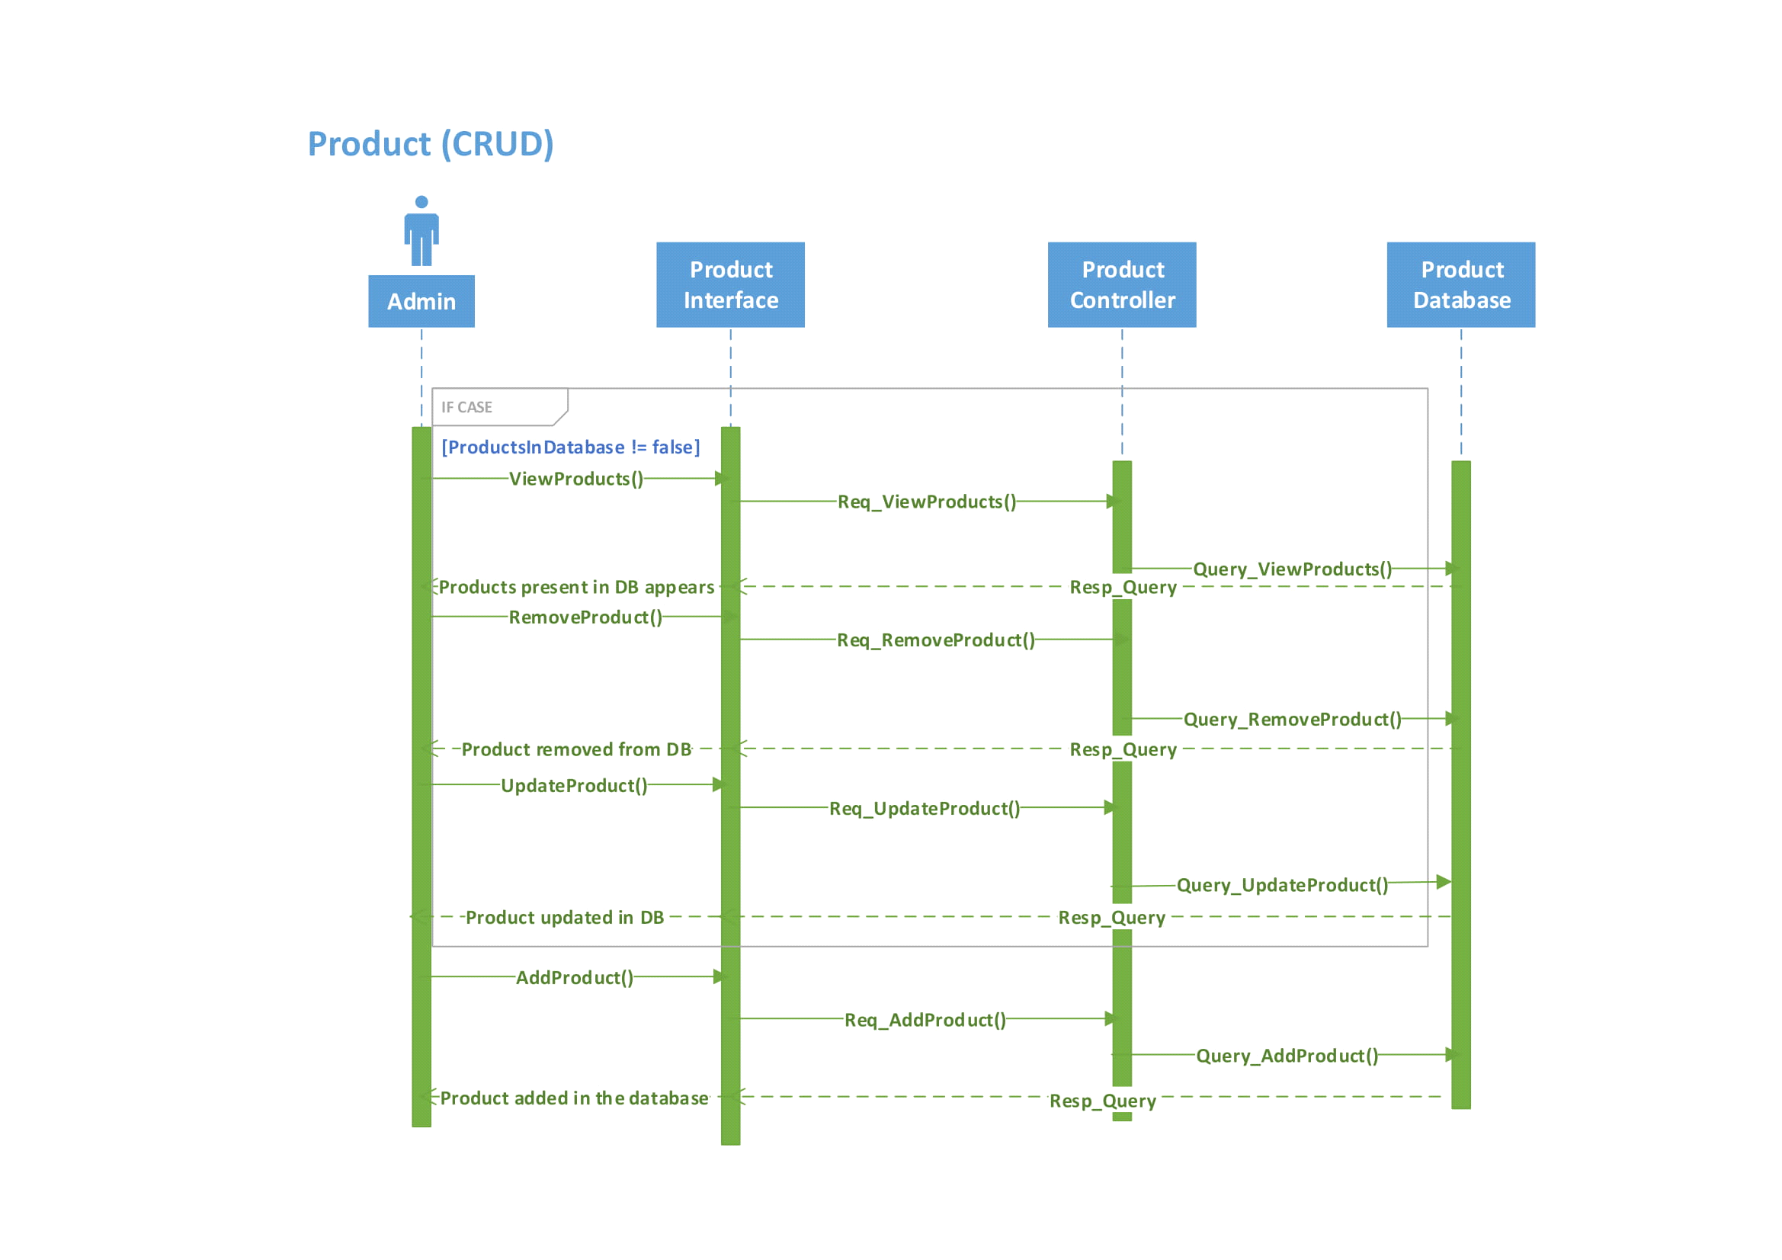

Figure 59 - Deal CRUD Sequence Diagram

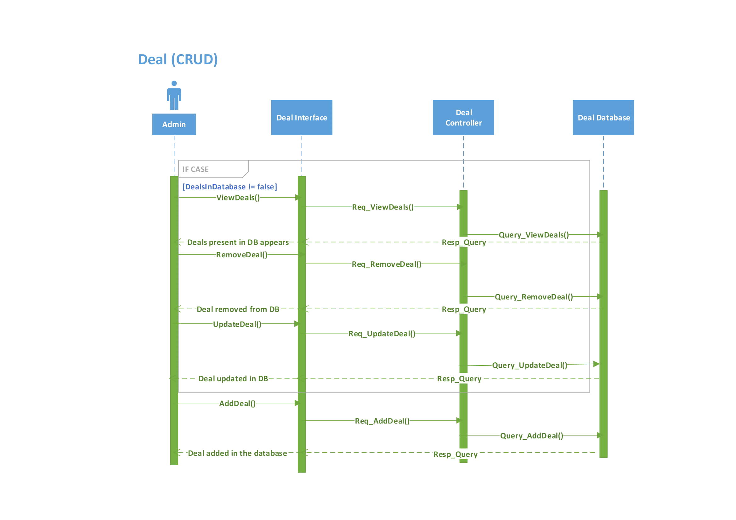

* **Software architecture**

We are using Laravel framework. This framework uses MVC (model, view, and controller) for implementation. This architecture pattern is best suited for designing web applications. The user requests some services and these services are sent to routers and then the router sends the request to the controller

MVC is an architectural pattern that separates the web application into three main components

* Model
* View
* Controller

Model:

All the web application domains are built on the model they represent the data that is being transferred to both the controller and view components. Models are stored outside the applications and are mostly database. When data changes it also updates controller. It mostly acts as a data storage system.

View:

The view represents the data that model contains it is the visual representation of the context of models. It is used for the graphical user interface of the application. It shows the data model on the page according to the requirements of the users that they had entered. It only displays data in form of GUIs.

Controller:

The controller act as a connection between model and views to process all the requests of the users and business logic. It manipulates data using model component and interacts with view component to render final input.

Figure 60 - Software Architecture

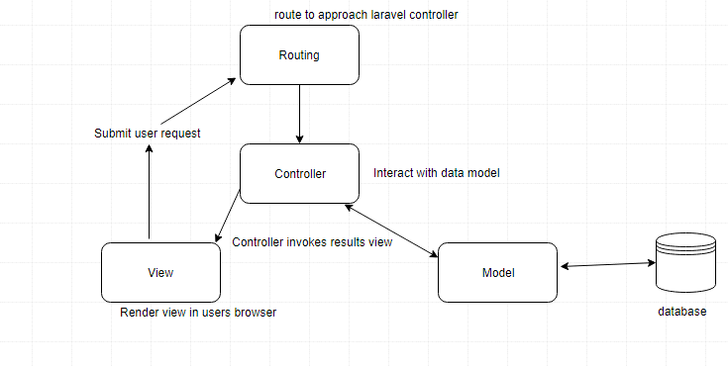

* **Class Diagram**

Figure 61 - Bake My Day Class Diagram

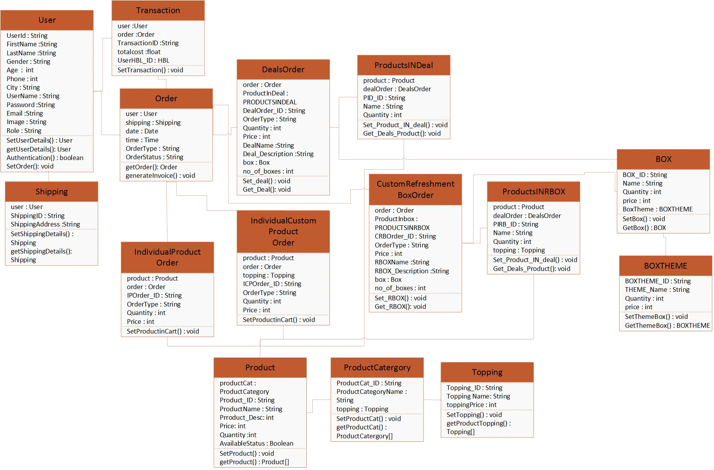

* **Database Diagram**

Figure 62 - Bake My Day Database Diagram

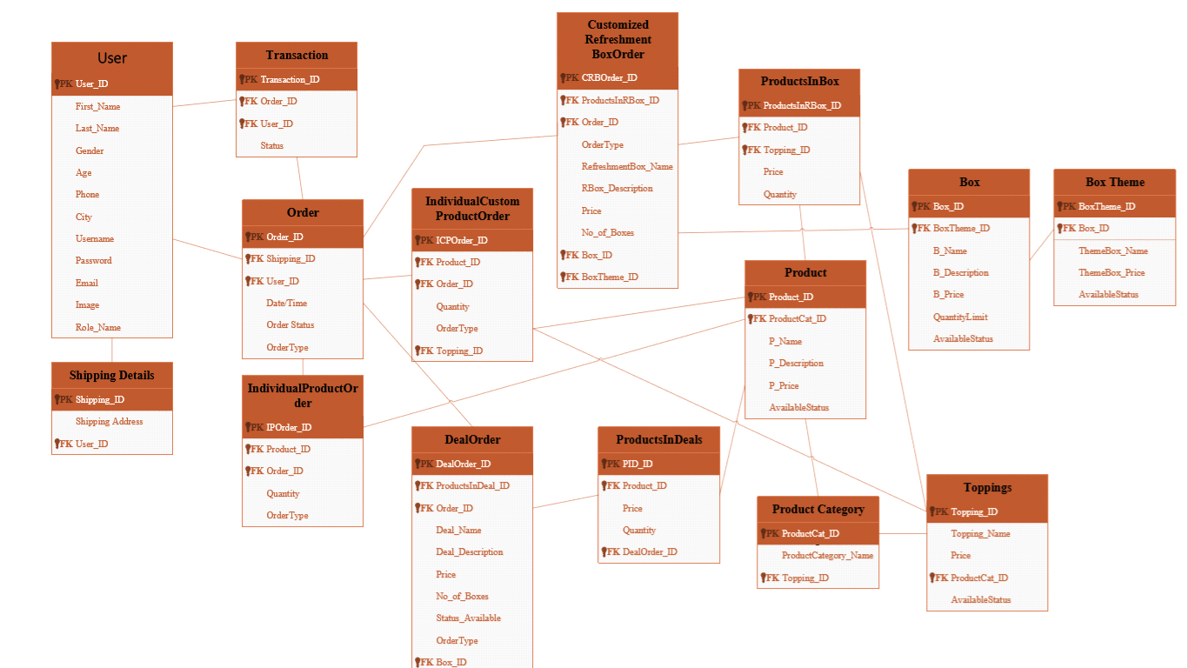

* **Network Diagram**

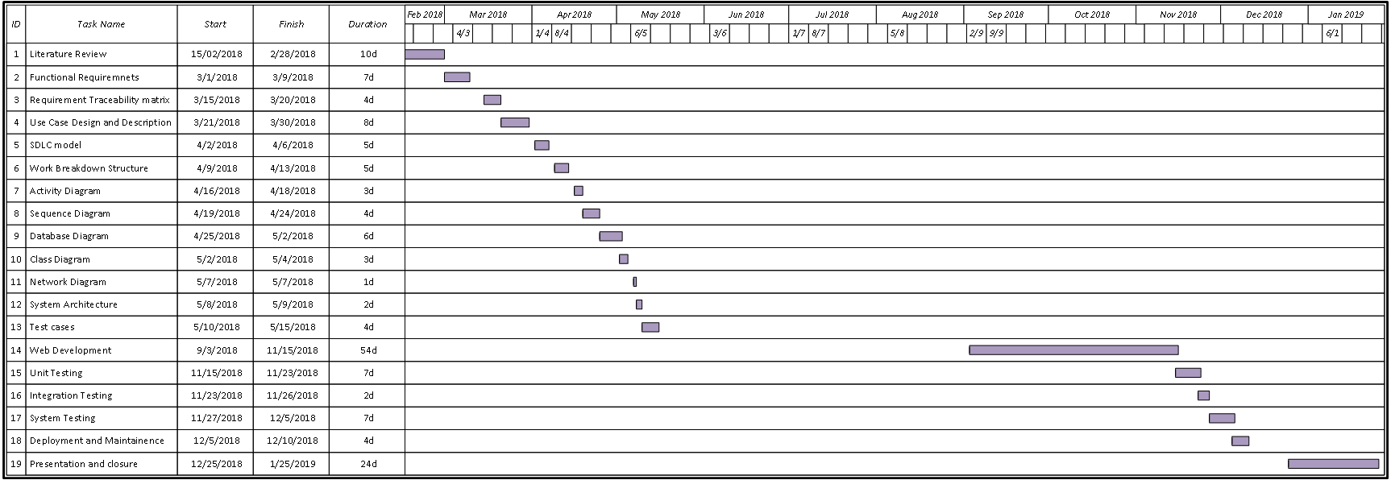Figure 63 - Network Diagram

* **Chapter #4: System Testing**
* **Test cases**

**Project Name: Bake My Day**

**Test Case ID:** TC ID 001

**Test Priority (Low/Medium/High):** High

**Module Name:** Create Account

**Test Title:** Verify information of admin/customer

**Description:** Creating account allows the user that is new to the system to create their account that will allow them to fully use the bakery system’s features.

**Pre-conditions:** Bake My Day homepage was already loaded.

**Dependencies:**

**Create Account (Valid test case)**

|  |  |  |  |  |
| --- | --- | --- | --- | --- |
| Steps | Test Steps | Test Data | Expected Result | Status(Pass/Fail) |
| 1 | Navigate from login page to sign up page |  | Admin/ Customer should be able to Signup | Pass |
| 2 | Provide valid name | Shanzeh Shaukat | Valid name | Pass |
| 3 | Provide valid phone no | 0321-3667510 | Valid phone no | Pass |
| 4 | Provide valid email | shanzehshaukat@gmail.com | Valid email | Pass |
| 5 | Provide valid DOB | 29/08/1996 | Valid DOB | Pass |
| 6 | Provide valid CNIC number | 35102-1567980-4 | Valid CNIC number | Pass |
| 7 | Select on Create Account button |  | Successfully Signed Up | Pass |

**Create Account (Invalid test case)**

|  |  |  |  |  |
| --- | --- | --- | --- | --- |
| Steps | Test Steps | Test Data | Expected Result | Status(Pass/Fail) |
| 1 | Navigate from login page to sign up page |  | Admin/ Customer should not be able to Signup | Fail |
| 2 | Provide valid name | 12g45ye | Invalid name | Fail |
| 3 | Provide valid phone no | 0301fvhjh785755 | Invalid phone no | Fail |
| 4 | Provide valid email | shanzehshaukat | Invalid email | Fail |
| 5 | Provide valid DOB | 43H/3T | Invalid DOB | Fail |
| 6 | Provide valid CNIC number | 5867cy | Invalid CNIC | Fail |
| 7 | Select on Create account button |  | Sign Up unsuccessful | Fail |

**Test Case ID:** TC ID 002

**Test Priority (Low/Medium/High):** High

**Module Name: Login**

**Test Title:** Verify information of admin/customer

**Description:** Log in allows the users that already have an account in the system to access the respective accounts that will allow them to fully use the bakery systems’ features.

**Pre-conditions:** The account in Bake My Day system already existed and the home page was loaded.

**Dependencies:**

**Login page (Valid test case)**

|  |  |  |  |  |
| --- | --- | --- | --- | --- |
| Steps | Test Steps | Test Data | Expected Result | Status(Pass/Fail) |
| 1 | Navigate to login page |  | Admin/ Customer should be able to Login | Pass |
| 2 | Provide valid username | Shanzeh Shaukat | Valid username | Pass |
| 3 | Provide valid password | Qwerty123 | Valid password | Pass |
| 4 | Select on the login button |  | Login successful | Pass |

**Login page (Invalid test case)**

|  |  |  |  |  |
| --- | --- | --- | --- | --- |
| Steps | Test Steps | Test Data | Expected Result | Status(Pass/Fail) |
| 1 | Navigate to login page |  | Admin/ Customer should not be able to | Fail |
| 2 | Provide valid username | 85//@#2 | Invalid username | Fail |
| 3 | Provide valid password | 44478ghfdgh58785gh558@89#- | Invalid password | Fail |
| 4 | Select on the login button |  | Login unsuccessful | Fail |

**Test Case ID:** TC ID 003

**Test Priority (Low/Medium/High):** High

**Module Name: Search Product**

**Test Title:** Verifying searching product

**Description:** Search item module allows the customer to select bakery items category. It also allows the customer to search item by keyword according to his/her choices by choosing flavors and ingredients.

**Pre-conditions:** The customer/admin was logged-in into respective account.

**Dependencies:**

**Search Product (Valid test case)**

|  |  |  |  |  |
| --- | --- | --- | --- | --- |
| Steps | Test Steps | Test Data | Expected Result | Status(Pass/Fail) |
| 1 | Navigate to search product page. |  | Customer should be able to search for product. | Pass |
| 2 | Enters the product name. | Cheese cake | Valid product name. | Pass |
| 3 | Select item category | Pizza | Valid Item | Pass |
| 4 | Provides flavour | strawberry | Valid flavour |  |
| 5 | Select ingredients | Extra cheese | Valid Ingredients |  |
| 4 | Select on the search button |  | Login successful | Pass |

**Search Product (Invalid test case)**

|  |  |  |  |  |
| --- | --- | --- | --- | --- |
| Steps | Test Steps | Test Data | Expected Result | Status(Pass/Fail) |
| 1 | Navigate to search product page. |  | Customer should not be able to search for product. | Fail |
| 2 | Enters the product name. | Dst6wr3 | Invalid product name. | Fail |
| 3 | Select item category | hjhhgfg | Invalid item | Fail |
| 4 | Provides flavor | fghjkjh | invalid flavor |  |
| 5 | Select ingredients | Bb44 | Invalid ingredients |  |
| 4 | Select on the search button |  | Searching Product unsuccessful | Fail |

**Test Case ID:** TC ID 004

**Test Priority (Low/Medium/High):** High

**Module Name: Order processing**

**Test Title:** Verifying order processing.

**Description:** Order processing module allows the customer to select his\her desired bakery product along with customized products. Also, he will be able to add, delete the selected product, and edit the quantity of selected product and giving the shipping order details.

**Pre-conditions:** The website must be live and the customer must be logged in to the system.

**Dependencies:**

**Order Processing (Valid test case)**

|  |  |  |  |  |
| --- | --- | --- | --- | --- |
| Steps | Test Steps | Test Data | Expected Result | Status(Pass/Fail) |
| 1 | Navigate to order processing page. |  | Customer should be able to get access to order processing. | Pass |
| 2 | Select product. | Cheese cake | Valid product name. | Pass |
| 3 | Add/ delete product. |  |  | Pass |
| 4 | Provides quantity of product. | 3 | Valid quantity | Pass |
| 5 | Confirms product. |  |  |  |
| 6 | Provides credit card number. | 5105105105105100 | Valid credit card. | Pass |
| 7 | Provides security pin code. | 340224188 | Valid security pin code. | Pass |
| 8 | Enters account number for transaction. | 1124 | Valid account number. | Pass |
|  |  |  |  |  |

**Order Processing (Invalid test case)**

|  |  |  |  |  |
| --- | --- | --- | --- | --- |
| Steps | Test Steps | Test Data | Expected Result | Status(Pass/Fail) |
| 1 | Navigate to order processing page. |  | Customer should not be able to get access to order processing. | Fail |
| 2 | Select product. | chbjsjyjh | Invalid product name. | Fail |
| 3 | Add/ delete product. |  |  |  |
| 4 | Provides quantity of product. | hjuj | Invalid quantity | Fail |
| 5 | Confirms product. |  |  |  |
| 6 | Provides credit card number. | hvue324343 | Invalid credit card number. | Fail |
| 7 | Provides security pin code. | Mnu78 | Invalid security pin code. | Fail |
| 8 | Enters account number for transaction. | W3sw | Invalid account number. | Fail |

**Test Case ID:** TC ID 007

**Test Priority (Low/Medium/High):** High

**Module Name: Customized Deals**

**Test Title:** Select customized orders with boxes.

**Description:** Customized Deals module allows the customer to select Box then select products according to his/her requirement and select customization details and then move towards order processing module. If customer wants to change box then he/she can change it also.

**Pre-conditions:** The customer must be log in to the system.

**Dependencies:**

**Customized deals (Valid test case)**

|  |  |  |  |  |
| --- | --- | --- | --- | --- |
| Steps | Test Steps | Test Data | Expected Result | Status(Pass/Fail) |
| 1 | Navigate to customized deal page where customer can firstly select boxes. |  | Customer should be able to get access to customized deal page. | Pass |
| 2 | Select shape of box | Heart shape | Valid box shape | Pass |
| 3 | Select size of box | Bakery cookies box | Valid box size | Pass |
| 4 | Select desired product | Chocolate Cake | Valid product name | Pass |
| 5 | Select customized options | Butter Cream Frosting |  |  |
| 6 | Add/ delete product. |  |  | Pass |
| 7 | Provides quantity of product. | 3 | Valid quantity | Pass |
| 8 | Confirms product. |  |  |  |
| 9 | Provides Credit card number | 5105105105105100 | Valid credit card | Pass |
| 10 | Provides security pin code. | 340224188 | Valid security pin code. | Pass |
| 11 | Enters account number for transaction. | 1124 | Valid account number. | Pass |

**Customized deals (Invalid test case)**

|  |  |  |  |  |
| --- | --- | --- | --- | --- |
| Steps | Test Steps | Test Data | Expected Result | Status(Pass/Fail) |
| 1 | Navigate to customized deal page where customer can firstly select boxes. |  | Customer should not be able to get access to customized deal page. | Fail |
| 2 | Select shape of box | Efdf@ | Invalid box shape | Fail |
| 3 | Select size of box | Dfe# | Invalid box size | Fail |
| 4 | Select desired product | chbjsjyjh | Invalid product name. | Fail |
| 5 | Select customized options | vgsgs | Invalid customized option | Fail |
| 6 | Add/ delete product. |  |  |  |
| 7 | Provides quantity of product. | hjuj | Invalid quantity | Fail |
| 8 | Confirms product. |  |  |  |
| 9 | Provides Credit card number | hvue324343 | Invalid credit card number. | Fail |
| 10 | Provides security pin code. | Mnu78 | Invalid security pin code. | Fail |
| 11 | Enters account number for transaction. | W3sw | Invalid account number. | Fail |

**Test Case ID:** TC ID 008

**Test Priority (Low/Medium/High):** High

**Module Name: Non Customized Deals**

**Test Title:** Select deal then select boxes.

**Description:** Non Customized Deals module allows the customer to select deal then select box according to his/her requirement and then customer can also view the details of product and then move towards order processing module. If customer wants to change box then he/she can change it also.

**Pre-conditions:** The customer must be log in to the system.

**Dependencies:**

**Non Customized deals (Valid test case)**

|  |  |  |  |  |
| --- | --- | --- | --- | --- |
| Steps | Test Steps | Test Data | Expected Result | Status(Pass/Fail) |
| 1 | Navigate to non-customized deal page where customer can select deals. |  | Customer should be able to get access to non-customized deal page. | Pass |
| 2 | Select desired product | Glazed Doughnuts and Drinks | Valid deal name | Pass |
| 3 | Select the box | Bakery cookies box | Valid box name | Pass |
| 4 | view the description of order |  |  |  |
| 6 | Add/ delete product. |  |  |  |
| 7 | Update quantity of product. | 3 | Valid quantity | Pass |
| 8 | Confirms product. |  |  |  |
| 9 | Provides Credit card number | 5105105105105100 | Valid credit card | Pass |
| 10 | Provides security pin code. | 340224188 | Valid security pin code. | Pass |
| 11 | Enters account number for transaction. | 1124 | Valid account number. | Pass |

**Non Customized deals (Invalid test case)**

|  |  |  |  |  |
| --- | --- | --- | --- | --- |
| Steps | Test Steps | Test Data | Expected Result | Status(Pass/Fail) |
| 1 | Navigate to non-customized deal page where customer can select deals. |  | Customer should not be able to get access to non-customized deal page. | Fail |
| 2 | Select desired product | bfhdsf | invalid deal name | Fail |
| 3 | Select the box | fgdf box | Invalid box name | Fail |
| 4 | view the description of order |  |  |  |
| 6 | Add/ delete product. |  |  |  |
| 7 | Update quantity of product. | fvhfhd | invalid quantity | Fail |
| 8 | Confirms product. |  |  |  |
| 9 | Provides Credit card number | hvue324343 | Invalid credit card number. | Fail |
| 10 | Provides security pin code. | Mnu78 | Invalid security pin code. | Fail |
| 11 | Enters account number for transaction. | W3sw | Invalid account number. | Fail |

**Test Case ID:** TC ID 009

**Test Priority (Low/Medium/High):** High

**Module Name: Select Box**

**Test Title:** Select boxes of different size and shapes.

**Description:** Selecting Boxes module allows the customer to select boxes of different sizes according to their price range and venue (Birthday, Meeting, weddings).

**Pre-conditions:** The customer has placed his/her order.

**Dependencies:**

**Select Box (Valid test case)**

|  |  |  |  |  |
| --- | --- | --- | --- | --- |
| Steps | Test Steps | Test Data | Expected Result | Status(Pass/Fail) |
| 1 | Navigate to select box page where customer can select his/her desired boxes. |  | Customer should be able to get access to select box page. | Pass |
| 2 | Select shape of box | Circle shape | Valid box shape | Pass |
| 3 | Select size of box | Cardboard bakery boxes | Valid box size | Pass |

**Select Box (Invalid test case)**

|  |  |  |  |  |
| --- | --- | --- | --- | --- |
| Steps | Test Steps | Test Data | Expected Result | Status(Pass/Fail) |
| 1 | Navigate to select box page where customer can select his/her desired boxes. |  | Customer should not be able to get access to select box page. | Fail |
| 2 | Select shape of box | xfgdfh | Invalid box shape | Fail |
| 3 | Select size of box | hfjdhf boxes | Invalid box size | Fail |

**Test Case ID:** TC ID 013

**Test Priority (Low/Medium/High):** High

**Module Name: Check Order Status**

**Test Title: Use to update the status of product.**

**Description:** Updating Order Status module allows the admin to update the status of the product.

**Pre-conditions:** The customer has placed his/her order.

**Dependencies:**

**Check Order Status (Valid test case)**

|  |  |  |  |  |
| --- | --- | --- | --- | --- |
| Steps | Test Steps | Test Data | Expected Result | Status(Pass/Fail) |
| 1 | Navigate to Check Order Status page where admin can update the status of the product. |  | Admin should be able to get access to Check Order Status page. | Pass |
| 2 | Customer change order | Ice cream cake | Valid name | Pass |
| 3 | Admin update order status |  | Order successfully updated. | Pass |

**Check Order Status (Invalid test case)**

|  |  |  |  |  |
| --- | --- | --- | --- | --- |
| Steps | Test Steps | Test Data | Expected Result | Status(Pass/Fail) |
| 1 | Navigate to Check Order Status page where admin can update the status of the product. |  | Admin should not be able to get access to Check Order Status page. | Fail |
| 2 | Customer change order | adfrcake | Invalid product name | Fail |
| 3 | Admin update order status |  | Order unsuccessfully updated | Fail |

* **References**
* <https://www.themobileindian.com/reviews/app-review-foodpanda-makes-ordering-food-simple-805>
* <http://www.apppicker.com/reviews/18766/foodpanda-app-review-food-delivery-made-easy>
* <https://www.capterra.com/p/141246/My-Online-Bakery/>
* <http://bakewheel.com/index.jsp>
* <http://www.supermeal.pk/>
* <https://www.ubereats.com/chandigarh/>

Appendix A

Include here the 1st page of Turnitin Report

Every supervisor has his/her own Turnitin account. If not then the supervisors are requested to get the account from Library as soon as possible.